Journal of Biogeography

SUPPORTING INFORMATION
Local adaptation drives population isolation in a tropical seabird
Guilherme Tavares Nunes & Leandro Bugoni

APPENDIX S1 Additional methodological details.

1. Population density calculations
Total area (km²) for each archipelago was obtained with the ruler tool in Google Earth Pro, by considering the maximum perimeter of emerged portions. Census-based population sizes for SPSP, FN, Rocas, and Abrolhos were obtained from Mancini, Serafini, & Bugoni (2016), and data for Cagarras and Moleques were obtained from Cunha, Alves, Rajão, & Lanna (2013) and Branco, Fracasso, & Moraes-Ornellas (2013) respectively.

2. Carbon and nitrogen isotopic data used for calculations of isotopic niche width
For calculating isotopic niche width, a previously published data set of carbon and nitrogen isotopic ratios for SPSP, FN, Rocas, and Abrolhos was used, which is based on blood samples obtained from breeding adults in 2010 and 2011 (Mancini, Hobson, & Bugoni, 2014). Additionally, samples of whole blood were taken from boobies breeding in Cagarras and Moleques in 2014 and processed in the laboratory following procedures described in Mancini et al. (2014). Because data from Mancini et al. (2014) were analyzed at a distinct laboratory, laboratory-biased results were assessed by running Pearson's correlation and t-test with 10 samples of Atlantic yellow-nosed albatross Thalassarche chlororhynchos, which were sent to both laboratories. Samples from the inter-laboratory comparison demonstrated a high correlation for carbon (r = .93; p-value < .001) and nitrogen (r = .98; P-value <.001). Similarly, deviations were not detected between means through a paired t-test for carbon (t = -1.29; df = 17.99; p-value = .21) and nitrogen (t = .19; df = 17.99; p-value = .84). Thus, samples from different laboratories were pooled for subsequent analysis. Stable isotope ratios were expressed in δ notation as parts per thousand (‰) differences from the international reference material Vienna Pee Dee Belemnite (VPDB) limestone for carbon, and atmospheric air for nitrogen.

REFERENCES
Branco, J. O., Fracasso, H. A. A. & Moraes-Ornellas V. S. (2013). Reproduction and demographic trends of Sula leucogaster at the Moleques do Sul Archipelago, Santa Catarina, Brazil. Biota Neotropica, 13, 39–45.
Cunha, L. S. T., Alves, V. S., Rajão, H. & Lanna, A. M. (2013). Aves do Monumento Natural das Ilhas Cagarras. In F. Moraes, A. Bertoncini, & A. Aguiar (Eds.), História, pesquisa e biodiversidade do Monumento Natural das Ilhas Cagarras (pp. 176–205). Rio de Janeiro: Museu Nacional.
Mancini, P. L., Hobson, K. A. & Bugoni, L. (2014). Role of body size in shaping the trophic structure of tropical seabird communities. Marine Ecology Progress Series, 497, 243–257.
Mancini, P. L., Serafini, P. P. & Bugoni, L. (2016). Breeding seabird populations in Brazilian oceanic islands: historical review, update and a call for census standardization. Revista Brasileira de Ornitologia, 24, 94–115.

APPENDIX S2 Outputs of statistical analyses
Table 2.1 Genetic diversity based on nine microsatellite loci for six colonies of brown boobies, Sula leucogaster, distributed in the southwest Atlantic Ocean. H_{O} = observed heterozygosity; H_{E} = expected heterozygosity from Hardy-Weinberg proportions (Nei, 1978); F_{IS} = inbreeding coefficient (Weir, & Cockerham, 1984); and A = number of alleles. SPSP = Saint Peter and Saint Paul Archipelago; FN = Fernando de Noronha; Rocas = Rocas Atoll; Moleques = Moleques do Sul. Bold values were deviated from Hardy-Weinberg equilibrium
Loci |  | SPSP (♀=12; ♂=12) |  |  |  |  | FN (♀=8; ♂=11) |  |  |  |  | Rocas (♀=11; ♂=8) |  |  |  |  | Abrolhos (♀=11; ♂=9) |  |  |  |  | Cagarras (♀=10; ♂=9) |  |  |  |  | Moleques (♀=9; ♂=9)
 |  | H_{O} | H_{E} | F_{IS} | A |  | H_{O} | H_{E} | F_{IS} | A |  | H_{O} | H_{E} | F_{IS} | A |  | H_{O} | H_{E} | F_{IS} | A |  | H_{O} | H_{E} | F_{IS} | A |  | H_{O} | H_{E} | F_{IS} | A
Sv2A-2 |  | 0.00 | 0.00 | 0.00 | 1 |  | 0.33 | 0.36 | 0.06 | 2 |  | 0.44 | 0.51 | 0.14 | 2 |  | 0.30 | 0.26 | -0.15 | 2 |  | 0.74 | 0.50 | -0.47 | 2 |  | 0.50 | 0.51 | 0.02 | 2
Sv2A-26 |  | 0.46 | 0.47 | 0.02 | 2 |  | 0.44 | 0.46 | 0.04 | 4 |  | 0.47 | 0.44 | -0.08 | 4 |  | 0.25 | 0.34 | 0.28 | 4 |  | 0.16 | 0.15 | -0.04 | 3 |  | 0.33 | 0.29 | -0.17 | 2
Sn2A-123 |  | 0.42 | 0.42 | 0.01 | 2 |  | 0.39 | 0.32 | -0.21 | 2 |  | 0.41 | 0.45 | 0.09 | 2 |  | 0.40 | 0.49 | 0.19 | 2 |  | 0.39 | 0.39 | -0.01 | 2 |  | 0.39 | 0.51 | 0.24 | 2
Sn2B-83 |  | 0.00 | 0.00 | 0.00 | 1 |  | 0.39 | 0.32 | -0.21 | 2 |  | 0.58 | 0.46 | -0.25 | 2 |  | 0.00 | 0.00 | 0.00 | 1 |  | 0.00 | 0.00 | 0.00 | 1 |  | 0.06 | 0.06 | 0.00 | 2
Sv2A-95 |  | 0.00 | 0.00 | 0.00 | 1 |  | 0.16 | 0.15 | -0.06 | 2 |  | 0.00 | 0.00 | 0.00 | 1 |  | 0.37 | 0.42 | 0.13 | 2 |  | 0.17 | 0.25 | 0.32 | 2 |  | 0.29 | 0.26 | -0.14 | 2
Sv2A-47 |  | 0.00 | 0.00 | 0.00 | 1 |  | 0.63 | 0.69 | 0.09 | 4 |  | 0.71 | 0.66 | -0.06 | 4 |  | 0.70 | 0.61 | -0.14 | 3 |  | 0.63 | 0.61 | -0.02 | 3 |  | 0.47 | 0.48 | 0.03 | 3
Sn2B-100 |  | 0.04 | 0.04 | 0.00 | 2 |  | 0.22 | 0.29 | 0.22 | 2 |  | 0.29 | 0.40 | 0.27 | 2 |  | 0.40 | 0.38 | -0.04 | 2 |  | 0.33 | 0.36 | 0.06 | 2 |  | 0.28 | 0.25 | -0.13 | 2
Sv2B-138 |  | 0.00 | 0.00 | 0.00 | 1 |  | 0.73 | 0.71 | -0.03 | 6 |  | 0.69 | 0.82 | 0.15 | 7 |  | 0.90 | 0.72 | -0.25 | 5 |  | 0.71 | 0.66 | -0.08 | 6 |  | 0.62 | 0.64 | 0.04 | 6
Sv2B-27 |  | 0.65 | 0.51 | -0.29 | 2 |  | 0.43 | 0.42 | -0.01 | 2 |  | 0.76 | 0.51 | -0.51 | 2 |  | 0.40 | 0.34 | -0.16 | 3 |  | 0.24 | 0.30 | 0.21 | 2 |  | 0.18 | 0.17 | -0.06 | 2
Mean |  | 0.17 | 0.16 | -0.09 | 1.4 |  | 0.41 | 0.41 | 0.00 | 2.9 |  | 0.49 | 0.47 | -0.03 | 2.9 |  | 0.41 | 0.40 | -0.04 | 2.7 |  | 0.37 | 0.36 | -0.04 | 2.6 |  | 0.35 | 0.35 | 0.02 | 2.6

Table 2.2 Coefficients of determination (R²) based on pairwise Pearson's correlations among environmental variables of six brown booby colonies along the southwestern Atlantic Ocean. Chlα = chlorophyll α concentration; SST = sea surface temperature; AT = air temperature; Density = population density; SEAc = Bayesian ellipse areas estimated from isotopic data of carbon and nitrogen. Bold values represent correlations with p-value < .01.
Chlα
0.903 | SST
0.865 | 0.884 | AT
0.084 | 0.137 | 0.152 | Density
0.001 | 0.102 | 0.029 | 0.084 | SEAc

Table 2.3 Coefficients of determination (R²) based on pairwise Pearson's correlations between distance matrices calculated with Mantel tests. Genetic distances were calculated with linearized D_{SW} (Shriver et al., 1995); GeoDis was calculated considering log-transformed geographical distances; and distance matrices for the remaining variables were calculated with the Mahalanobis dissimilarity index. D_{SW} = between-population genetic distance; D_{SW} w/o SPSP = between-population genetic distance in a scenario without Saint Peter and Saint Paul Archipelago; GeoDis = geographical distances between archipelagos; Chlα = chlorophyll α concentration; SST = sea surface temperature; AT = air temperature; Density = population density; SEAc = Bayesian ellipses area based on carbon and nitrogen isotopic ratios. Correspondence between matrices of environmental (Chlα, SST, AT, Density, and SEAc) and genetic distances (D_{SW} and D_{SW} w/o SPSP) were performed with partial Mantel tests, controlling for the effect of between-population geographical distance (GeoDis). Bold values represent p-values < .01
D_{SW}
- | D_{SW} w/o SPSP
0.001 | 0.075 | GeoDis
0.013 | 0.021 | 0.511 | Chla
0.013 | 0.014 | 0.785 | 0.741 | SST
0.040 | 0.066 | 0.748 | 0.667 | 0.699 | AT
0.790 | 0.001 | 0.002 | 0.032 | 0.014 | 0.013 | Density
0.091 | 0.013 | 0.092 | -0.198 | -0.068 | -0.184 | -0.214 | SEAc

Figure 2.1 Proportion of each allele frequency range for the brown booby, Sula leucogaster, colonies in the south-western Atlantic Ocean. Mode-shifted distributions, that is, a distribution with fewer alleles in the low frequency class (< .2) than in one or more intermediate frequency classes (e.g. .41–.6), indicate populations bottlenecked less than about a dozen generations ago. SPSP = Saint Peter and Saint Paul Archipelago; FN = Fernando de Noronha Archipelago; Rocas = Rocas Atoll; Moleques = Moleques do Sul Archipelago

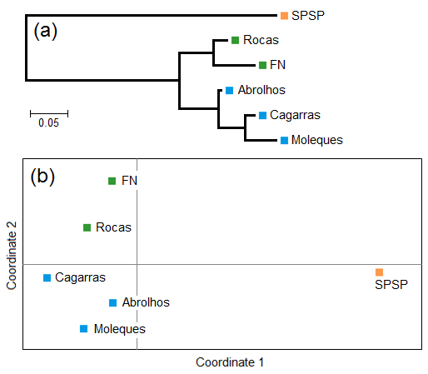
Figure 2.2 Cluster arrangements based on genetic data of six colonies of brown boobies, Sula leucogaster, in the south-western Atlantic Ocean. (a) Phylogenetic tree built with the neighbor-joining method from a matrix of between-population genetic distances (D_{SW}, Shriver et al., 1995); and (b) multivariate bidimensional clustering based on pairwise genetic distances (D_{SW}) provided by Principal Coordinate Analysis. The two principal coordinates explained 91.9% of the total variance. SPSP = Saint Peter and Saint Paul Archipelago; FN = Fernando de Noronha Archipelago; Rocas = Rocas Atoll; Moleques = Moleques do Sul Archipelago

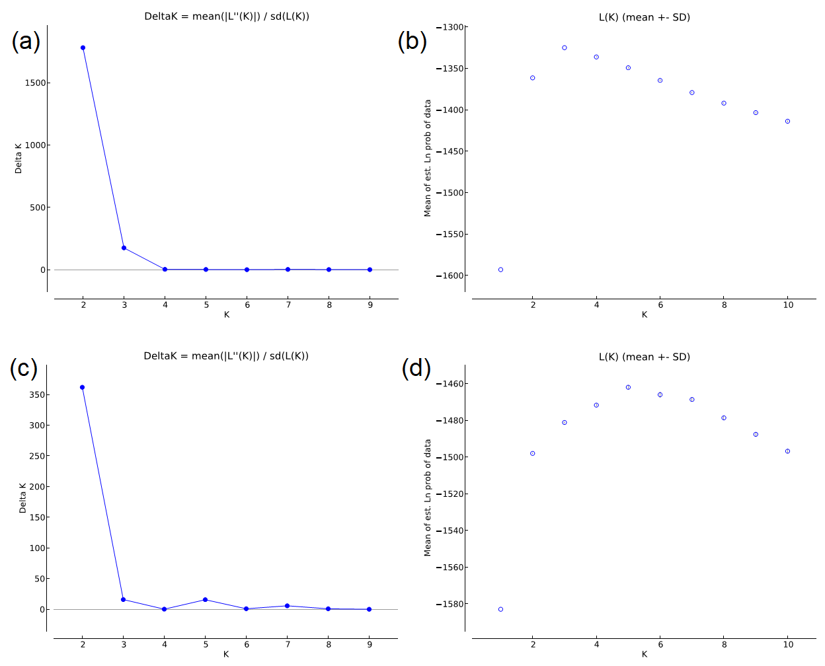
Figure 2.3 (a) and (c): method used for detecting the best number of clusters (K) based on Evanno, Regnaut, & Goudet (2005) in scenarios with and without individuals from Saint Peter and Saint Paul Archipelago, respectively. (b) and (d): mean likelihood L(K) and variance per K value from STRUCTURE data in scenarios with and without individuals from Saint Peter and Saint Paul Archipelago respectively

Figure 2.4 Bayesian ellipses based on isotopic data of carbon and nitrogen with 95% Credibility Interval and corrected for small sample size, as implemented in the package SIBER. SPSP = Saint Peter and Saint Paul Archipelago; FN = Fernando de Noronha Archipelago; Rocas = Rocas Atoll; Moleques = Moleques do Sul Archipelago

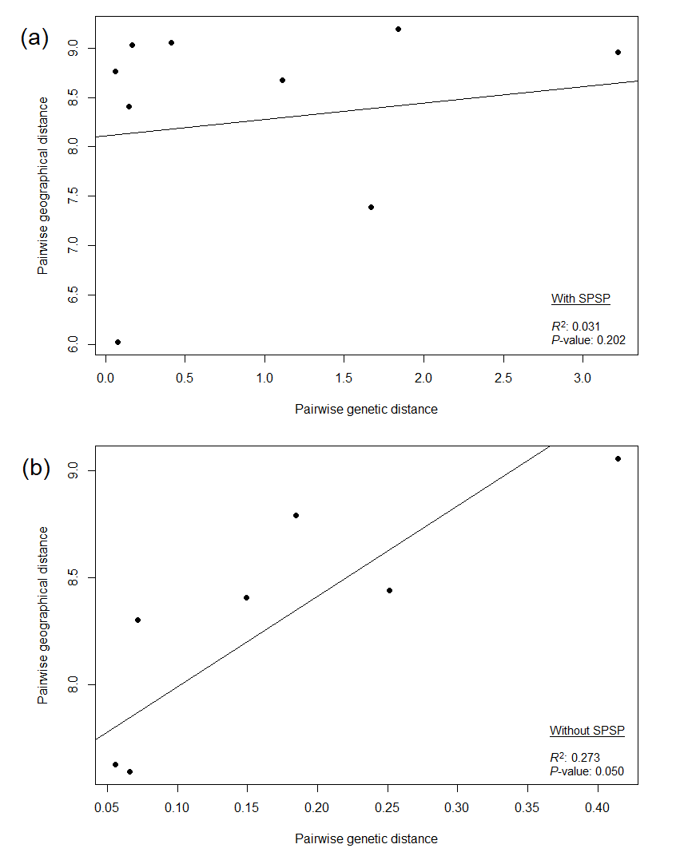
Figure 2.5 Correspondence between pairwise geographical (log-transformed) and genetic distances (linearized D_{SW}) from brown boobies, Sula leucogaster, in the southwestern Atlantic Ocean, considering scenarios with (a) and without (b) the Saint Peter and Saint Paul Archipelago (SPSP). Coefficients of determination (R²) based on pairwise Pearson's correlations, and p-values are shown in the figures

REFERENCES
Evanno, G., Regnaut, S., & Goudet, J. (2005). Detecting the number of clusters of individuals using the software STRUCTURE: A simulation study. Molecular Ecology, 14, 2611–2620.
Nei, M. (1978). Estimation of average heterozygosity and genetic distance from a small number of individuals. Genetics, 89, 583–590.
Shriver, M. D., Jin, L., Boerwinkle, E., Deka, R., Ferrell, R. E., & Chakraborty, R. (1995). A novel measure of genetic distance for highly polymorphic tandem repeat loci. Molecular Biology and Evolution, 12, 914–920.
Weir, B. S., & Cockerham, C. C. (1984). Estimating F-statistics for the analysis of population structure. Evolution, 38, 1358–1370.

