SUPPORTING INFORMATION
Appendix S6
A framework for mapping the distribution seabirds by integrating tracking, demography and phenology
More details can be found at https://github.com/anacarneiro/DensityMaps

Seabird density distributions at quarterly and annual resolutions

Figures S1-S36. Annual population-level density distributions for 22 species of albatrosses and petrels (36 populations) breeding in the Southern Ocean based on tracking, phenology and demography data. The colour gradient refers to the percentage of the population represented within each 5x5° grid. Darker shades (of blue) depict a greater density of birds. For details on the number of individuals, see Appendix S6 Table S1.
Figures S37-S72. Quarterly population-level density distributions for 22 species of albatrosses and petrels (36 populations) breeding in the Southern Ocean based on tracking, phenology and demography data. The colour gradient refers to the percentage of the population represented within each 5 x 5° grid. Darker shades (of blue) depict a greater density of birds. For details on the number of individuals, see Appendix S6 Table S1.

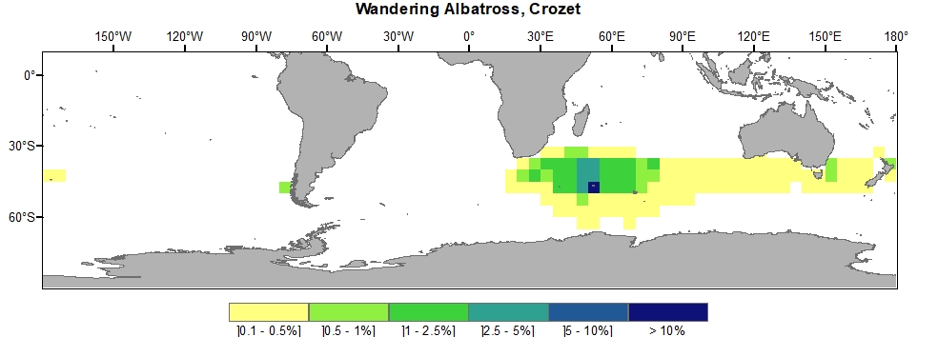
Figure S1. Wandering Albatross, Crozet

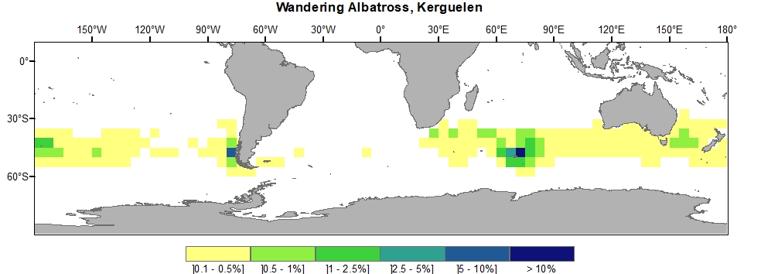
Figure S2. Wandering Albatross, Kerguelen

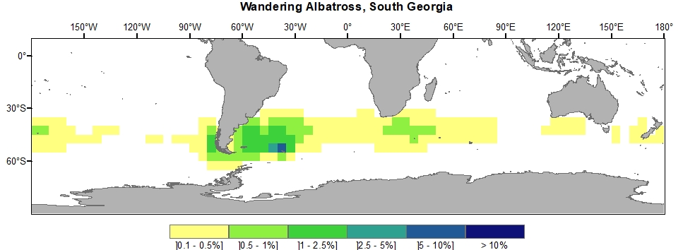
Figure S3. Wandering Albatross, South Georgia

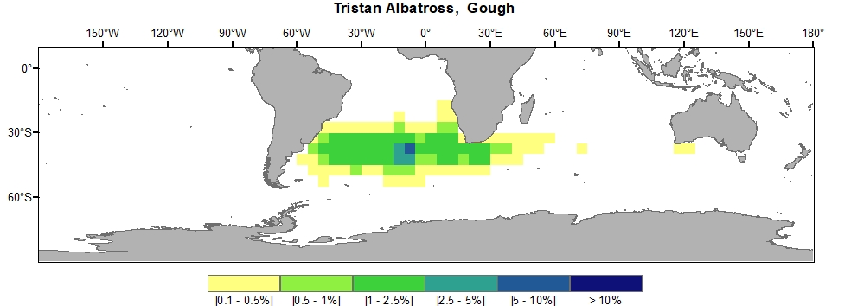
Figure S4. Tristan Albatross, Gough

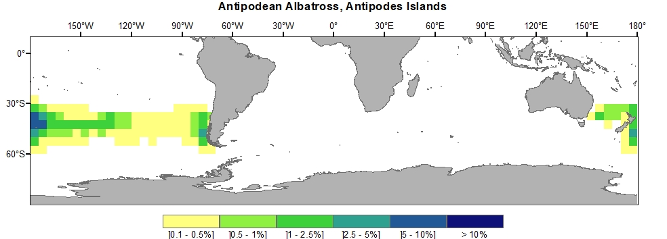
Figure S5. Antipodean Albatross, Antipodes Islands

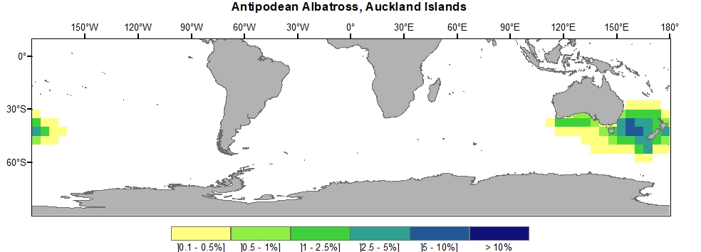
Figure S6. Antipodean Albatross, Auckland Islands

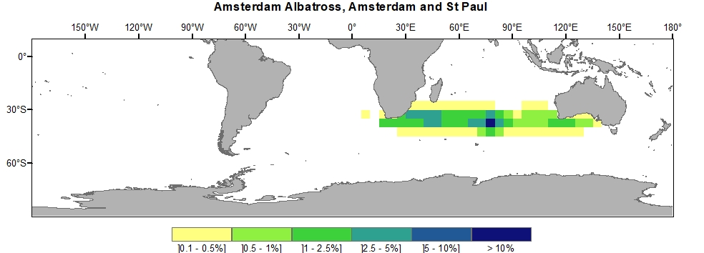
Figure S7. Amsterdam Albatross, Amsterdam and St Paul

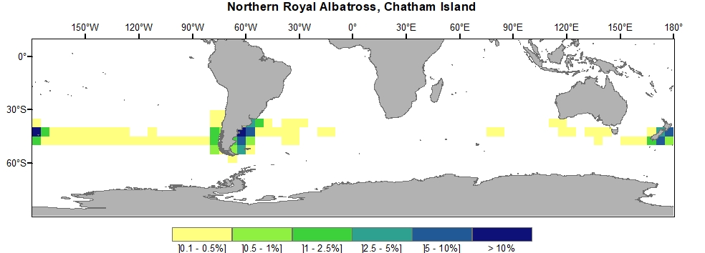
Figure S8. Northern Royal Albatross, Chatham Island

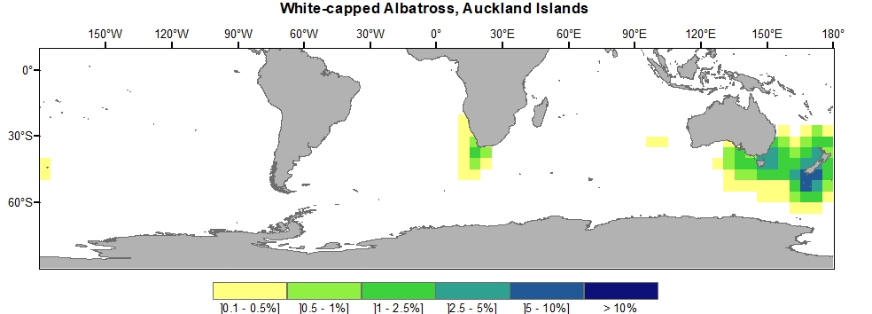
Figure S9. White-capped Albatross, Auckland Islands

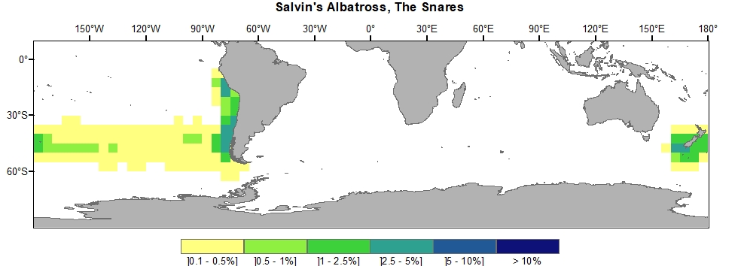
Figure S10. Salvin’s Albatross, The Snares

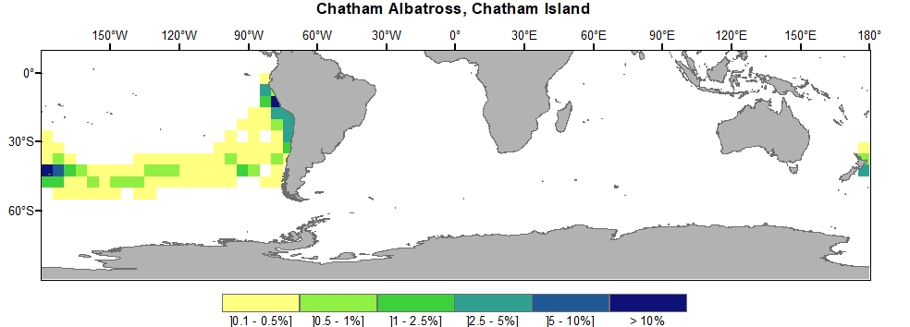
Figure S11. Chatham Albatross, Chatham Island

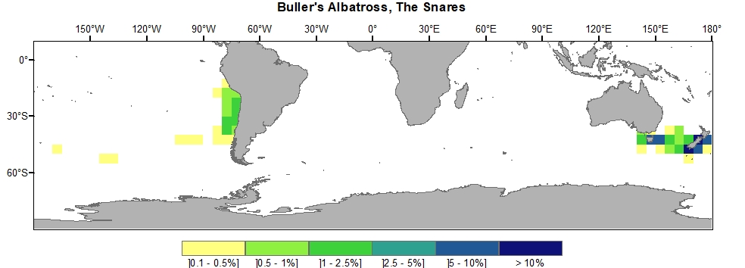
Figure S12. Buller’s Albatross, The Snares

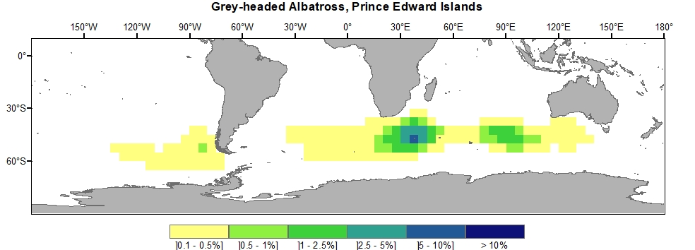
Figure S13. Grey-headed Albatross, Prince Edward Islands

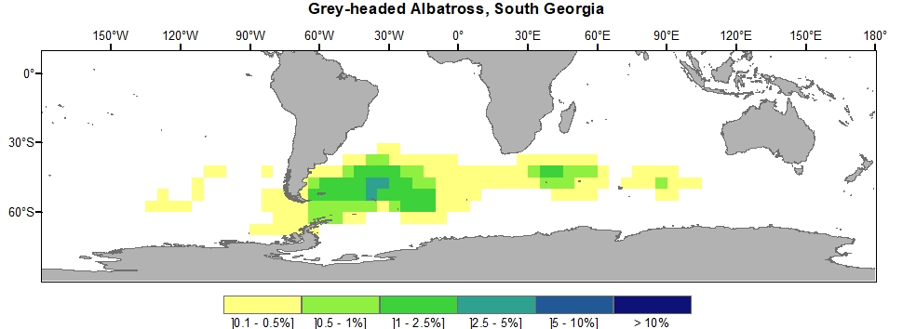
Figure S14. Grey-headed Albatross, South Georgia

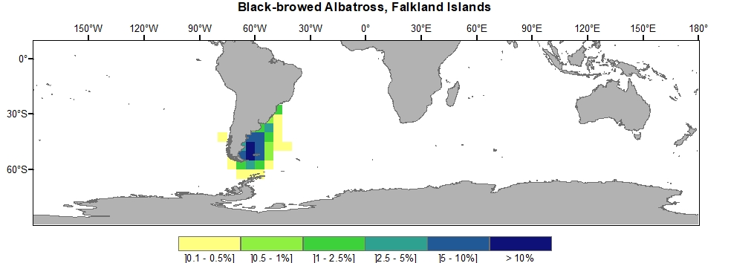
Figure S15. Black-browed Albatross, Falkland Islands

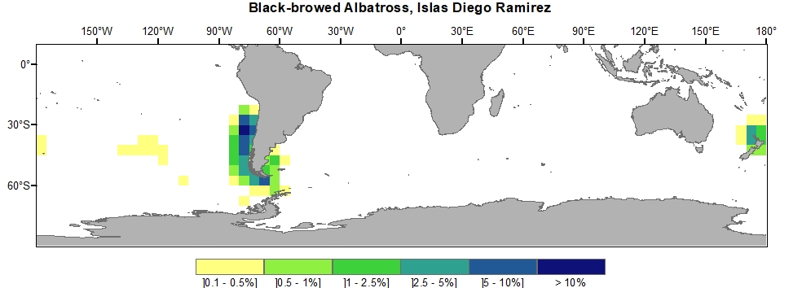
Figure S16. Black-browed Albatross, Islas Diego Ramirez

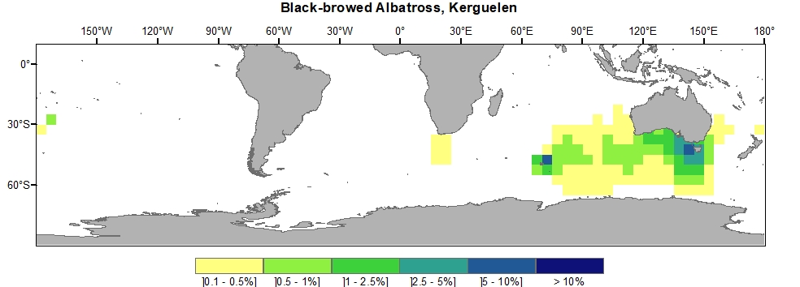
Figure S17. Black-browed Albatross, Kerguelen

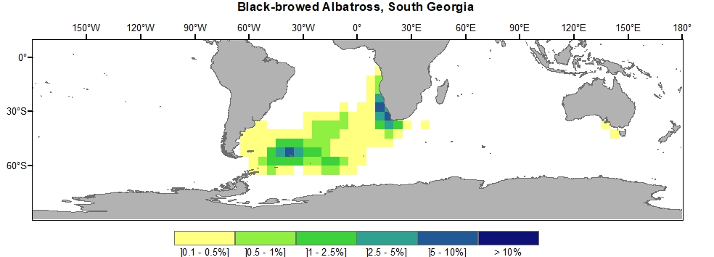
Figure S18. Black-browed Albatross, South Georgia

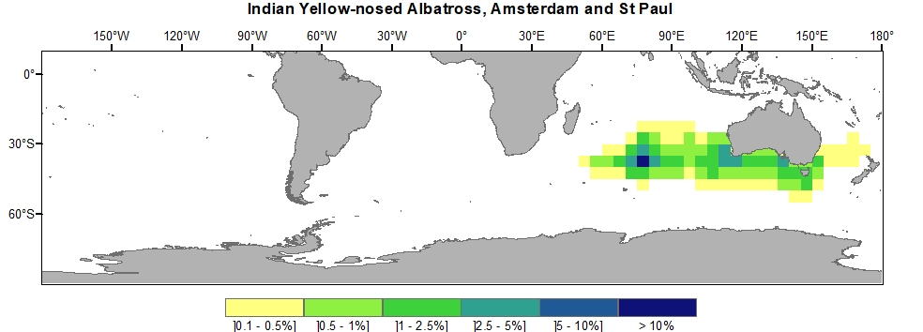
Figure S19. Indian Yellow-nosed Albatross, Amsterdam and St Paul

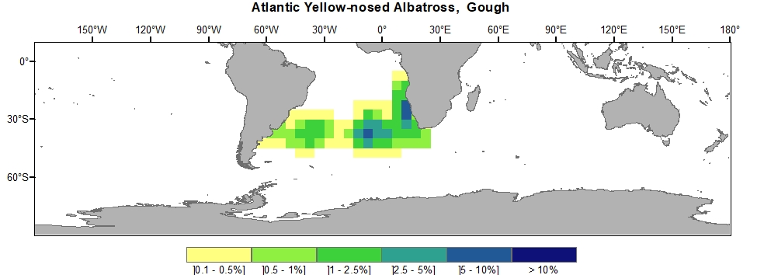
Figure S20. Atlantic Yellow-nosed Albatross, Gough

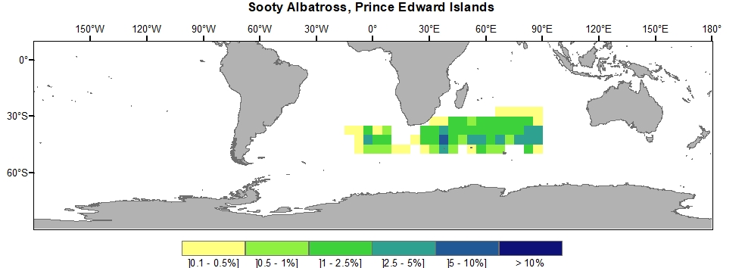
Figure S21. Sooty Albatross, Prince Edward Islands

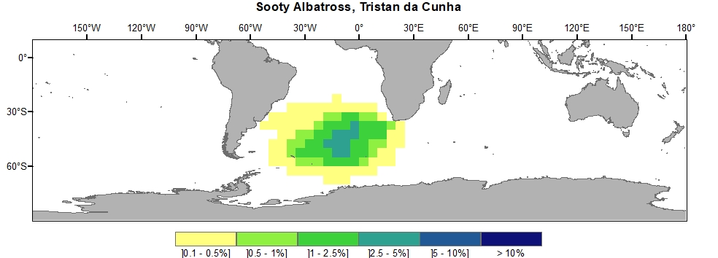
Figure S22. Sooty Albatross, Tristan da Cunha

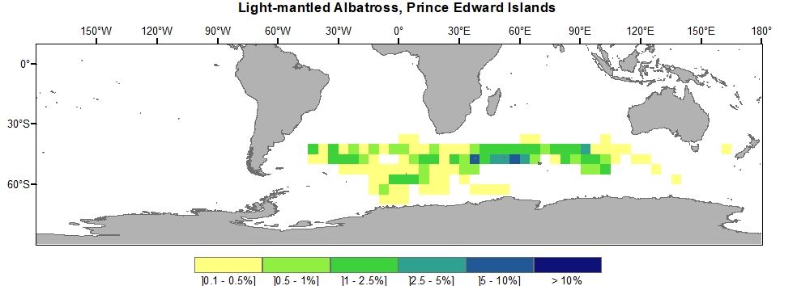
Figure S23. Light-mantled Albatross, Prince Edward Islands

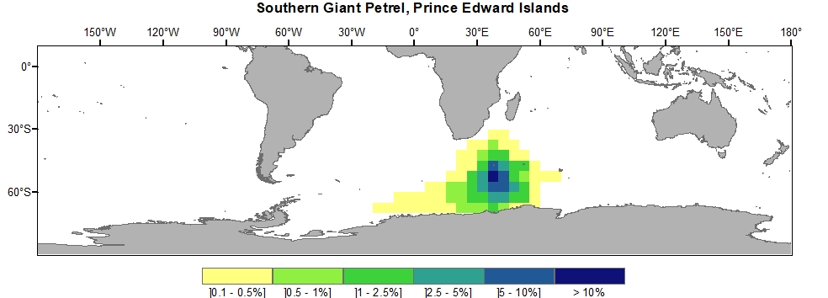
Figure S24. Southern Giant Petrel, Prince Edward Islands
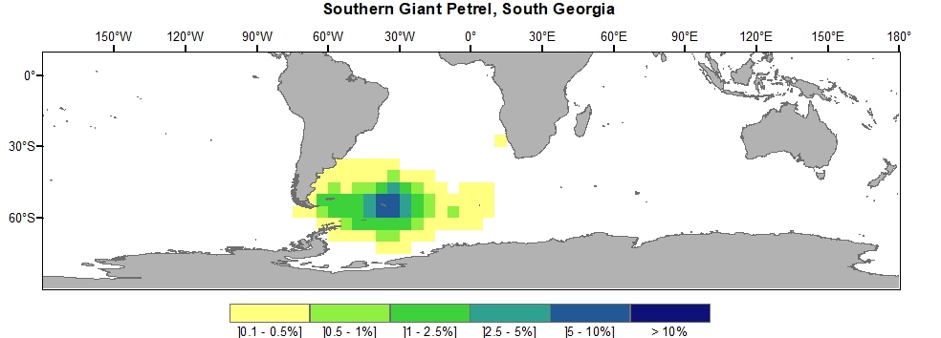
Figure S25. Southern Giant Petrel, South Georgia

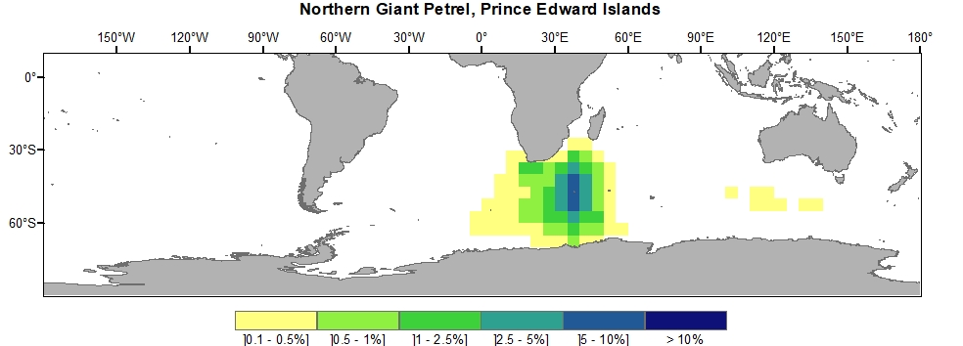
Figure S26. Northern Giant Petrel, Prince Edward Islands

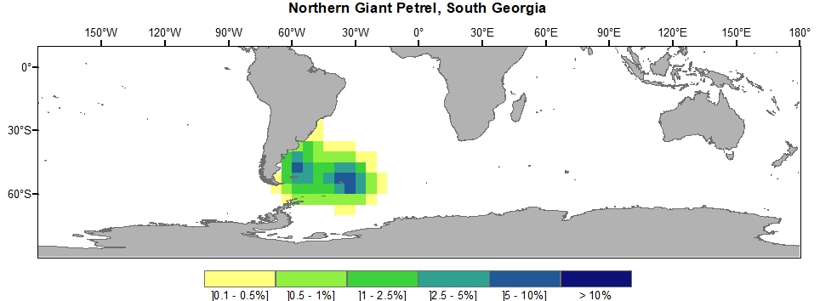
Figure S27. Northern Giant Petrel, South Georgia

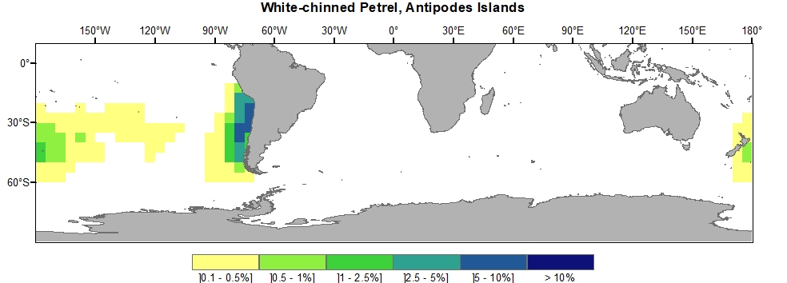
Figure S28. White-chinned Petrel, Antipodes Islands

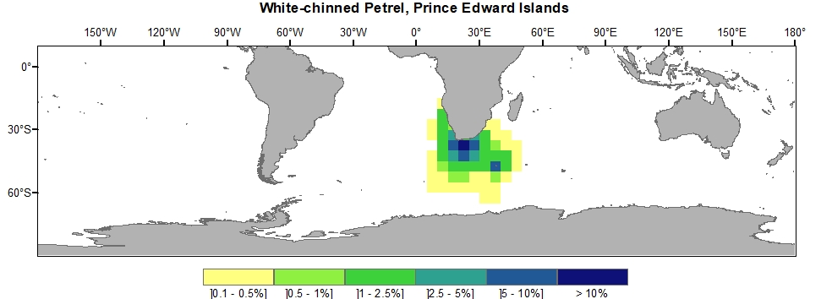
Figure S29. White-chinned Petrel, Prince Edward Islands

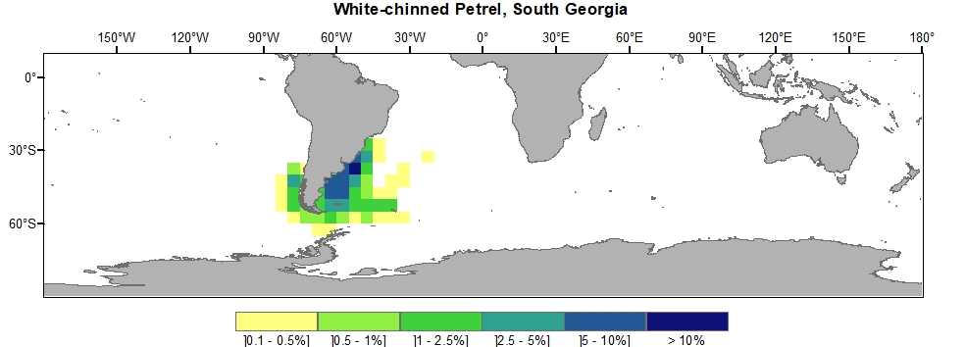
Figure S30. White-chinned Petrel, South Georgia

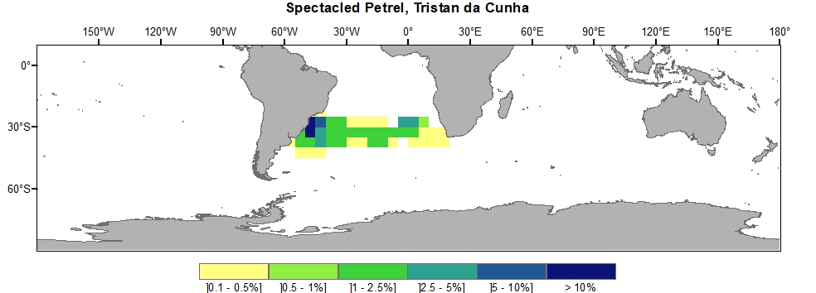
Figure S31. Spectacled Petrel, Tristan da Cunha

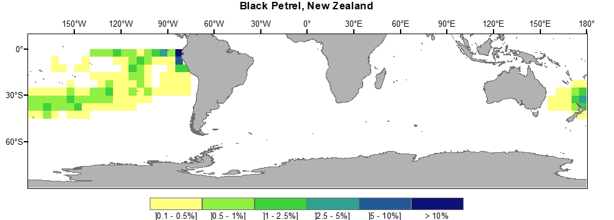
Figure S32. Black Petrel, New Zealand

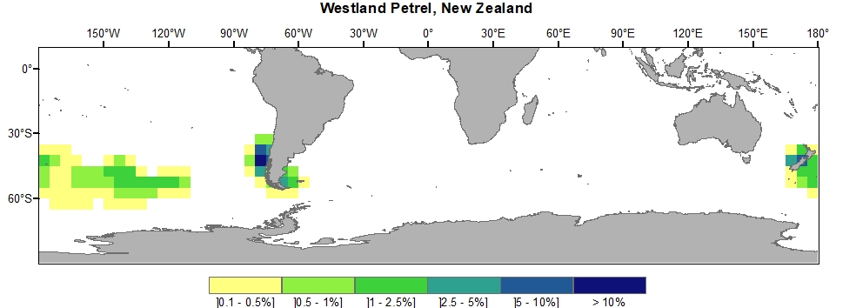
Figure S33. Westland Petrel, New Zealand

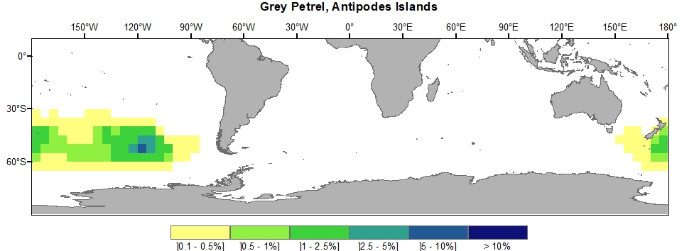
Figure S34. Grey Petrel, Antipodes Islands

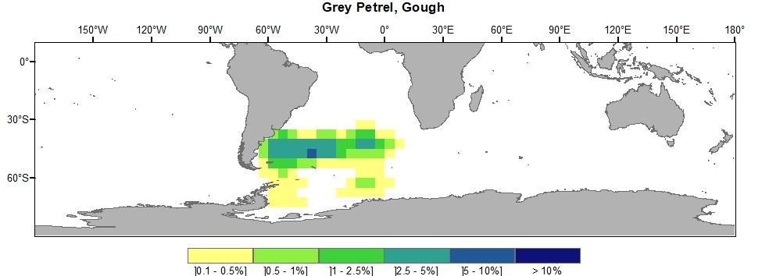
Figure S35. Grey Petrel, Gough

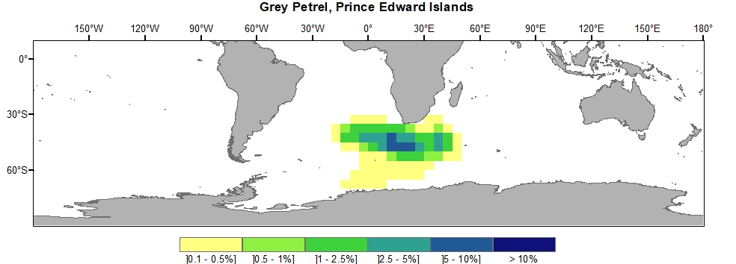
Figure S36. Grey Petrel, Prince Edward Islands

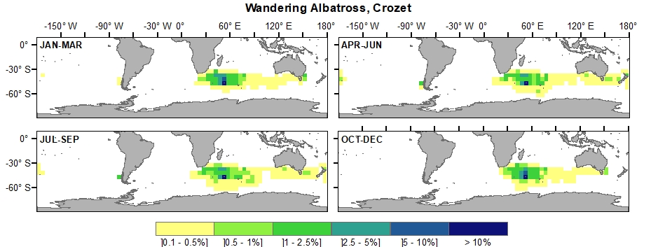
Figure S37. Wandering Albatross, Crozet

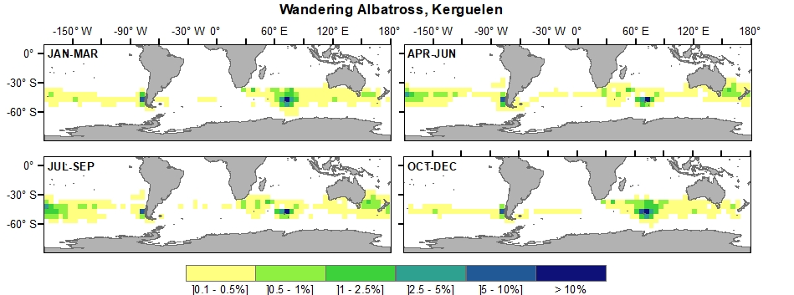
Figure S38. Wandering Albatross, Kerguelen

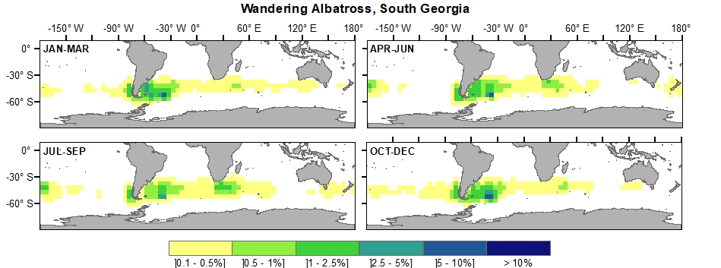
Figure S39. Wandering Albatross, South Georgia
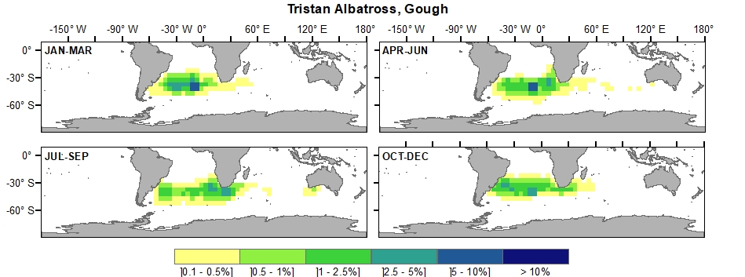
Figure S40. Tristan Albatross, Gough

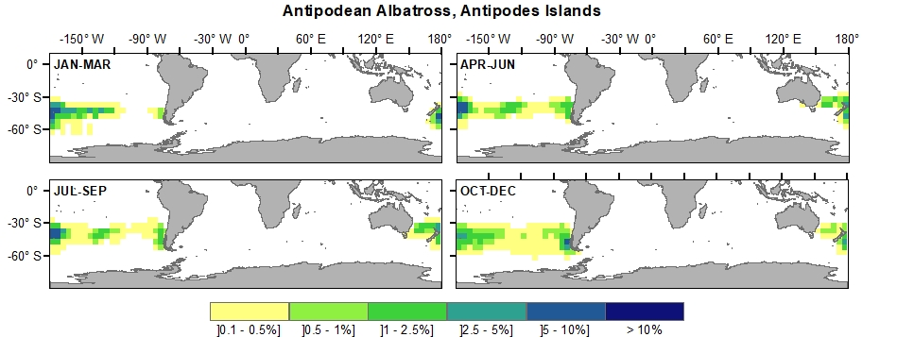
Figure S41. Antipodean Albatross, Antipodes Islands

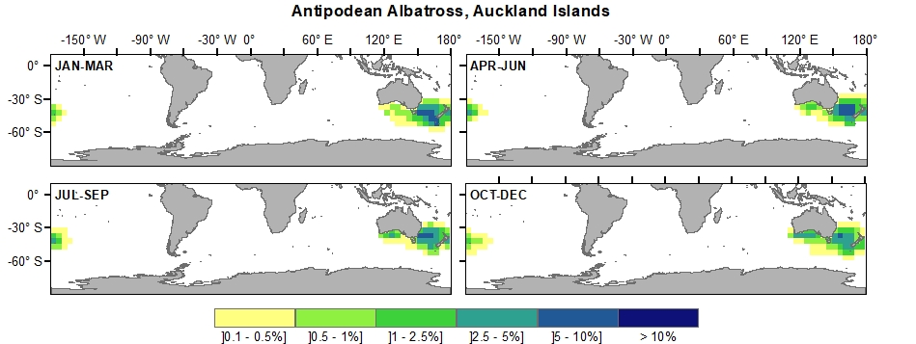
Figure S42. Antipodean Albatross, Auckland Islands
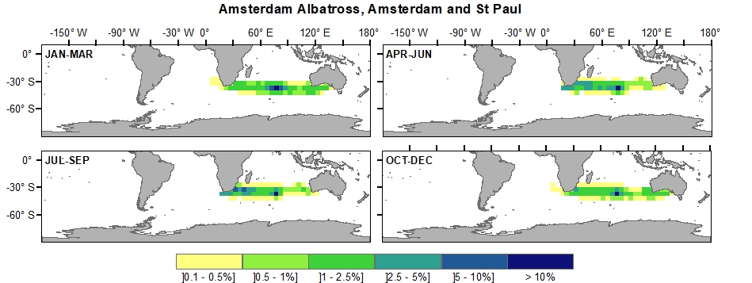
Figure S43. Amsterdam Albatross, Amsterdam and St Paul

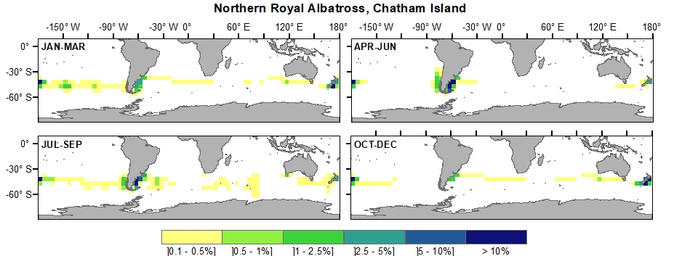
Figure S44. Northern Royal Albatross, Chatham Island

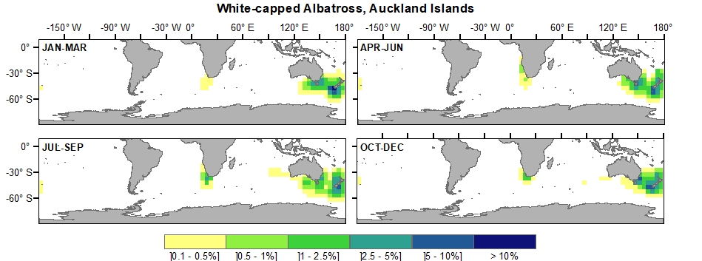
Figure S45. White-capped Albatross, Auckland Islands
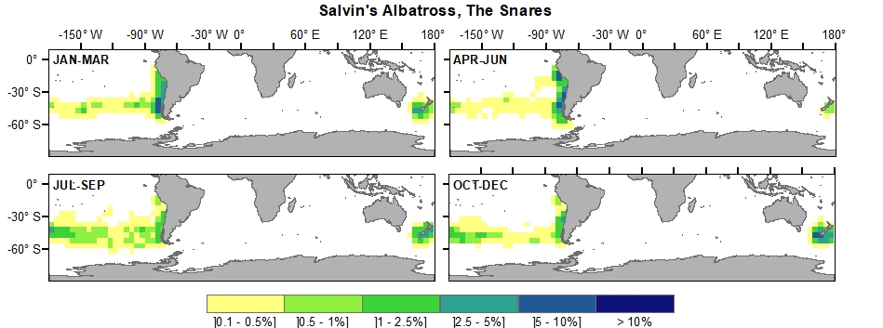
Figure S46. Salvin’s Albatross, The Snares

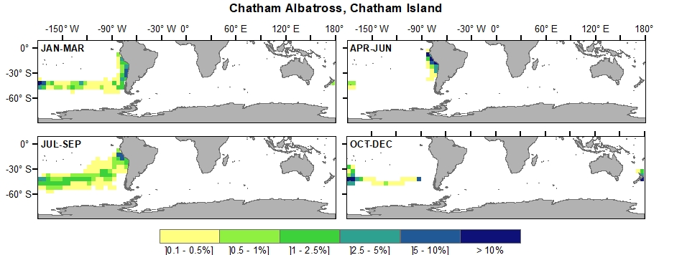
Figure S47. Chatham Albatross, Chatham Island

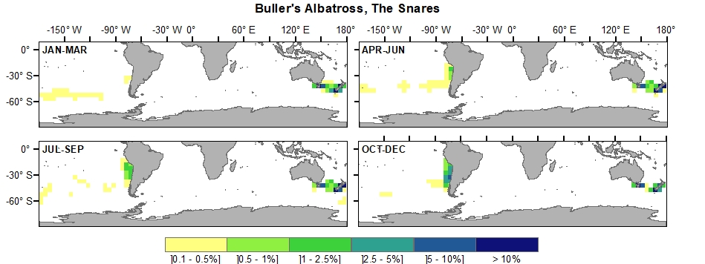
Figure S48. Buller’s Albatross, The Snares
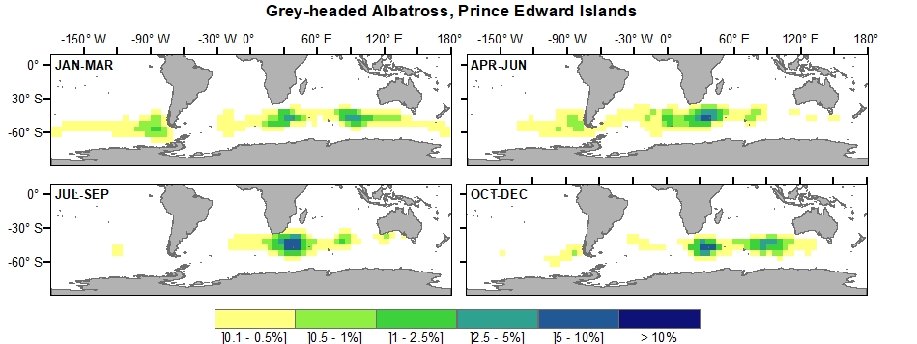
Figure S49. Grey-headed Albatross, Prince Edward Islands

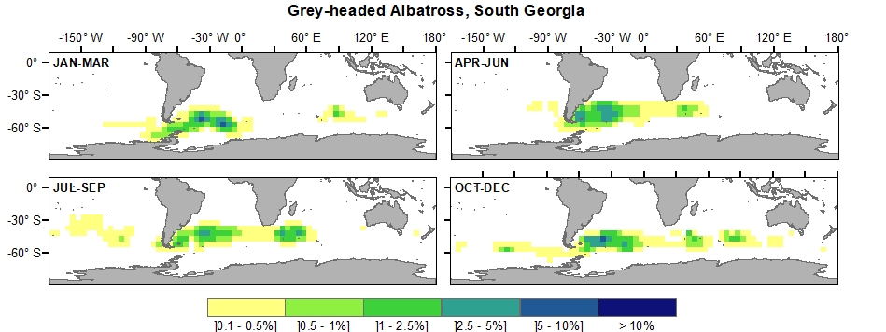
Figure S50. Grey-headed Albatross, South Georgia

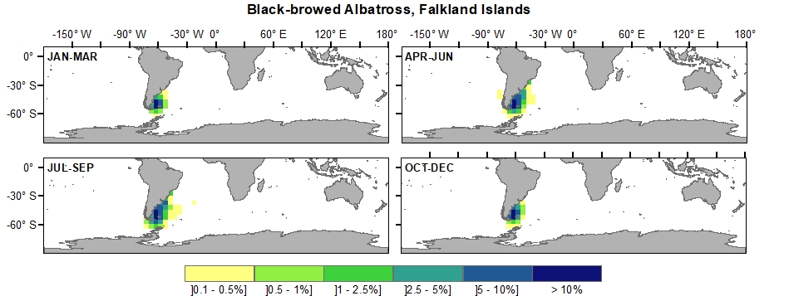
Figure S51. Black-browed Albatross, Falkland Islands
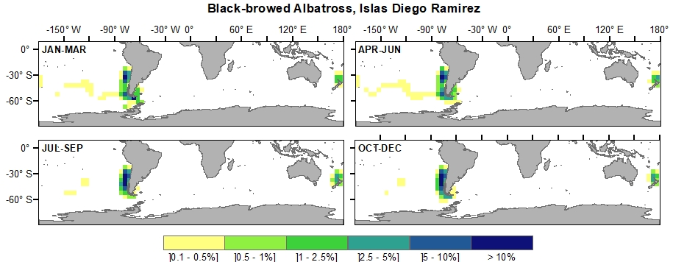
Figure S52. Black-browed Albatross, Islas Diego Ramirez

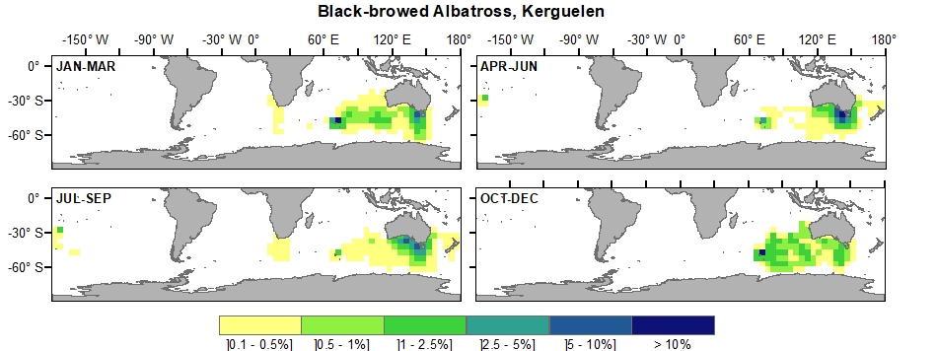
Figure S53. Black-browed Albatross, Kerguelen

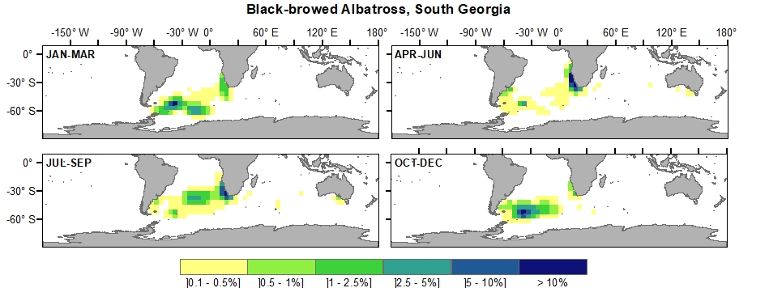
Figure S54. Black-browed Albatross, South Georgia
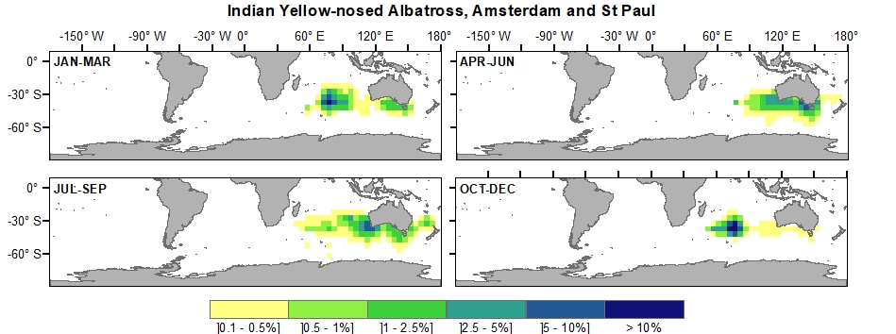
Figure S55. Indian Yellow-nosed Albatross, Amsterdam and St Paul

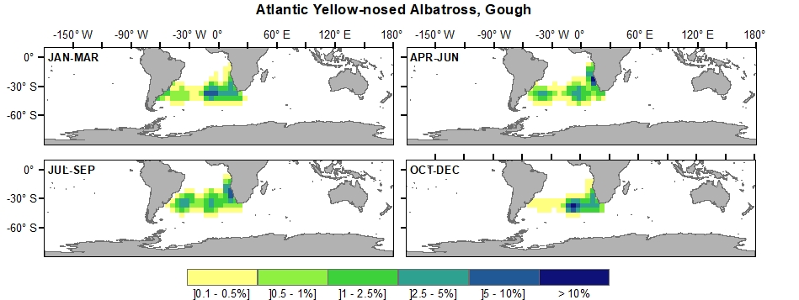
Figure S56. Atlantic Yellow-nosed Albatross, Gough

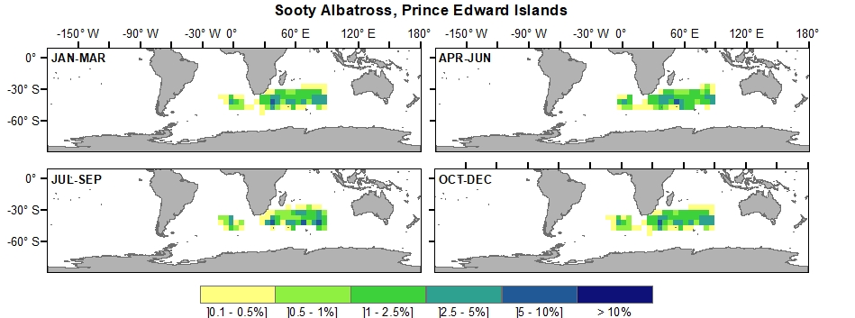
Figure S57. Sooty Albatross, Prince Edward Islands
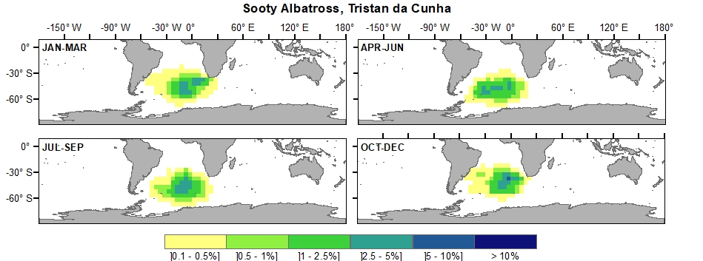
Figure S58. Sooty Albatross, Tristan da Cunha

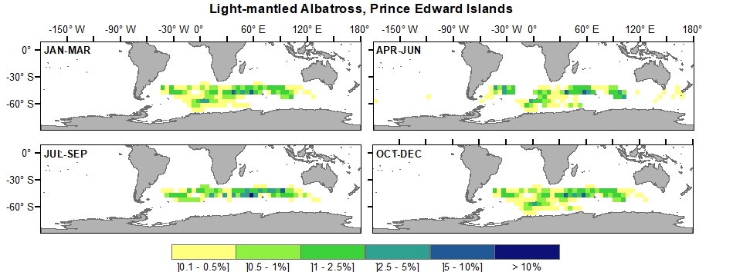
Figure S59. Light-mantled Albatross, Prince Edward Islands

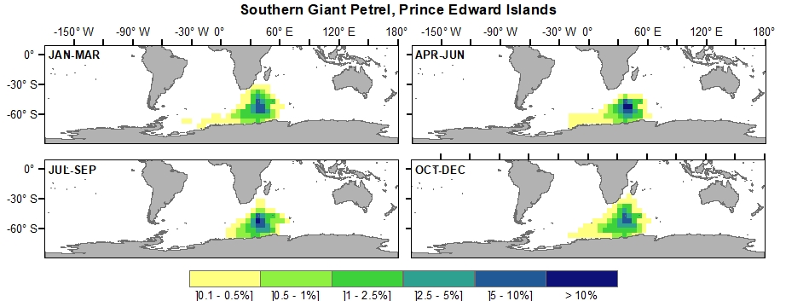
Figure S60. Southern Giant Petrel, Prince Edward Islands
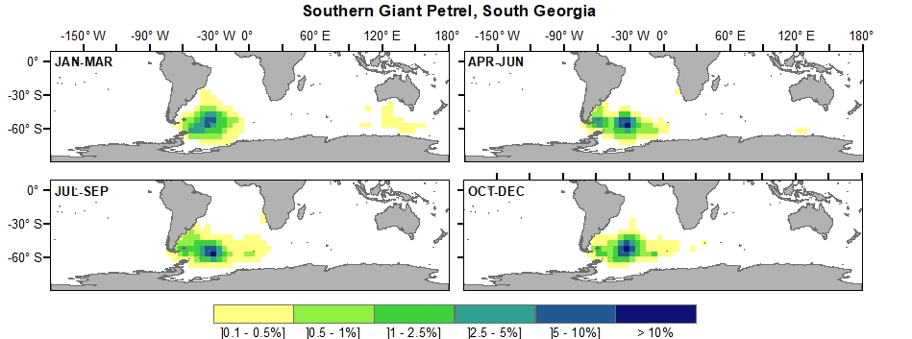
Figure S61. Southern Giant Petrel, South Georgia

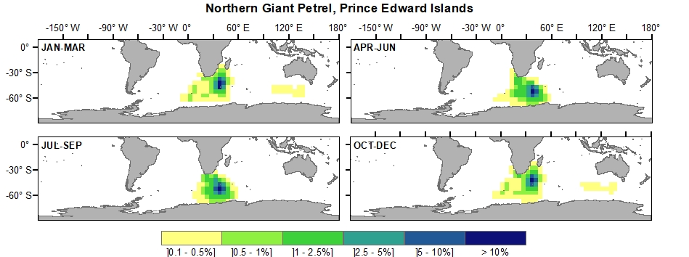
Figure S62. Northern Giant Petrel, Prince Edward Islands

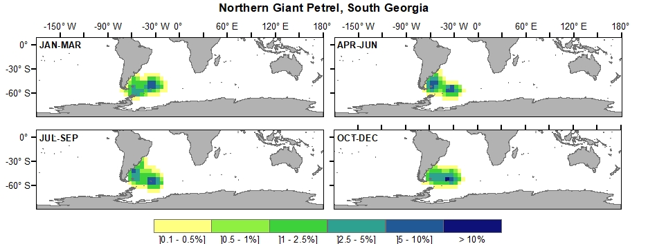
Figure S63. Northern Giant Petrel, South Georgia
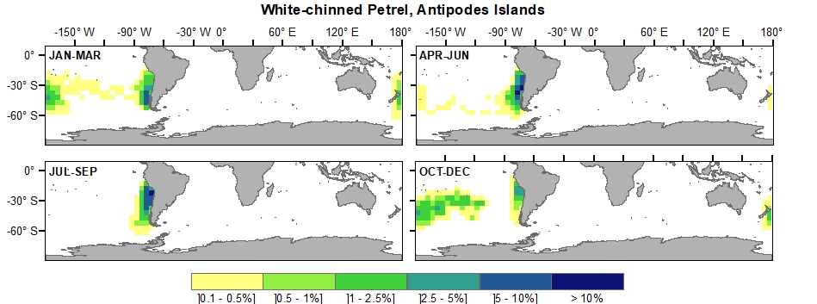
Figure S64. White-chinned Petrel, Antipodes Islands

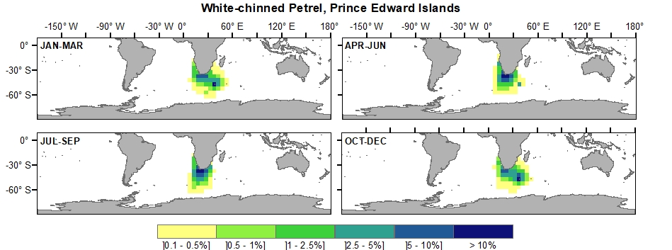
Figure S65. White-chinned Petrel, Prince Edward Islands

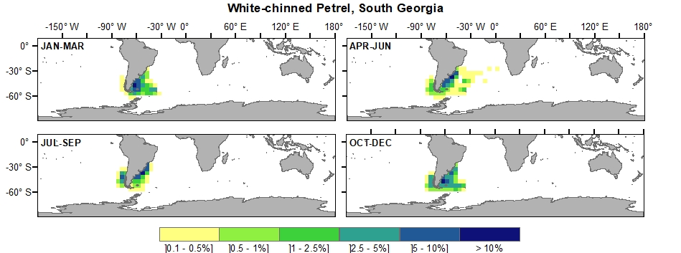
Figure S66. White-chinned Petrel, South Georgia
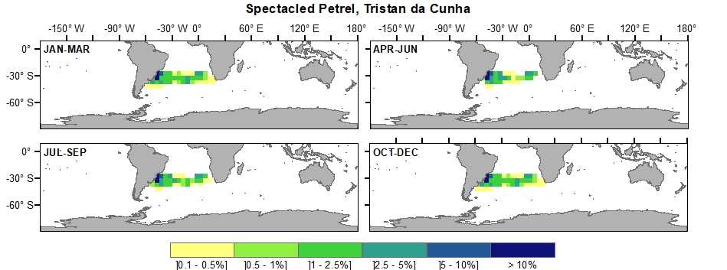
Figure S67. Spectacled Petrel, Tristan da Cunha

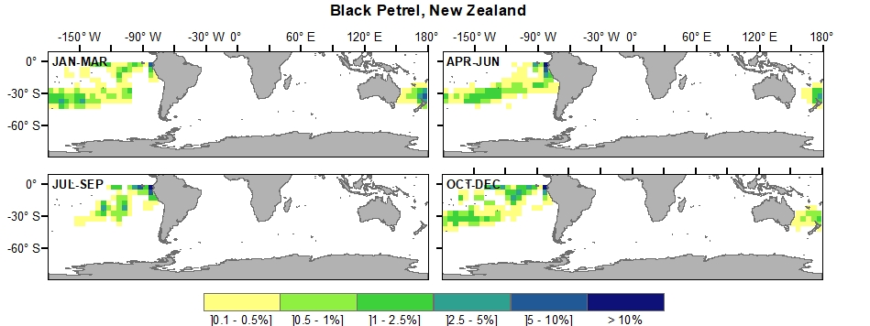
Figure S68. Black Petrel, New Zealand

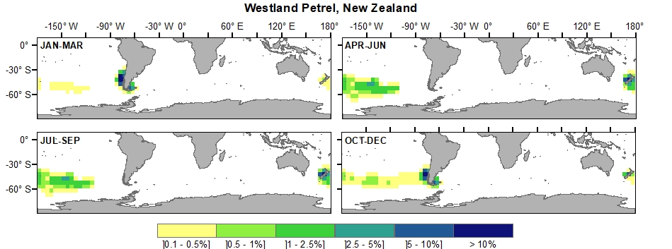
Figure S69. Westland Petrel, New Zealand
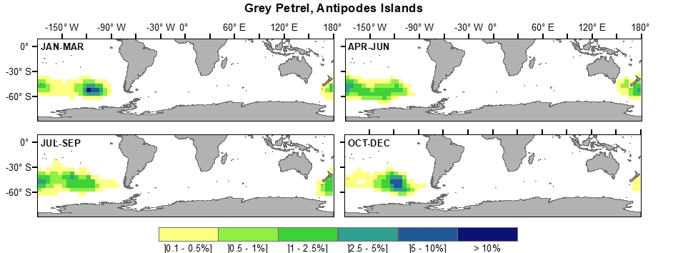
Figure S70. Grey Petrel, Antipodes Islands

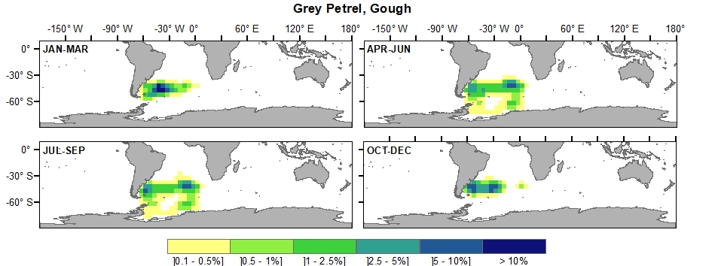
Figure S71. Grey Petrel, Gough

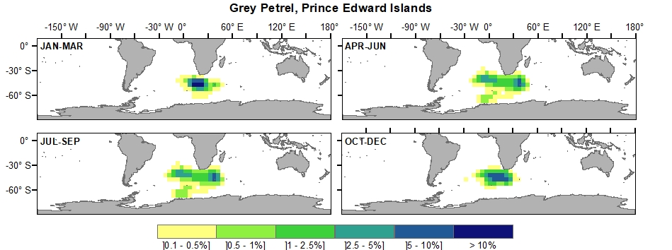
Figure S72. Grey Petrel, Prince Edward Islands

TABLE S1 Number of individuals per year-quarter and year-round. The population represented varies between quarters because one member of each pair is at the colony at any one time during the pre-laying, incubation and brood-guard stages, and this at-colony bird is not represented in our distributions.
Common name | Island or  Island Group | Quarter 1  (Jan-Mar) | Quarter 2  (Apr-Jun) | Quarter 3  (Jul-Sep) | Quarter 4  (Oct-Dec) | Year-  round
Wandering Albatross | Crozet | 12,001 | 13,418 | 13,813 | 13,310 | 13,135
Wandering Albatross | Kerguelen | 7,896 | 8,763 | 9,020 | 8,727 | 8,601
Wandering Albatross | South Georgia | 17,630 | 19,236 | 19,447 | 18,767 | 18,770
Tristan Albatross | Gough | 7,310 | 8,953 | 8,956 | 8,228 | 8,362
Antipodean Albatross | Antipodes Islands | 30,162 | 32,242 | 34,135 | 34,124 | 32,666
Antipodean Albatross | Auckland Islands | 36,749 | 41,028 | 42,704 | 41,427 | 40,477
Amsterdam Albatross | Amsterdam and St Paul | 318 | 310 | 352 | 351 | 333
Northern Royal Albatross | Chatham Island | 27,267 | 33,201 | 33,103 | 26,281 | 29,963
White-capped Albatross | Auckland Islands | 505,226 | 558,546 | 559,380 | 481,533 | 526,171
Salvin's Albatross | The Snares | 5,259 | 5,286 | 4,571 | 4,343 | 4,865
Chatham Albatross | Chatham Island | 26,005 | 26,227 | 23,753 | 20,965 | 24,238
Buller's Albatross | The Snares | 50,023 | 56,830 | 58,873 | 58,970 | 56,174
Grey-headed Albatross | Prince Edward Islands | 57,719 | 59,046 | 56,352 | 49,577 | 55,674
Grey-headed Albatross | South Georgia | 403,862 | 414,774 | 411,548 | 366,685 | 399,217
Black-browed Albatross | Falkland Islands | 2,123,819 | 2,106,629 | 2,046,845 | 1,731,983 | 2,002,319
Black-browed Albatross | Islas Diego Ramirez | 320,553 | 319,009 | 307,744 | 261,490 | 302,199
Black-browed Albatross | Kerguelen | 20,337 | 21,088 | 20,744 | 17,468 | 19,909
Black-browed Albatross | South Georgia | 405,932 | 434,256 | 431,685 | 355,783 | 406,914
Indian Yellow-nosed Albatross | Amsterdam and St Paul | 86,547 | 86,994 | 79,897 | 65,954 | 79,848
Atlantic Yellow-nosed Albatross | Gough | 34,345 | 34,461 | 32,680 | 29,668 | 32,789
Sooty Albatross | Prince Edward Islands | 17,276 | 17,345 | 16,830 | 14,837 | 16,572
Sooty Albatross | Tristan da Cunha | 54,919 | 54,889 | 53,304 | 46,509 | 52,405
Light-mantled Albatross | Prince Edward Islands | 3,490 | 3,603 | 3,634 | 2,997 | 3,431
Southern Giant Petrel | Prince Edward Islands | 14,731 | 14,723 | 14,171 | 12,332 | 13,989
Southern Giant Petrel | South Georgia | 24,788 | 26,257 | 26,280 | 22,327 | 24,913
Northern Giant Petrel | Prince Edward Islands | 4,748 | 4,736 | 4,264 | 4,434 | 4,545
Northern Giant Petrel | South Georgia | 24,813 | 24,796 | 24,192 | 20,634 | 23,609
White-chinned Petrel | Antipodes Islands | 137,537 | 150,905 | 150,529 | 126,452 | 141,356
White-chinned Petrel | Prince Edward Islands | 162,890 | 164,819 | 164,417 | 137,978 | 157,526
White-chinned Petrel | South Georgia | 3,224,443 | 3,391,268 | 3,398,133 | 2,763,295 | 3,194,285
Spectacled Petrel | Tristan da Cunha | 125,370 | 125,681 | 116,915 | 95,978 | 115,986
Black Petrel | New Zealand | 10,342 | 12,241 | 10,446 | 8,718 | 10,437
Westland Petrel | New Zealand | 29,959 | 26,813 | 27,370 | 29,709 | 28,463
Grey Petrel | Antipodes Islands | 245,388 | 236,514 | 271,997 | 271,943 | 256,460
Grey Petrel | Prince Edward Islands | 24,800 | 22,671 | 25,998 | 25,992 | 24,865
Grey Petrel | Gough | 70,443 | 69,813 | 76,980 | 77,017 | 73,563

