SUPPORTING INFORMATION
Appendix S9
A framework for mapping the distribution seabirds by integrating tracking, demography and phenology
More details can be found at https://github.com/anacarneiro/DensityMaps

Pelagic longline fishing effort and overlap with seabird distributions

Figure S1. Annual (a) and quarterly (b) pelagic longline fishing effort averaged across years (2007-2016). Effort values are shown per 1,000,000 hooks.
Figure S2. The seasonal overlap of black-browed albatross from Falkland Islands with pelagic longline fisheries averaged across years (2007-2016). Darker shades [of red] depict a greater overlap. The colour gradient refers to the number of individuals multiplied by number of hooks within each 5x5° grid. Maps are based on data for a) adult breeders (successful and failed breeders; during the breeding and non-breeding seasons), b) adult breeders and non-breeders (the latter representing birds not attempting to breed this year), and c) all life-history stages (which includes information for adult breeders and non-breeders, juveniles and immatures).
Figure S3. The seasonal overlap of wandering albatross from Crozet with pelagic longline fisheries averaged across years (2007-2016). Darker shades [of red] depict a greater overlap. The colour gradient refers to the number of individuals multiplied by number of hooks within each 5x5° grid. Maps are based on data for a) adult breeders (successful and failed breeders; during the breeding and non-breeding seasons), b) adult breeders and non-breeders (the latter representing birds not attempting to breed this year), and c) all life-history stages (which includes information for adult breeders and non-breeders, juveniles and immatures).

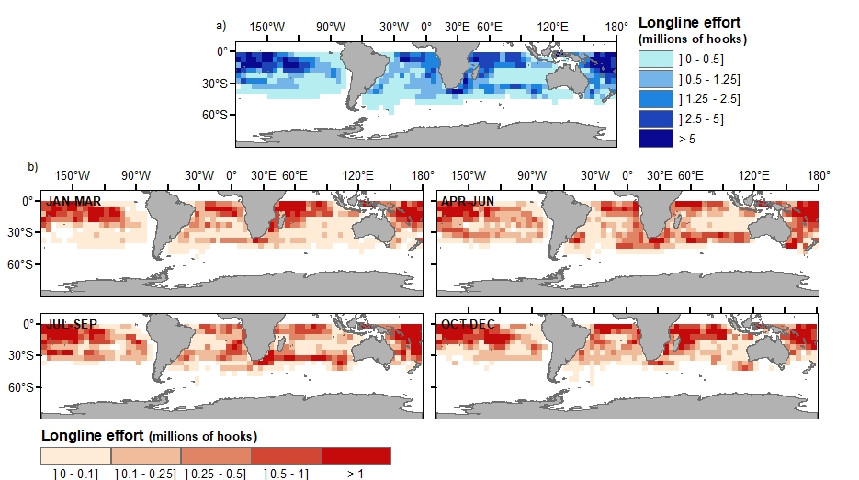

Figure S1.
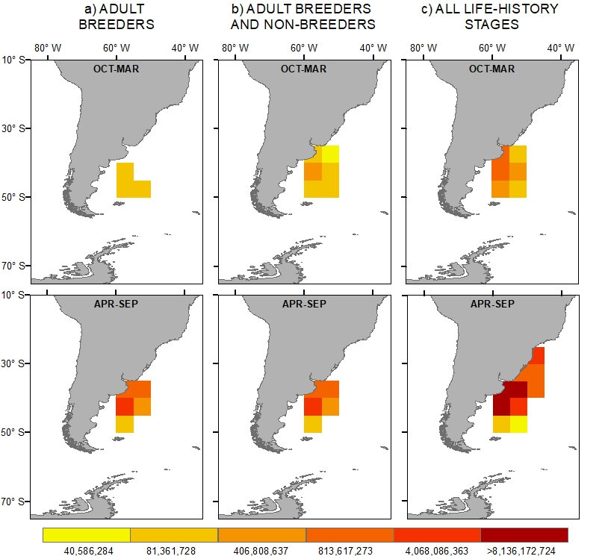

Figure S2.

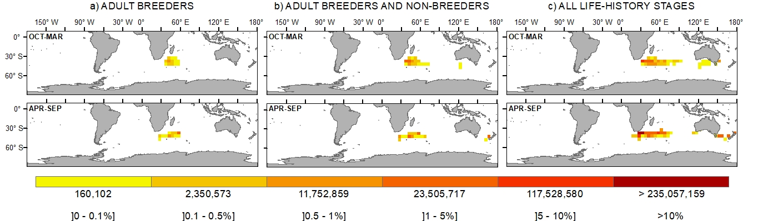

Figure S3.

