Appendix A
Methodology for estimating the degree of mutilation as a percentage of bill linear length

From photographs, when available, we estimated the degree of mutilation as a percentage of bill linear length (the straight-line distance from the beginning of the gape along the commissure of the two mandibles to the tip of the bill), based on the known culmen length for each species, using the software ImageJ (Schneider et al., 2012).

First, each photo was scaled based on the known mean culmen length (CL; the distance from the base of the feathers at the top of the bill to the bill tip) for each species obtained from the bibliography (Figure A1, Table A1). Subsequently, base-nostril length (BNL; the distance along the nasolabial groove from the base of the feathers to the beginning of the naricorn) and bill actual length (BAL; the distance along the commissure from the gape to the distal end of the damaged mandible(s)) were estimated (Figure A1). When both mandibles were missing, BAL was calculated based on the BNL. Then, the degree of mutilation was estimated as (BAL/BLL) × 100.

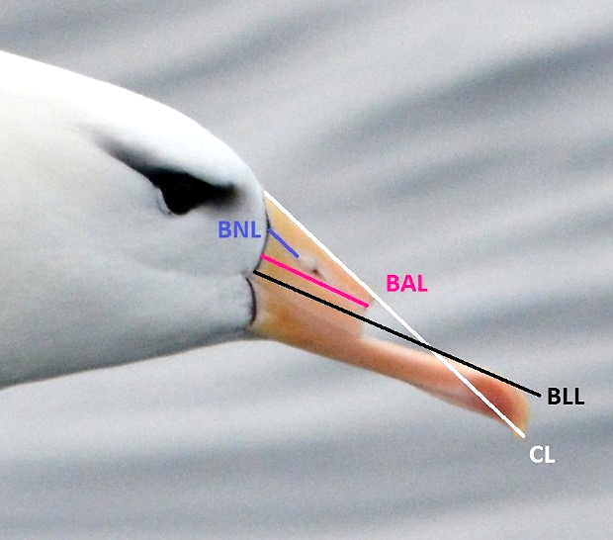
Figure A1. Measurements used to quantify the degree of mutilation, as a percentage of bill linear length. Each photo was scaled based on the known mean value of culmen length (CL) for each species (Table 1). Subsequently, bill linear length (BLL), base-nostril length (BNL) and bill actual length (BAL) were estimated. When both mandibles were missing, BAL was calculated based on the BNL. Photo: Julián Bastida.

Table A1. Morphometric measures used to estimate the degree of mutilation for each species. Mean culmen length (CL) was obtained from the bibliography, while bill linear length (BLL) and base-nostril length (BNL) were estimated with the software ImageJ. Threat status according to IUCN (2019): EN – Endangered, VU – Vulnerable, LC – Least Concern.
Species (threat status) | CL | BLL | BNL | Reference
Northern royal albatross (EN) | 161.0 | 139.3 |  | Jiménez et al., 2012
Southern royal albatross (VU) | 173.0 | 148.7 |  | Jiménez et al., 2012
Black-browed albatross (LC) | 118.0 | 99.2 | 12.2 | Jiménez et al., 2012
Atlantic yellow-nosed albatross (EN) | 116.0 | 99.0 |  | Jiménez et al., 2012
Southern giant petrel (LC) | 81.0 | 86.3 |  | Jiménez et al., 2012
Spectacled petrel (VU) | 51.0 | 50.8 |  | Jiménez et al., 2012
Manx shearwater (LC) | 34.9 | 40.0 |  | Bull et al., 2005
Cory’s shearwater (LC) | 52.8 | 53.1 | 14.8 | Navarro et al., 2009

References
Bull, L.S., Bell, B.E.N.D., Pledger, S., 2005. Patterns of size variation in the shearwater genus Puffinus. Mar. Ornithol. 33, 27–39.
Jiménez, S., Domingo, A., Abreu, M., Brazeiro, A., 2012. Risk assessment and relative impactsof Uruguayan pelagic longliners on seabird. Aquat. Living Resour. 25, 281–295. https://doi.org/10.1051/alr/2012026
Navarro, J., Kliontzopoulou, A., González-Solís, J., 2009. Sexual dimorphism in bill morphology and feeding ecology in Cory’s shearwater (Calonectris diomedea). Zoology 112, 128–138. https://doi.org/10.1016/j.zool.2008.05.001
Schneider, C.A., Rasband, W.S., Eliceiri, K.W., 2012. NIH Image to ImageJ: 25 years of image analysis. Nat. Methods 9, 671–675.

