SUPPORTING INFORMATION
Appendix S3
A framework for mapping the distribution seabirds by integrating tracking, demography and phenology
More details can be found at https://github.com/anacarneiro/DensityMaps

Demography analysis
Figure S1. State transitions in the general seabird age-structured Leslie-Lefkovitch matrix model used to model a population of females in order to estimate the proportion of each population in each life-history stage, following Abraham et al., (2016). The model has one adult state and one state for each immature year class until recruitment into the breeding population. Each year, a proportion $S_{a}$ of adult birds and $S_{j}$ of immature birds survive. All immatures are assumed to recruit into the breeding population at age $a.f.b.$, the average age at first breeding. For each adult female in the population, $BF×BS×0.5$ first-year female immatures are produced each year, where $BF$ is the breeding frequency (the approximate proportion of the adult population attempting to breed in any given year), $BS$ is the breeding success (the proportion of breeding attempts resulting in a fledged chick) and the sex ratio is assumed to be even ($0.5$).

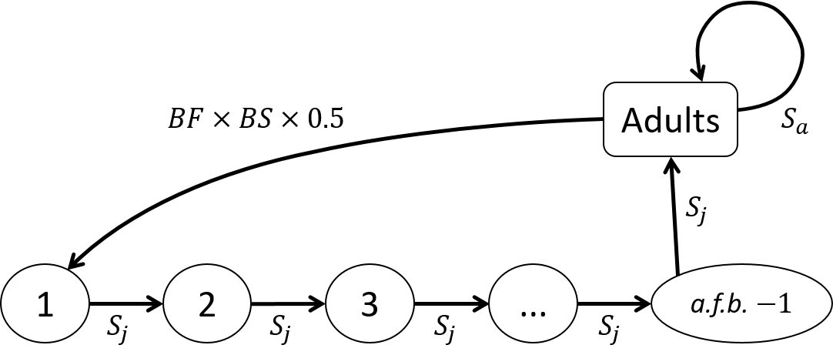

Demography modelling
For each population (each species at each island group), we constructed a matrix model (see Fig. S1) with number of age classes $=a.f.b$ and used the function stable.stage from the R package popbio to calculate the stable stage distribution (R Core Team, 2016; Stubben & Milligan, 2007). The immature age classes were split into “juveniles” (first year fledglings) and “immatures” (sum of all year classes from 2 to recruitment, Fig. S1) in order to create the density distribution maps using juvenile and immature spatial data. The proportion of adults was split into a proportion of adults breeding each year (breeders) and a proportion of adults skipping breeding each year (adult non-breeders) using breeding frequency $BF$, where $\text{breeders}=\text{adults}×BF$ and $\text{non-breeders}=\text{adults}×(1-BF)$. The proportion of breeders was further split into successful and fail breeders using breeding success $BS$, where $\text{successful breeders}=\text{breeders}×BS$ and $\text{fail breeders}=\text{breeders}×(1-BS)$. For more details, please see the R scripts available on GitHub.

References
Abraham, E., Yvan, R., & Clements, K. (2016). Evaluating threats to New Zealand seabirds. Report for the Department of Conservation, New Zealand.
Stubben, C., & Milligan, B. (2007). Estimating and analyzing demographic models using the popbio package in R. Journal of Statistical Software, 22(1), 1–23. doi: 10.18637/jss.v022.i11

