Appendix B

Table B1. Detailed information on the on-board observations of albatrosses and petrels deliberately killed or injured by handline fisheries off Brazil. Details include species (AYN: Atlantic yellow-nosed albatross; SPP: spectacled petrel; GSH: Great shearwater; COR: Cory's shearwater; SHW: unidentified shearwater); date; if the bird was dead or alive; Injury or kill type; other notes and the corresponding photo in Fig. 1. The asterisks indicate birds that were killed or injured in the vessel carrying the on-board observer.
# | Species | Date | Dead/Alive | Notes on injury/death | Other notes | Figure
1 | AYN* | 10 Feb 2006 | Dead | Upper bill amputated and shoulder wound. | Hooked alive and killed by fishermen. | 3A
2 | GSH | 10 Feb 2006 | Dead | Shoulder/neck wound. Dying bird. | Hauled on board. | 3B
3 | GSH* | 19 Feb 2006 | Alive | Open wound close to the bill | Hooked alive and injured during handling. Released alive. No picture. | na
4 | GSH* | 19 Feb 2006 | Dead | Killed by hitting the head. | Hooked alive and killed by fishermen. | 3C
5 | COR | 19 Feb 2006 | Dead | Broken neck. | Hauled on board. | 3D
6 | GSH | 20 Feb 2006 | Dead | Head trauma. | Hauled on board. No picture. | na
7 | GSH | 23 Feb 2006 | Alive | Broken leg + dorsal scar, injured few days ago. | Hauled on board. | 3E
8 | SPP | 25 Feb 2006 | Dead | Killed by hitting the head. | Hauled on board. No picture. | na
9 | SPP | 26 Feb 2006 | Dead | Killed by hitting the head. | Hauled on board. No picture. | na
10 | SPP | 27 Feb 2006 | Dead | Killed by hitting the head. | Hauled on board. | 3F
11 | AYN | 27 Feb 2006 | Dead | Killed by hitting the head. Adult. | Hauled on board. | 3F
12 | GSH | 06 Jun 2006 | Alive | Wounded Wing. | Hauled on board. | 3G
13 | SHW | 27 Feb 2006 | Dead | Floating on the sea surface. | Not hauled on board. No picture. | na
14 | SHW | 27 Feb 2006 | Dead | Floating on the sea surface | Not hauled on board. No picture. | na
15 | SHW | 27 Feb 2006 | Dead | Floating on the sea surface | Not hauled on board. No picture. | na
16 | SHW | 27 Feb 2006 | Dead | Floating on the sea surface | Not hauled on board. No picture. | na

Table B2. Detailed information on the records of albatrosses and petrels with bill mutilation. Details include species (AYN: Atlantic yellow-nosed albatross; BBA: black-browed albatross; MSH: Manx shearwater; NRA: northern royal albatross; SGP: southern giant petrel; SPP: spectacled petrel; SRA: southern royal albatross; COR: Cory's shearwater; MOL: Unidentified mollymawk; Thalassarche spp.); age class; date; country; location; if the bird was dead or alive; if upper, lower or both mandible were mutilated (Mandible); the degree of mutilation (% Bill missing); if the bird was photographed; the corresponding figure in Figure C1; photo credits and other notes.
# | Species | Age class | Date | Country | Location | Dead/alive | Mandible | % Bill missing | Photo (Y/N) | Figure | Other notes
1 | SGP | Immature | 03 July 1999 | Brazil | Praia Grande Beach | Alive | Upper | 71 | Y | A | Rescued on the beach. Died on 30 Nov 2011.
2 | NRA | Adult | 23 July 2005 | Uruguay | Offshore | Alive | Upper | na | N | na | Observed from vessel.
3 | SGP | Immature | 15 June 2008 | Brazil | APA da Baleia Franca | Alive | Upper | na | N | na | Rescued on the beach. Died same day.
4 | SRA | Adult | 26 August 2008 | Uruguay | Offshore | Alive | Upper | 50 | Y | B | Photographed from vessel.
5 | BBA | Adult | 26 August 2009 | Uruguay | Offshore | Alive | Upper | na | Y | C | Photographed from vessel.
6 | BBA | Adult | 01 October 2009 | Brazil | Cassino Beach | Dead | Upper | na | N | na | Dead on the beach.
7 | BBA | Adult | 22 April 2010 | Brazil | Offshore | Alive | Upper | 71 | Y | D | Photographed from vessel.
8 | BBA | Adult | 10 July 2010 | Argentina | Offshore | Alive | Both | na | N | na | Observed from vessel.
9 | BBA | Adult | 02 November 2010 | Argentina | Offshore | Alive | Upper | na | N | na | Observed from vessel.
10 | NRA | na | 20 March 2011 | Brazil | Cassino Beach | Dead | Upper | 79 | Y | E | Dead on the beach.
11 | BBA | Adult | 22 May 2011 | Uruguay | Offshore | Alive | Upper | 39 | Y | F | Photographed from vessel.
12 | BBA | Adult | 17 July 2012 | Brazil | Offshore | Alive | Upper | 61 | Y | G | Photographed from vessel.
13 | BBA | Adult | 07 August 2012 | Brazil | Offshore | Alive | Upper | 63 | Y | H | Photographed from vessel.
14 | BBA | Immature | 01 June 2013 | Uruguay | Offshore | Alive | Upper | 75 | Y | I | Photographed from vessel.
15 | BBA | Adult | 06 June 2013 | Brazil | Imbé Beach | Dead | Both | 59 | Y | J | Dead on the beach. Housed in Bird Collection of MUCIN (MUCIN 0356).
16 | NRA | Adult | 09 June 2013 | Uruguay | Offshore | Alive | Upper | 3 | Y | K | Photographed from vessel.
17 | BBA | Adult | 27 August 2013 | Uruguay | Offshore | Alive | Upper | na | Y | L | Photographed from vessel.
18 | BBA | Adult | 30 September 2013 | Brazil | Offshore | Alive | Upper | 100 | Y | M | Photographed from vessel.
19 | BBA | Adult | 10 October 2013 | Brazil | Xangri-lá Beach | Dead | Upper | 50 | Y | N | Dead on the beach. Housed in Bird Collection of MUCIN (MUCIN 0741).
20 | BBA | Immature | 16 October 2013 | Brazil | Imbé Beach | Dead | Upper | 59 | Y | O | Dead on the beach.
21 | BBA | Immature | 16 October 2013 | Brazil | Imbé Beach | Dead | Upper | 72 | Y | P | Dead on the beach.
22 | BBA | Adult | 07 August 2015 | Brazil | Mar Grosso Beach | Dead | Upper | 19 | Y | Q | Dead on the beach.
23 | BBA | Adult | 12 August 2015 | Argentina | Offshore | Alive | Upper | 62 | Y | R | Photographed from vessel.
24 | BBA | Adult | 16 August 2015 | Uruguay | Offshore | Alive | Upper | 57 | Y | S | Photographed from vessel.
25 | BBA | Adult | 21 August 2015 | Brazil | Imbé Beach | Dead | Upper | 44 | Y | T | Dead on the beach.
26 | BBA | Adult | 09 September 2015 | Brazil | Offshore | Alive | Upper | na | N | na | Observed from vessel.
27 | BBA | Immature | 17 March 2016 | Brazil | Cassino Beach | Dead | Upper | 75 | Y | U | Dead on the beach.
28 | BBA | Adult | 20 March 2016 | Brazil | Offshore | Alive | Both | 70 | Y | V | Photographed from vessel.
29 | BBA | Immature | 28 April 2016 | Brazil | Maresias Beach | Alive | Upper | 82 | Y | W | Rescued on the beach, weigth= 2.570 kg. Died two days later.
30 | BBA | na | 12 May 2016 | Brazil | Imbé Beach | Dead | Both | 100 | Y | X | Dead on the beach.
31 | BBA | Immature | 12 May 2016 | Brazil | Imbé Beach | Dead | Upper | 82 | Y | Y | Dead on the beach Housed in Bird Collection of MUCIN (MUCIN 1039).
32 | BBA | Adult | 13 May 2016 | Brazil | Offshore | Alive | Upper | 42 | Y | Z | Photographed from vessel.
33 | BBA | Immature | 26 May 2016 | Brazil | Mongaguá Beach | Alive | Upper | 49 | Y | AA | Rescued on the beach. Died few days later.
34 | BBA | Immature | 02 July 2016 | Uruguay | Offshore | Alive | Upper | 45 | Y | AB | Photographed from vessel.
35 | SRA | Adult | 09 September 2016 | Brazil | Torres Beach | Dead | Upper | 48 | Y | AC | Dead on the beach. Housed in Bird Collection of MUCIN (MUCIN 0810).
36 | MSH | na | 17 September 2016 | Brazil | Juréia | Alive | Upper | 67 | Y | AD | Rescued on the beach. Died few days later.
37 | SPP | na | 07 April 2017 | Uruguay | Offshore | Alive | Both | 13 | Y | AE | Photographed from vessel.
38 | BBA | Immature | 06 May 2017 | Brazil | Offshore | Alive | Upper | na | N | na | Observed from vessel.
39 | BBA | Immature | 14 June 2017 | Uruguay | Offshore | Alive | Upper | 45 | Y | AF | Photographed from vessel.
40 | MOL | na | 22 June 2017 | Brazil | Imbé Beach | Dead | Upper | na | Y | AG | Dead on the beach.
41 | YNA | Adult | 25 June 2017 | Brazil | Pontal do Sul | Dead | Lower | 39 | Y | AH | Dead on the beach.
42 | BBA | na | 20 July 2017 | Brazil | Pinhal Beach | Dead | Upper | 62 | Y | AI | Dead on the beach.
43 | BBA | Immature | 07 August 2017 | Brazil | Imbé Beach | Dead | Upper | 20 | Y | AJ | Dead on the beach.
44 | BBA | Adult | 23 October 2018 | Uruguay | Offshore | Alive | Upper | 55 | Y | AK | Photographed from vessel.
45 | SGP | Immature | 27 February 2019 | Uruguay | Offshore | Alive | Upper | 71 | Y | AL | Photographed from vessel.
46 | COR | na | 07 June 2019 | Brazil | Imbé Beach | Dead | Both | 74 | Y | AM | Dead on the beach.

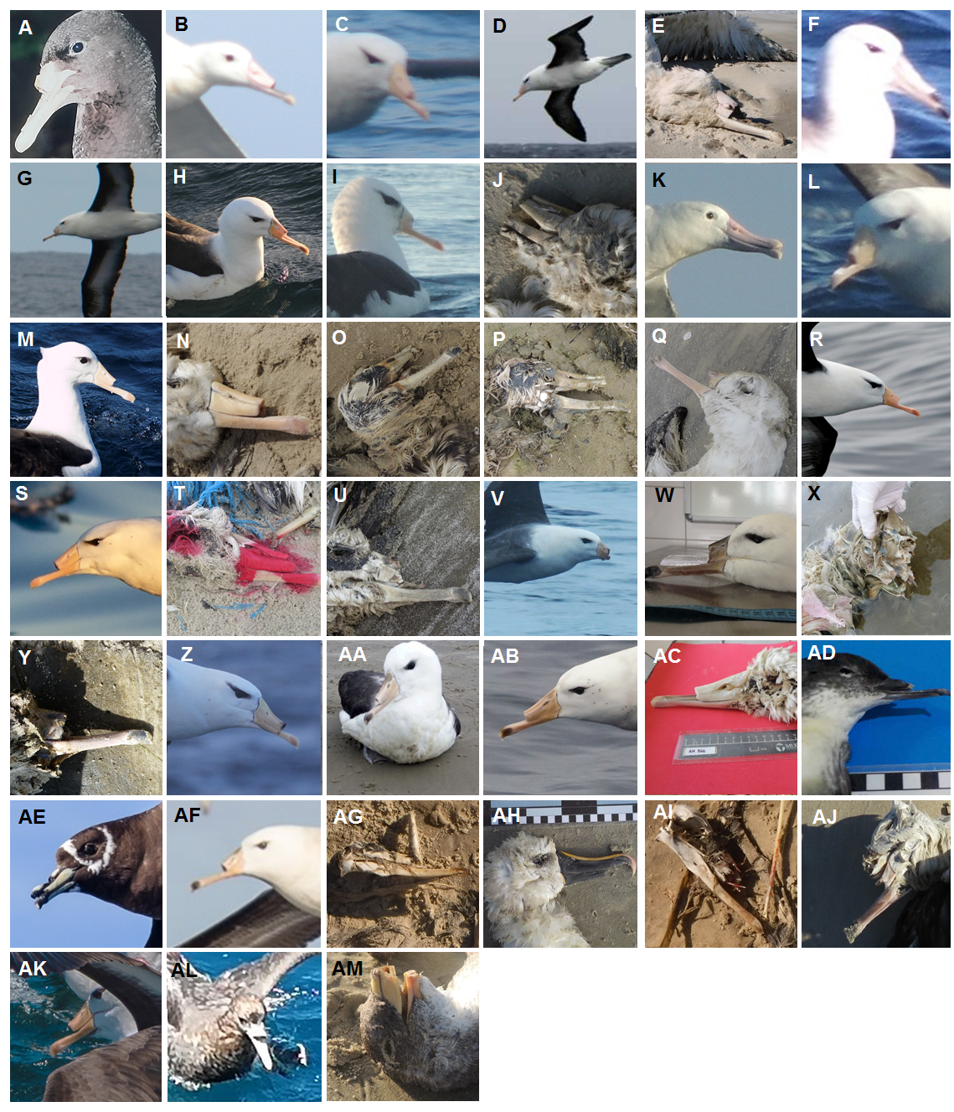
Figure C1. Documented records of albatrosses and petrels with bill mutilation. Corresponding photo credits in Table B2.

