Supporting Information

Appendix A
Table A.1
Plant species included in our personal reference database used in BLAST searches performed in the metabarcoding analysis, with their respective GenBank accession numbers. All species listed here are encountered in areas where the target herbivores (southern screamer, sheep and cattle) were sampled on the southern Brazilian coastal plain. Sequences obtained during the present study are underlined.
Family | Plant species | GenBank accession numbers
Asteraceae | Ambrosia tenuifolia | MH985562
Araliaceae | Hydrocotyle bonariensis | MT263960
 | Lilaeopsis brasiliensis | MT263964
 | Bacharis trimera | MT263957
Campanulaceae | Lobelia hederaceae | MT263969
Cyperaceae | Cyperus luzulae | MT263970
 | Eleocharis bonariensis | MT263953
 | Eleocharis palustris | KC584961
 | Eleocharis sp. | MT263959
Fabaceae | Desmodium sp. | MT263967
 | Trifolium repens | MT263950
 | Trifolium polymorphum | MT263952
Plantaginaceae | Plantago sp. | MT263961
Poaceae | Calamagrostis sp. | MT263955
 | Cynodon dactylon | MT263956
 | Echinochloa sp. | KR048646
 | Luziola peruviana | MT263962
 | Leersia hexandra | MT263963
 | Lolium perene | MT263951
 | Paspalum notatum | MT263965
 | Paspalum distichum | MT263968
 | Paspalum vaginatum | AY69149
 | Paspalum sp. | MT263954
 | Polygonum sp. | MT263966
 | Setaria geniculata | MF143749
Pontederiaceae | Eichhornia crassipes | MT263958
Verbenaceae | Phyla nodiflora | MF064938

Table A.2
Isotopic values of blood and faeces from the southern screamer, cattle and sheep and their potential food items as determined through SIA for samples collected on the southern Brazilian coastal plain.

Consumers | Sample | δ¹³C | δ¹⁵N
Cattle | Blood (n = 43) | -18.36 ± 0.87 | 7.76 ± 0.7
 | Faeces (n = 15) | -21.87 ± 2.41 | 5.66 ± 1.43
Southern Screamer | Blood (n = 49) | -26.87 ± 0.96 | 6.97 ± 1.61
 | Faeces (n = 41) | -28.09 ± 1.56 | 5.11 ± 1.86
Sheep | Blood (n = 19) | -20.48 ± 1.51 | 9.02 ± 0.56
 | Faeces (n = 19) | -22.31 ± 2.26 | 5.36 ± 0.83
Food itens
Aquatic plants | Leaf (n = 2) | -28.55 ± 0.08 | 7.81 ± 2.33
 | Eichhornia crassipes
 | Hydrocotyle bonariensis
C3 Grass | Leaf (n = 4) | -29.17 ± 0.51 | 5.37 ± 2.09
 | Luziola peruviana
 | Lobelia hederacea
 | Calamagrostis sp.
 | Leersia sp.
C4 Grass | Leaf (n = 2) | -13.55 ± 0.45 | 7.97 ± 3.32
 | Paspalum sp.
 | Cynodon dactylon
Legume | Leaf (n = 2) | -30.03 ± 0.46 | -0.81 ± 0.80
 | Trifolium repens
 | Trifolium polymorphum
Sedges | Leaf (n = 3) | -29.74 ± 0.41 | 7.81 ± 1.81
 | Eleocharis bonariensis
 | Eleocharis sp. 2
 | Eleocharis sp. 3

Table A.3
Contribution of different food items for each herbivorous species (southern screamer, sheep and cattle) sampled on the southern Brazilian coastal plain as measured by the faecal isotope mixing models (95% credibility intervals). These values were further used to calculate the interactions and dietary partitioning among herbivores through network analysis.
 | Sedges | C4 Grass | C3 Grass | Legume | Aquatic plants
Southern screamer | 0 – 0.2 | 0 – 0.7 | 0 – 0.3 | 0.5 – 0.7 | 0 – 0.2
Sheep | 0 – 0.4 | 0.1 – 0.3 | 0 – 0.5 | 0 – 0.2 | 0 – 0.3
Cattle | 0 – 0.4 | 0 – 0.7 | 0 – 0.3 | 0.5 – 0.7 | 0 – 0.2

Table A.4
Contribution of different species or groups of plants in the diet of the southern screamer, cattle and sheep on the southern Brazilian coastal plain, as determined from microhistological analysis in faecal samples. Frequency of occurrence (FO%), prey-specific numeric contribution (PN%), relative prey-specific proportion in the area of each fragment (PA%) and the prey-specific relative importance index (%PSIRI). Most important items by %PSIRI are presented in bold.
Food itens |  | Southern Screamer (n = 32) |  |  |  | Cattle (n = 16) |  |  |  | Sheep (n = 16)
 | Functional group | FO% | PN% | PA% | %PSIRI | FO% | PN% | PA% | %PSIRI | FO% | PN% | PA% | %PSIRI
Monocotyledoneae
Agrostis montevidensis Spreng. | Grass |  |  |  |  | 12.5 | 2.2 | 4.6 | 0.4 | 18.8 | 1.3 | 1.2 | 0.2
Calamagrostis sp. | Grass | 2.9 | 0.2 | 0.6 |  | 6.25 | 0.2 | 0.3 |  | 6.2 | 0.4 | 0.5
Cynodon dactylon (L.) Pers. | Grass |  |  |  |  | 37.5 | 6.4 | 7.0 | 2.5 | 31.3 | 1.0 | 1.3 | 0.3
Echinocloa polystachia (Kunt) Hitchc. | Grass | 8.8 | 1.6 | 7.3 | 0.4 | 50.0 | 1.3 | 1.6 | 0.7 | 25 | 5.1 | 5.1 | 1.2
Eleocharis sp. | Sedges | 58.8 | 3.2 | 7.1 | 3.0 | 93.7 | 32.9 | 33.3 | 31.06 | 100 | 35.6 | 35.4 | 35.5
Eragrostis sp. | Grass | 2.9 | 0.6 | 0.3
Leersia hexandra Sw. | Grass | 5.9 | 4.3 | 10.1 | 0.4 | 56.2 | 15.7 | 10.3 | 7.3 | 56. | 12.8 | 11.2 | 6.7
Lolium perenne | Grass | 2.9 | 0.1 |  |  |  |  |  |  | 6.2 | 2.4 | 2.4 | 0.1
Luziola peruviana Juss. Ex J.F.Gmel. | Grass |  |  |  |  | 43.7 | 33.0 | 30.7 | 14.0 | 43.8 | 16.0 | 13.4 | 6.4
Oryza sp. | Grass |  |  |  |  | 18.7 | 51.5 | 51.2 | 9.6
Panicum sp. | Grass | 11.7 | 1.1 | 7.03 | 0.5 | 18.7 | 0.7 | 1.1 | 0.2 | 12.5 | 1.1 | 1.1 | 0.1
Paspalidium paludivagum (Hitchc. & Chase) Parodi | Grass | 2.9 | 1.2 | 1.1 |  | 12.5 | 3.3 | 1.6 | 0.3 | 25 | 1.2 | 1.5 | 0.3
Paspalum distichum L. | Grass |  |  |  |  | 12.5 | 3.3 | 3.6 | 0.4 | 12.5 | 11.9 | 12.4 | 1.5
Paspalum vaginatum Sw. | Grass |  |  |  |  | 18.7 | 2.0 | 1.8 | 0.3 | 25 | 5.8 | 6.4 | 2.3
Paspalum sp. | Grass |  |  |  |  | 75 | 6.1 | 7.3 | 5.0 | 43.8 | 5.9 | 6.2 | 2.6
Polypogon chilensis (Kunth) Pilg. | Grass | 2.9 | 1.2 | 7.2 | 0.1 | 12.5 | 0.4 | 0.8 | 1.0 | 18.8 | 3.5 | 4.0 | 0.7
Setaria geniculata (Lam.) P.Beanv. | Grass | 2.9 | 0.5 | 1.1 | 0.02 |  |  |  |  | 12.5 | 2.2 | 1.9 | 0.2
Cyperaceae | Sedges | 26.5 | 2.1 | 4.5 | 0.8 | 68.7 | 1.1 | 1.3 | 0.8 | 62.5 | 7.4 | 7.7 | 4.7
Unidentified Poaceae | Grass | 85.3 | 10.2 | 17.1 | 11.7 | 100 | 21.3 | 21.6 | 21.5 | 100 | 31.2 | 31.8 | 31.6
Unidentified Monocotyledoneae |  | 26.5 | 1.3 | 1.8 | 0.4 | 18.7 | 2.9 | 2.8 | 0.5 | 31.3 | 4.3 | 3.5 | 1.2
Eudicotyledoneae
Ambrosia tenuifolia Spreng. | Forb | 11.7 | 1.1 | 9.8 | 0.6 | 12.5 | 2.2 | 4.6 | 0.4
Ecripta prostata (L.) | Forb | 2.9
Eichhornia sp. | Forb | 14.7 | 24.3 | 53.6 | 5.7 | 6.2 | 0.3 | 0.2
Phyla nodiflora (L.) Greene. | Forb | 23.5 | 2.4 | 11.9 | 1.7 | 6.2 | 0.1 | 0.1 |  | 18.7 | 3.3 | 2.2 | 0.5
Salpichroa sp. | Shrub | 5.8 | 0.9 | 4.3 | 0.1
Solanum sp. | Shrub |  |  |  |  | 6.2 | 9.0 | 5.0 | 0.4 | 12.5 | 8.3 | 8.2 | 1.0
Trifolium repens L. | Legume | 52.9 | 30.4 | 53.0 | 22.1 | 6.2 | 0.3 | 0.2 |  | 6.2 | 5.1 | 4.5 | 0.3
Solanaceae | Shrub | 2.9 | 0.1 | 0.8 |  | 6.2 | 0.5 | 0.3 | 1
Unidentified Eudicotyledoneae |  | 97 | 6.80 | 40.2 | 52.5 | 62.5 | 5.4 | 4.6 | 3.1 | 75 | 1.4 | 1.3 | 1.0

Table A.5
Main plant families and species identified in faecal samples of the southern screamer, cattle and sheep on the southern Brazilian coastal plain and their respective relative read abundance (RRA) as determined through metabarcoding analysis. Most important plant families identified by RRA are presented in bold.
Read identification |  |  | Relative Read Abundance per family
Family | Main species identified |  | Southern screamer  (n = 26) |  | Sheep  (n = 15) |  | Cattle  (n = 12)
Araliaceae | Hydrocotyle bonariensis | 8.59 |  | 0.40 |  | 0.55
Asteraceae | Conyza sp. | 7.80 |  | 3.39 |  | 33.96
 | Enydra sp.
Boraginaceae | Heliotropium sp. | 1.32 |  | 1.98 |  | 0.01
Campanulaceae | Lobelia hederacea | 2.60 |  | 0.55 |  | 1.07
Caryophylaceae | Stellaria media | 2.26 |  | 1.33 |  | 0.03
Fabaceae | Trifolium repens | 14.85 |  | 6.44 |  | 9.45
 | Trifolium polymorphum
Onagraceae | Ludwigia grandiflora | 11.21 |  | 38.60 |  | 10.58
Plantaginaceae | Plantago sp. | 4.34 |  | 0.37 |  | 1.11
Poaceae | Lolium perenne | 25.22 |  | 3.82 |  | 14.21
 | Luziola peruviana
Polygonaceae | Polygonum sp. | 3.51 |  | 0.23 |  | 3.16
Verbenaceae | Phyla nodiflora | 1.79 |  | 39.11 |  | 19.10
Others |  | 16.51 |  | 3.78 |  | 6.77

Table A.6
Food items identified at the species or genus level in faecal samples of the southern screamer, cattle and sheep on the southern Brazilian coastal plain and their respective relative read abundance (RRA) as determined through metabarcoding analysis.
Read identification |  |  |  | Relative Read Abundance
Family | Plant functional group | Food itens |  | Southern screamer  (n = 26) | Cattle  (n = 12) | Sheep  (n = 15)
Acacieae | Legume | Acacia sp. |  | 0.04 |  | 0.01
Sapindaceae | Shrub | Allophylus psilospermus |  |  |  | 0.01
Amaranthaceae | Forb | Alternanthera philoxeroides |  | 0.28 |  | 0.02
Amaranthaceae | Forb | Amaranthus sp. |  |  |  | 0.04
Asteraceae | Forb | Ambrosia tenuifolia |  |  | 0.16 | 0.01
Primulaceae | Forb | Anagallis sp. |  |  | 0.09 | 0.06
Azollaceae/Salviniaceae | Forb | Azolla caroliniana |  | 0.27
Azollaceae/Salviniaceae | Forb | Azolla mexicana |  | 2.15 | 0.03 | 0.01
Asteraceae | Shrub | Baccharis sp. |  |  | 0.22 | 0.02
Betulaceae | Tree | Betula sp. |  |  | 0.21
Poaceae | Grass | Calamagrostis sp. |  | 0.52 | 0.23 | 0.01
Caryophyllaceae | Forb | Cerastium sp. |  | 0.01 | 0.02
Asteraceae | Forb | Conyza bonariensis |  |  | 0.89 | 0.02
Asteraceae | Forb | Conyza sumatrensis |  | 2.75 | 14.17 | 0.08
Asteraceae | Forb | Cotula sp. |  | 0.01
Cucurbitaceae | Forb | Cucumis melo |  | 0.17
Cucurbitaceae | Forb | Cucurbita sp. |  |  | 0.49 | 0.05
Poaceae | Grass | Cynodon dactylon |  | 0.02 | 0.61 | 0.08
Cyperaceae | Sedges | Cyperus sp. |  | 0.01 | 0.10 | 0.02
Thymelaeaceae | Shrub | Daphnopsis sp. |  |  | 0.03
Fabaceae | Legume | Desmodium adscendens |  |  | 0.05 | 0.02
Fabaceae | Legume | Desmodium styracifolium |  | 0.06 | 0.41 | 0.08
Fabaceae | Legume | Desmodium sp. |  | 0.44 | 6.92 | 1.99
Poaceae | Grass | Dichanthelium boscii |  |  | 0.04
Convolvulaceae | Forb | Dichondra repens |  |  |  | 0.14
Poaceae | Grass | Digitaria sanguinalis |  |  | 0.11 | 0.02
Poaceae | Grass | Echinochloa sp. |  |  | 0.02
Pontederiaceae | Forb | Eichhornia crassipes |  | 2.17 | 0.39 | 0.15
Asteraceae | Forb | Eclipta prostrata |  | 0.29 | 2.75 | 0.16
Cyperaceae | Sedges | Eleocharis sp. |  | 0.08 | 0.10 | 0.01
Asteraceae | Forb | Enydra sessilis |  | 0.08 | 11.85 | 0.53
Asteraceae | Forb | Erechtites hieraciifolius |  |  | 0.01
Asteraceae | Forb | Erechtites valerianifolius |  |  | 1.43 | 0.01
Asteraceae | Forb | Erigeron sumatrensis |  |  | 0.02
Myrtaceae | Tree | Eucalyptus sp. |  |  | 1.08 | 0.05
Verbenaceae | Forb | Glandularia bipinnatifida |  |  | 0.18 | 0.01
Fabaceae | Legume | Glycine max |  | 0.03
Boraginaceae | Forb | Heliotropium filiforme |  |  |  | 0.01
Boraginaceae | Forb | Heliotropium pilosum |  | 0.48 | 0.01 | 0.93
Boraginaceae | Forb | Heliotropium procumbens |  | 0.84 |  | 1.05
Pontederiaceae | Forb | Heteranthera reniformis |  | 0.32
Araliaceae | Forb | Hydrocotyle verticillata |  | 1.89 | 0.08 | 0.08
Araliaceae | Forb | Hydrocotyle vulgaris |  | 0.03
Araliaceae | Forb | Hydrocotyle bonariensis |  | 6.77 | 0.46 | 0.33
Asteraceae | Forb | Hypochaeris incana |  | 0.05 | 1.00 | 2.31
Hypoxidaceae | Forb | Hypoxis leptocarpa |  |  | 0.01 | 0.07
Aquafoliaceae | Shrub/Tree | Ilex paraguariensis |  | 0.03 | 0.06
Isoetaceae | Graminoid | Isoetes engelmannii |  | 0.03 | 0.02 | 0.05
Juglandaceae | Tree | Juglans sigillata |  | 0.15
Juncaceae | Rushes | Juncus sp. |  |  | 1.91 | 2.14
Poaceae | Grass | Koeleria capensis |  | 0.19 | 1.46 | 0.52
Cyperaceae | Sedges | Kyllinga brevifolia |  |  | 0.18 | 0.07
Cyperaceae | Sedges | Kyllinga polyphylla |  |  | 0.24 | 0.07
Asteraceae | Forb | Lactuca sp. |  | 0.01
Asteraceae | Forb | Laggera alata |  |  | 0.03
Polypodiaceae | Forb | Lepisorus oligolepidus |  |  | 0.04 | 0.01
Poaceae | Grass | Leersia hexandra |  |  | 0.32 | 0.08
Apiaceae | Forb | Lilaeopsis sp. |  | 0.84 | 0.26 | 0.05
Campanulaceae | Forb | Lobelia hederacea |  | 2.70 | 1.07 | 0.55
Poaceae | Grass | Lolium multiflorum |  |  |  | 0.01
Poaceae | Grass | Lolium perenne |  | 0.05 | 0.17 | 0.44
Onagraceae | Forb | Ludwigia adscendens |  |  | 0.05 | 0.01
Onagraceae | Forb | Ludwigia grandiflora |  | 11.38 | 10.53 | 38.59
Poaceae | Grass | Luziola peruviana |  | 25.18 | 5.62 | 0.82
Fabaceae | Legume | Medicago ruthenica |  | 0.10 | 0.47 | 0.14
Cucurbitaceae | Forb | Melothria pendula |  |  | 0.28
Asteraceae | Forb | Mikania glomerata |  |  | 0.09
Asteraceae | Forb | Mikania laevigata |  |  | 0.52
Asteraceae | Forb | Mikania micrantha |  |  | 0.04 | 0.01
Haloragaceae | Forb | Myriophyllum aquaticum |  | 4.05 | 0.05 | 0.01
Haloragaceae | Forb | Myriophyllum robustum |  | 3.80
Poaceae | Grass | Oplismenus burmannii |  |  |  | 0.05
Poaceae | Grass | Oryza sativa |  | 0.01 | 0.13
Oxalidaceae | Forb | Oxalis articulata |  | 0.01 |  | 0.08
Oxalidaceae | Forb | Oxalis gyrorhiza |  |  | 0.01 | 0.02
Poaceae | Grass | Panicum sp. |  | 0.02 | 0.29 | 0.29
Poaceae | Grass | Paspalum dilatatum |  |  | 3.34 | 0.66
Poaceae | Grass | Paspalum distichum |  |  | 0.50 | 0.15
Poaceae | Grass | Paspalum thunbergii |  |  | 0.79 | 0.30
Passifloraceae | Forb | Passiflora caerulea |  |  |  | 0.02
Polygonaceae |  | Polygonaceae |  | 2.21 | 2.18 | 0.22
Fabaceae | Legume | Phaseolus coccineus |  | 4.38 | 0.55 | 0.71
Verbenaceae | Forb | Phyla dulcis |  | 0.97 | 9.72 | 20.32
Verbenaceae | Forb | Phyla nodiflora |  | 0.84 | 8.85 | 18.77
Pinaceae | Tree | Pinus pseudostrobus |  | 0.11
Plantaginaceae | Forb | Plantago depressa |  |  | 0.11 | 0.06
Plantaginaceae | Forb | Plantago sp. |  | 4.54 | 0.99 | 0.31
Poaceae | Grass | Poa annua |  | 0.01 | 0.01 | 0.08
Polygonaceae | Forb | Polygonum orientale |  |  | 0.02
Polygonaceae | Forb | Polygonum paraguayense |  |  | 0.03
Polygonaceae | Forb | Polygonum sp. |  | 1.33 | 0.93 | 0.01
Potamogetonaceae | Forb | Potamogeton sp. |  |  |  | 0.01
Rubiaceae | Forb | Richardia scabra |  |  | 0.32 | 0.04
Polygonaceae | Forb | Rumex sanguineus |  |  | 0.01
Rhamnaceae | Forb | Scutia buxifolia |  |  | 0.06
Asteraceae | Forb | Senecio chilensis |  |  | 0.08
Asteraceae | Forb | Senecio flavus |  |  | 0.12
Asteraceae | Forb | Senecio macranthus |  |  | 0.07
Fabaceae | Legume | Sesbania punicea |  |  | 0.02
Poaceae | Grass | Setaria pumila |  | 0.02 | 0.24 | 0.02
Poaceae | Grass | Setaria parviflora |  | 0.01 | 0.34 | 0.28
Malvaceae | Forb | Sida spinosa |  |  | 0.06 | 0.20
Solanaceae | Shrub | Solanum berthaultii |  | 0.12 |  | 0.06
Solanaceae | Shrub | Solanum commersonii |  | 0.07 |  | 0.04
Solanaceae | Shrub | Solanum tuberosum |  | 0.07 |  | 0.10
Asteraceae | Forb | Soliva anthemifolia |  | 4.56 | 0.09 | 0.23
Asteraceae | Forb | Soliva sessilis |  | 0.06
Asteraceae | Forb | Sphagneticola calendulacea |  |  | 0.48 | 0.01
Caryophyllaceae | Forb | Stellaria media |  | 2.26 | 0.01 | 1.33
Asteraceae | Forb | Tetragonotheca repanda |  |  | 0.04
Fabaceae | Legume | Trifolium repens |  | 7.45 | 0.85 | 1.46
Fabaceae | Legume | Trifolium polymorphum |  | 2.40 | 0.18 | 2.05
Juncaginaceae | Forb | Triglochin scilloides |  | 0.01 |  | 0.01
Poaceae | Grass | Trisetum irazuense |  | 0.07
Ulmaceae | Forb | Ulmus laciniata |  | 0.06
Verbenaceae | Forb | Verbena bonariensis |  |  | 0.15
Verbenaceae | Forb | Verbena officinalis |  |  | 0.01
Verbenaceae | Forb | Verbena urticifolia |  |  | 0.37 | 0.02
Fabaceae | Legume | Vigna luteola |  | 0.08
Fabaceae | Legume | Vigna oblongifolia |  | 0.05
Asteraceae | Forb | Wedelia tegetis |  |  | 0.07

Appendix B

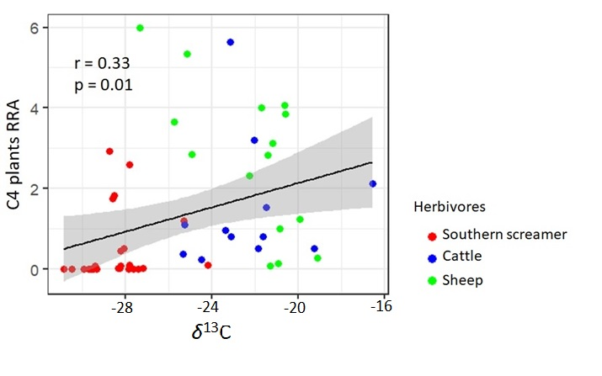

Fig. B.1 Correlation between Relative Read Abudance (RRA) of C4 plants (y-axis) and faecal stable carbon isotope values (x-axis, in ‰). The correlation was calculated based on values of individual samples obtained from southern screamer, cattle and sheep on the southern Brazilian coastal plain.

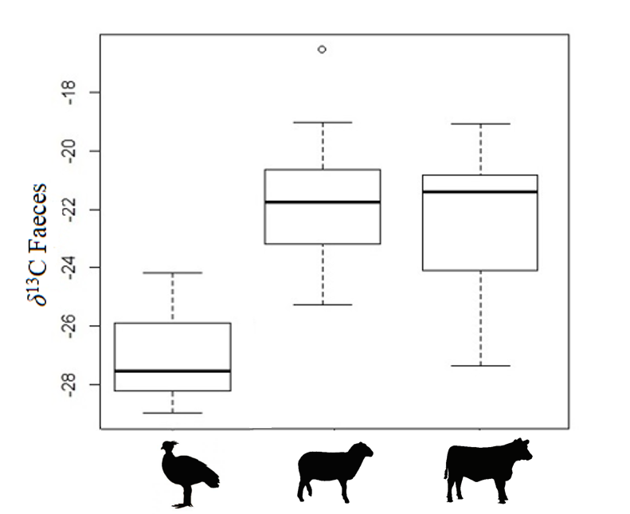

Fig. B.2 Differences in δ¹³C values (‰) inferred from the same faecal samples analysed for microhistological and metabarcoding inferences for the southern screamer, sheep and cattle on the southern Brazilian coastal plain.

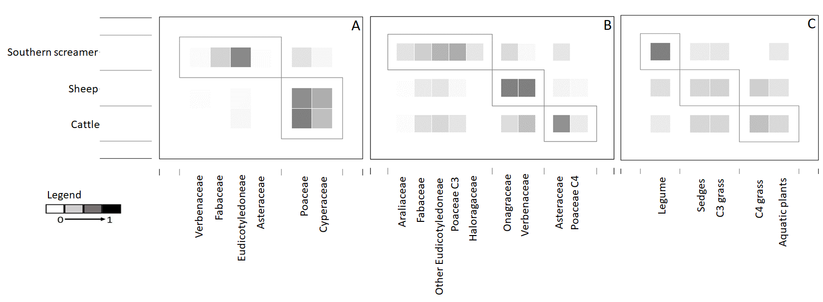
Fig. B.3 Matrices of bipartite networks among three herbivores, southern screamer, cattle and sheep, on the southern Brazilian coastal plain. (A) Modules generated for the prey-specific index of relative importance (%PSIRI). (B) Modules generated for relative read abundance (RRA). (C) Modules generated for stable isotopes analysis (SIA). Legumes were represented by the genus Trifolium sp. whereas Eichhornia crassipes and Hydrocotyle bonariensis represent aquatic plants

