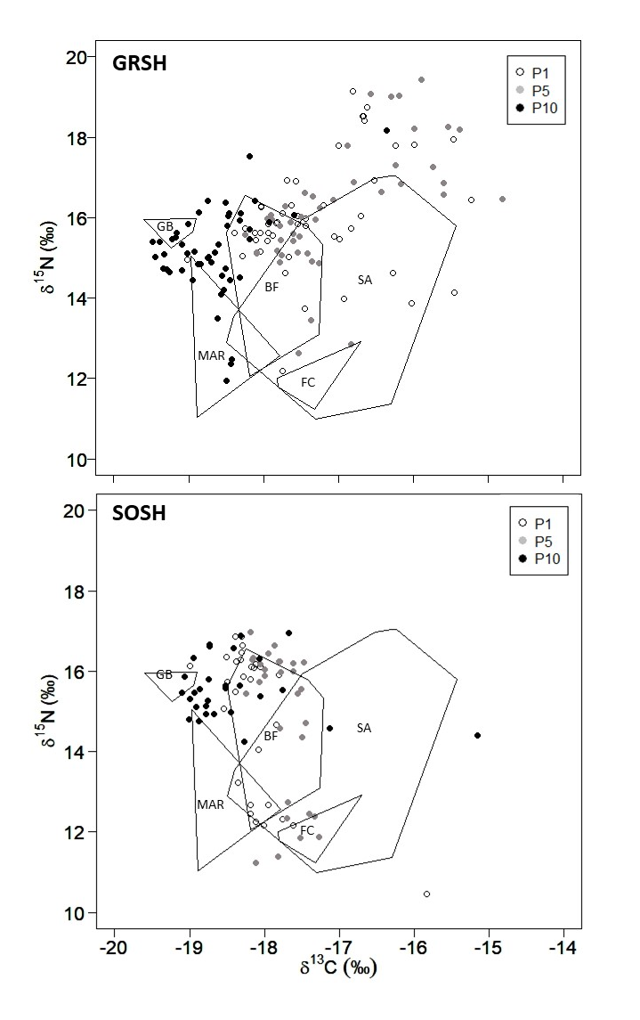

**Figure S1** Primary feather stable isotope ratios (δ15N and δ13C) of P1 (open circle; dotted line ellipse), P5 (grey circle; gray ellipse) and P10 (black circle; black ellipse) for Great (top) and Sooty (bottom) Shearwater captured during July–August on the northeast coast of Newfoundland. Convex hulls (used as references) were based on the stable isotope ratios of feathers from Great Shearwaters sampled in Bay of Fundy (BF, growing secondary feathers; R. A. Ronconi unpubl, data), South Atlantic (SA; growing body feathers; Bugoni *et al.* 2010) and Flemish Cap (FC; growing primary feathers, P1 and P5; P. C. Carvalho unpubl. data) as well as grown primary feathers (P5) from Sooty Shearwaters that were assumed to have moulted on the Grand Banks (GB) and Mid-Atlantic Ridge (MAR; Hedd *et al.* 2012).



**Figure S2** The number of Great (black) and Sooty (gray) Shearwaters captured during 5-day periods of July-August 2014 and 2015 on the northeast coast of Newfoundland. Note that ‘206’ is July 25.

Table S1 Summary of the number of individuals captured each year per species in Newfoundland. Note that the first capture date in 2014 was July 13 for Great Shearwaters (GRSH) and July 15 for Sooty Shearwaters (SOSH) and in 2015 was July 16 for Sooty Shearwaters and Jul 19 for Great Shearwaters.

|  |  |  |
| --- | --- | --- |
| **Year/Month** | **GRSH** | **SOSH** |
| 2014 |  |  |
| July | 45 | 41 |
| August | 30 | 0 |
| 2015 |  |  |
| July | 22 | 19 |
| August | 29 | 16 |
| Total | 126 | 76 |