Appendix 1
Supplementary material 1
Information about the scientific cruises carried out by Waterbirds and Sea Turtles Laboratory - Federal University of Rio Grande and BirdLife Seabirds’ Tracking selected for modelling.

Table SM1.1.
Sampling effort by scientific cruise realized by Waterbirds and Sea Turtles Laboratory /FURG projects, year, predominant season, number of Counting Stations (CS) and seabirds’ species detected.
Area sampled | Scientific Cruise | Year | Season | Counting Stations | Species
21°–32°S;  37°–52°W | CI | 2011 | Warm | 143 | PA/PC/AG/TC
23°–35°S;  41°–52°W | Talude I | 2009 | Warm | 121 | PA/PI/AG/TC
 | Talude III | 2010 |  | 183 | PA/PC/PI/AG/TC
 | Talude V | 2012 |  | 227 | PA/PC/PI/AG/TC
 | Talude VIII | 2014 |  | 142 | PA/PC/PI/AG/TC
 | Talude II | 2010 | Cold | 117 | PA/PC/PI/AG/TC
 | Talude IV | 2011 |  | 203 | PA/PC/PI/AG/TC
 | Talude VI | 2013 |  | 203 | PA/PC/PI/AG/TC
 | Talude VII | 2014 |  | 145 | PA/PC/PI/AG/TC
 | Talude IX | 2015 |  | 93 | PA/PC/PI/AG/TC
21°–23°S;  28°–43°W | Trindade I | 2011 | Cold | 121 | PC/AG/TC
 | Trindade II | 2011 | Warm | 77 | TC
 | Trindade III | 2012 | Warm | 156 | PI/AG
 | Trindade IV | 2014 | Cold | 65 | TC
 | Trindade V | 2014 | Cold | 62 | TM
 | Trindade VII | 2015 | Warm | 75 | TM

Table SM1.2.
Seabird trackings selected to modelling, data owners’ information and sampling period.
Species | Tracking number | Data owner | Sampling period
Wandering Albatross Diomedea exulans | 460 | Richard Phillips | 02/2004 - 10/2004
 | 462 | Richard Phillips | 02/2003 - 03/2007
 | 1405 | Richard Phillips | 11/2007 - 12/2009
 | 1503 | Richard Phillips | 01/2012 - 03/2012
Atlantic Yellow-nosed Albatross Thalassarche chlororhynchos | 1104 | Ben Dilley; Peter Ryan | 10/2014 - 12/2014
 | 1412 | Leandro Bugoni | 01/2015 - 05/2015
 | 1560 | Leandro Bugoni | 08/2019 - 02/2020
Atlantic Petrel Pterodroma incerta | 966 | Jacob González-Solís; Peter Ryan | 08/2010 - 07/2013
White-chinned Petrel Procellaria aequinoctialis | 439 | Richard Phillips | 02/2003 - 10/2003
 | 1396 | Richard Phillips | 04/2015 - 07/2015
 | 1500 | Richard Phillips | 01/2015 - 11/2015
 | 1558 | Richard Phillips | 12/2009 - 01/2010
Spectacled Petrel Procellaria conspicillata | 554 | Leandro Bugoni | 08/2006 - 08/2007
 | 858 | Peter Ryan | 10/2009 - 05/2010
Great Shearwater Ardenna gravis | 662 | Robert Ronconi;  Peter Ryan | 09/2009 - 06/2010
 | 663 | Robert Ronconi;  Peter Ryan | 11/2009 - 11/2010
 | 665 | Robert Ronconi;  Peter Ryan | 08/2006 - 03/2010
 | 982 | Jacob González-Solís; Peter Ryan | 11/2008 - 01/2014

Supplementary material 2
Script for the analyses performed in RStudio version 1.4.1106.

## Mean wind speed at 10 m above the sea level (monthly averages (2010 to 2014)##
#rWind’ v.1.1.7 package for download and manage surface wind data from the Global Forecasting System <https://www.ncei.noaa.gov/products/weather-climate-models/global-forecast>#
#rasterfile: https://coastwatch.pfeg.noaa.gov/erddap/griddap/erdQAwindmday.html#
>library(rWind)
>zw <- raster(file.choose(), varname="wind_speed") #zonal windy mensal windy velocity m/s#
>e <- extent (r1, r2, c1, c2) #geographic área#
>rzw <- crop(zw, e)
>writeRaster(rzw, filename="filename.tif", overwrite=TRUE)
>mw <- raster(file.choose(), varname="y_wind") #meridional windy mensal windy velocity m/s#
>e <- extent (r1, r2, c1, c2) #geographic área#
>rmw <- crop(mw, e)
>writeRaster(tc, filename="filename.tif", overwrite=TRUE)
>predwind <- stack(rzw, rmw)
> writeRaster(predwind, filename="filename.tif", overwrite=TRUE)
######

#Species Distribution Modelling - sdm package, disponible in http://www.biogeoinformatics.org/#
#install_github('babaknaimi/sdm')#
>library(sdm)
>library(raster)
>library(rgdal)
>library(openxlsx)
>library(usdm)
#Species occurrences. Presence only#
>sp <- shapefile('specie.shp')
>plot(sp)
>head(sp@data)
##Environmental variables rasterfiles##
>lst <- list.files(pattern='tif$')
>lst
>area<- extent (r1, r2, c1, c2) #geographic área#
>preds <- stack(lst)
>preds
#Environmental variables collinearity: variance inflation factor (VIF)#
>v <- vifstep(preds)
>v
>preds <- exclude(preds)
>preds
>vifcor(preds)
>plot(preds)
##Ecological niche modellig. Presence only (d) and background (d2)##
>d <- sdmData(Occurrence~., train=sp, predictors = preds)
>d
>d2 <- sdmData(Occurrence~., train=sp, predictors = preds, bg=list(n=10000)
>d2
>m<-sdm(Occurrence~.,data=d2,methods=c('maxent'),replication=c('cross'), cv.folds=10, test.percent=30)
>gui(m)# AUC and TSS results#
>varimp <- getVarImp(m)#Variable importance#
>varimp
>plot(varimp)
#Spatial prediction: Niche suitability index (NSI) map#
>p <- predict(m, newdata=preds, filename=“filename.img”, mean=T)
>p
>plot(p)
######

# Boyce Index (BI)#
>library(ecospat)
#The argument fit is a vector containing the predicted suitability values#
#The argument obs is a vector containing the predicted suitability values of the validation points (presence records)#
>obs<-read.table(file = "species_presence.csv", header = TRUE, sep = ";")
>head(obs)
>obsp<-obs[,1:2]
>fit <- raster("predict_species.asc")
>ecospat.boyce (fit, obs, nclass = 0, window.w = "default", res = 100, PEplot = TRUE)
>boy
>write.xlsx(boy, "species_boyce.xlsx")
######

##ENMTools provides metrics for measuring similarity between ENMs predictions. These include Schoener’s D (Schoener 1968).#
>library(ENMTools)
>warm <-raster(“specie1_warm.img”)#Niche suitability index rasterfile, warm season.#
>cold <-raster(“specie1_cold.img”)#Niche suitability index rasterfile, cold season.#
>raster.overlap(warm,cold)
######

Supplementary material 3
Variable Importance values for Ecological Niche Modellings.

Fig. SM3.1. Variable Importance values for warm months’ Ecological Niche Modellings. Variable Importance for Bathymetry (m); Distance from the Nearest Shore (m); Sea Surface Primary Production (g/m3/day); Sea Surface Salinity (PSS); Sea Surface Temperature (ºC) and Wind speed (m/s) used to modelling the niche for: DE - Wandering Albatross, TC - Atlantic Yellow-nosed Albatross, PI - Atlantic Petrel, PA - White-chinned Petrel, PC - Spectacled Petrel, TM - Black-browed Albatross and AG - Great Shearwater.
Fig. SM3.2. Variable importance values for cold months’ Ecological Niche Modellings. Variable Importance for Bathymetry (m); Distance from the Nearest Shore (m); Sea Surface Primary Production (g/m3/day); Sea Surface Salinity (PSS); Sea Surface Temperature (°C) and Wind speed (m/s) used to modelling the niche for: DE - Wandering Albatross, TC - Atlantic Yellow-nosed Albatross, PI - Atlantic Petrel, PA - White-chinned Petrel, PC - Spectacled Petrel, TM - Black-browed Albatross and AG - Great Shearwater.

Supplementary material 4
Seasonal spatial predictions of ecological niche models (ENM) to all species in warm and cold modelling, with niche suitability index (NSI) >0.5 to 0.7 and >0.71 to 1.

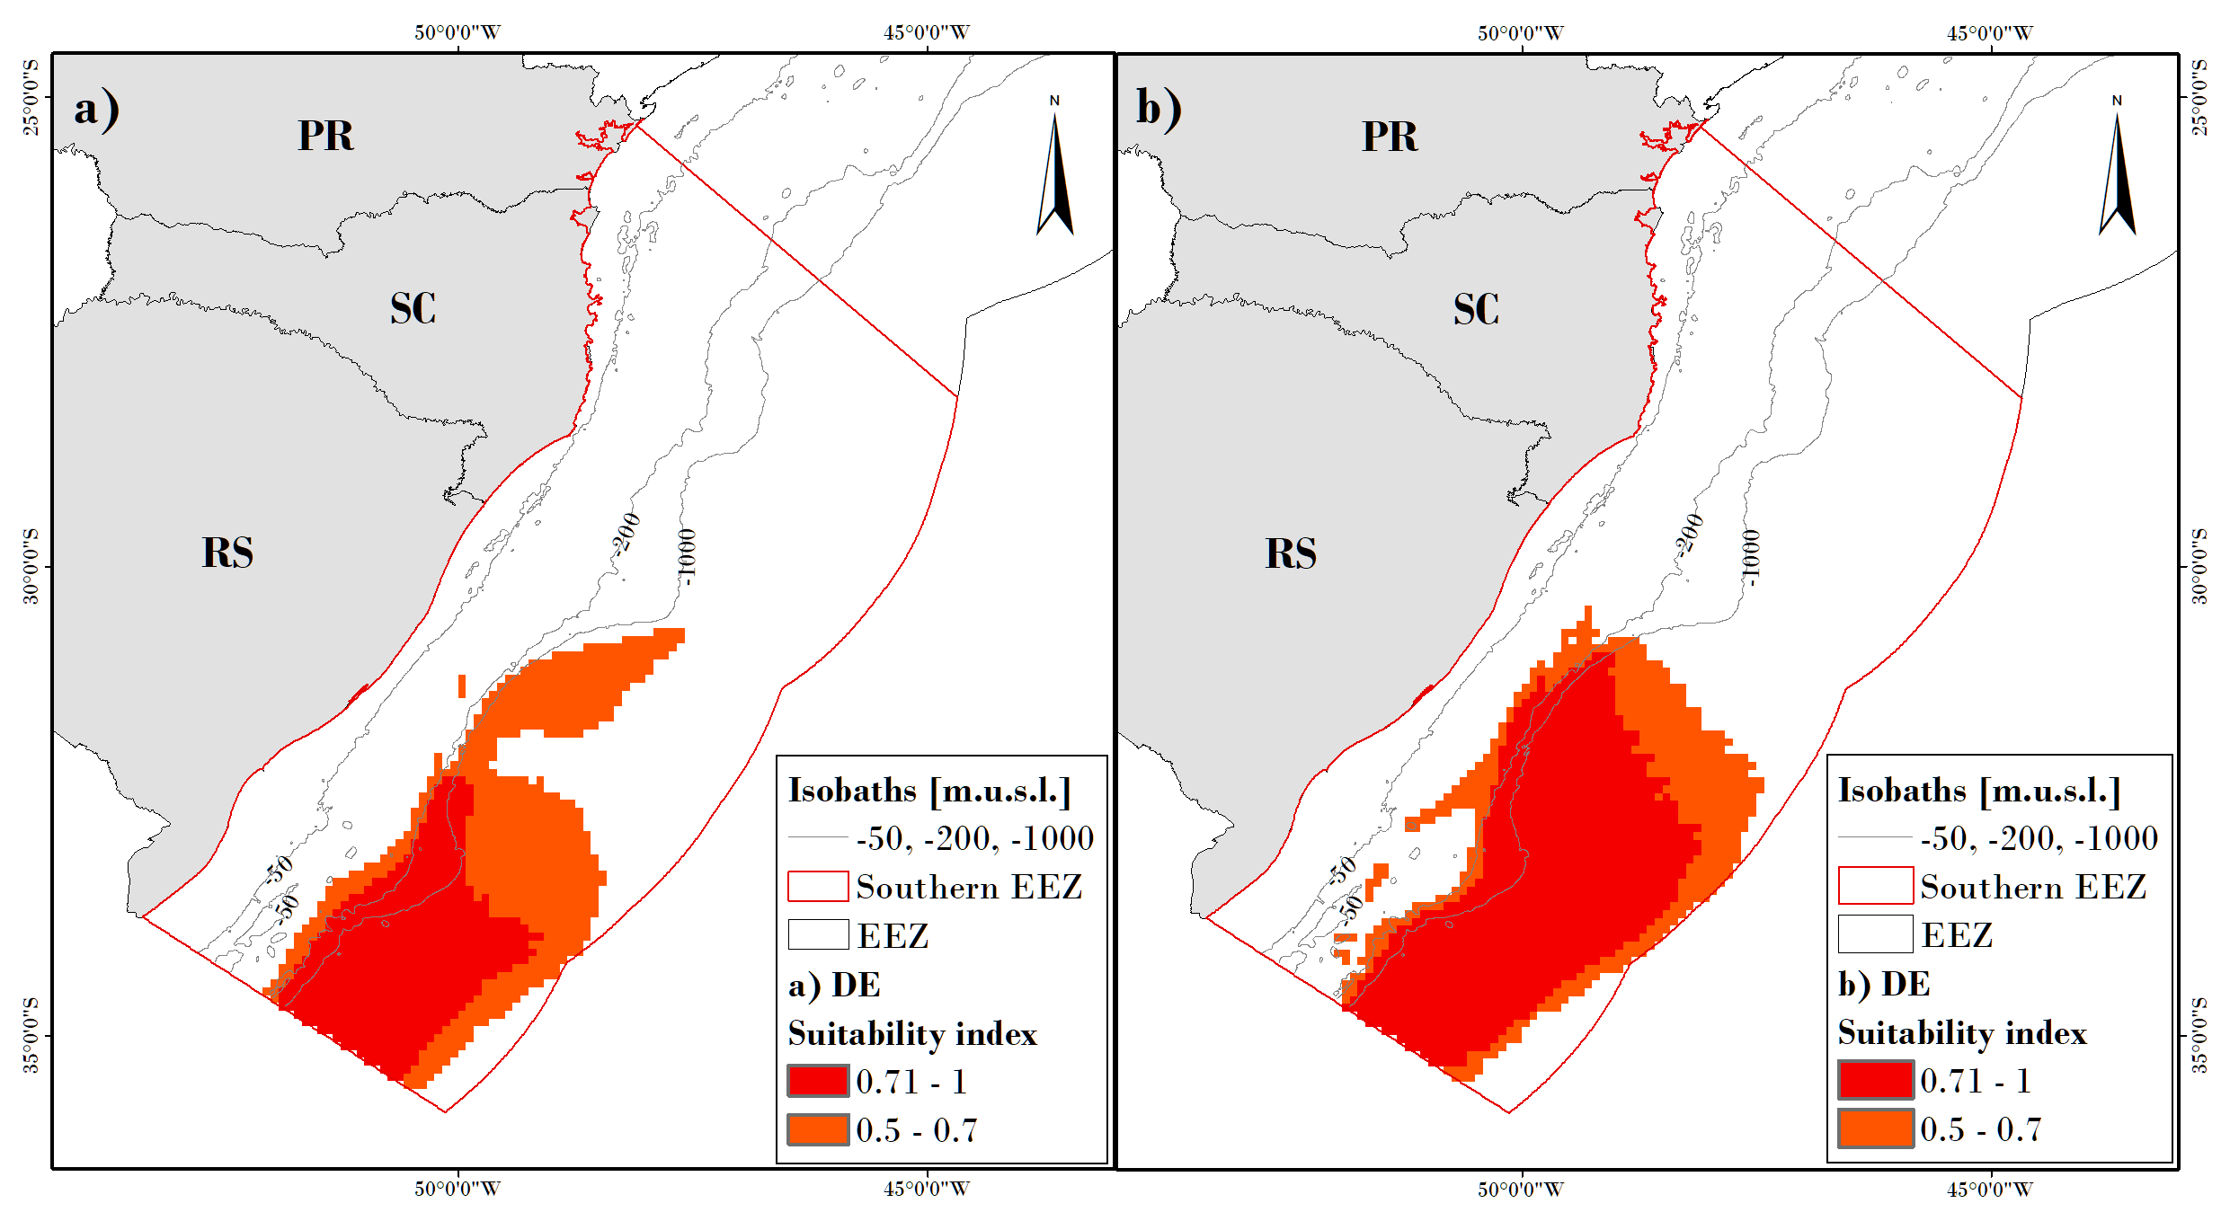
Fig. SM4.1. Seasonal spatial predictions of Ecological Niche Models (ENM) to Wandering Albatross (DE), displayed as Niche Suitability Index (NSI) >0.5 to 0.7 and >0.71 to 1, to a) warm months and b) cold months modelling.
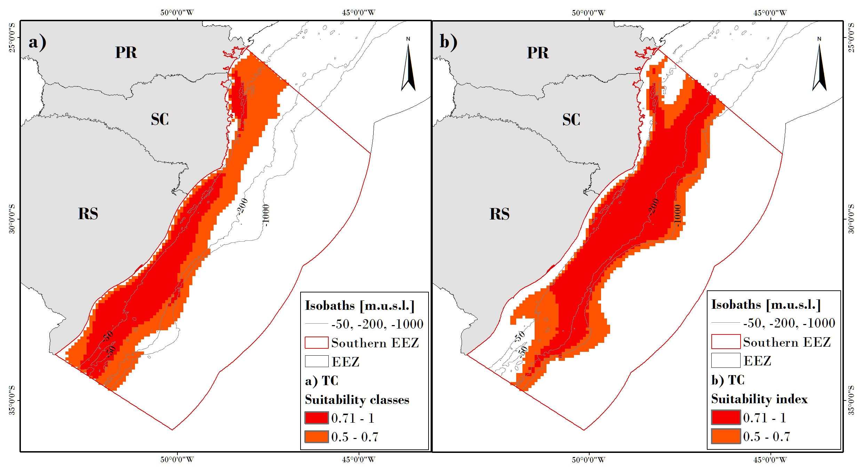
Fig. SM4.2. Seasonal spatial predictions of Ecological Niche Models (ENM) to Atlantic Yellow-nosed Albatross (TC), displayed as Niche Suitability Index (NSI) >0.5 to 0.7 and >0.71 to 1, to a) warm months and b) cold months modelling.
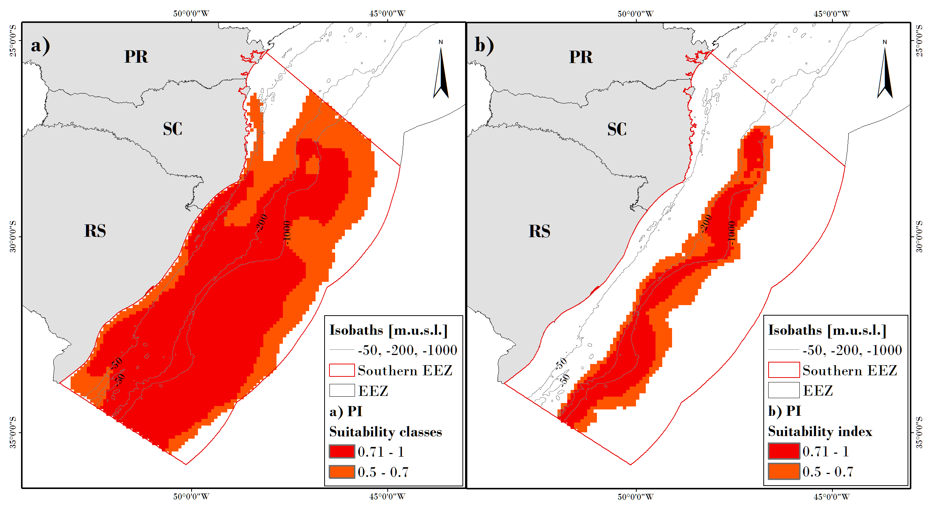
Fig. SM4.3. Seasonal spatial predictions of Ecological Niche Models (ENM) to Atlantic Petrel (PI), displayed as Niche Suitability Index (NSI) >0.5 to 0.7 and >0.71 to 1, to a) warm months and b) cold months modelling.
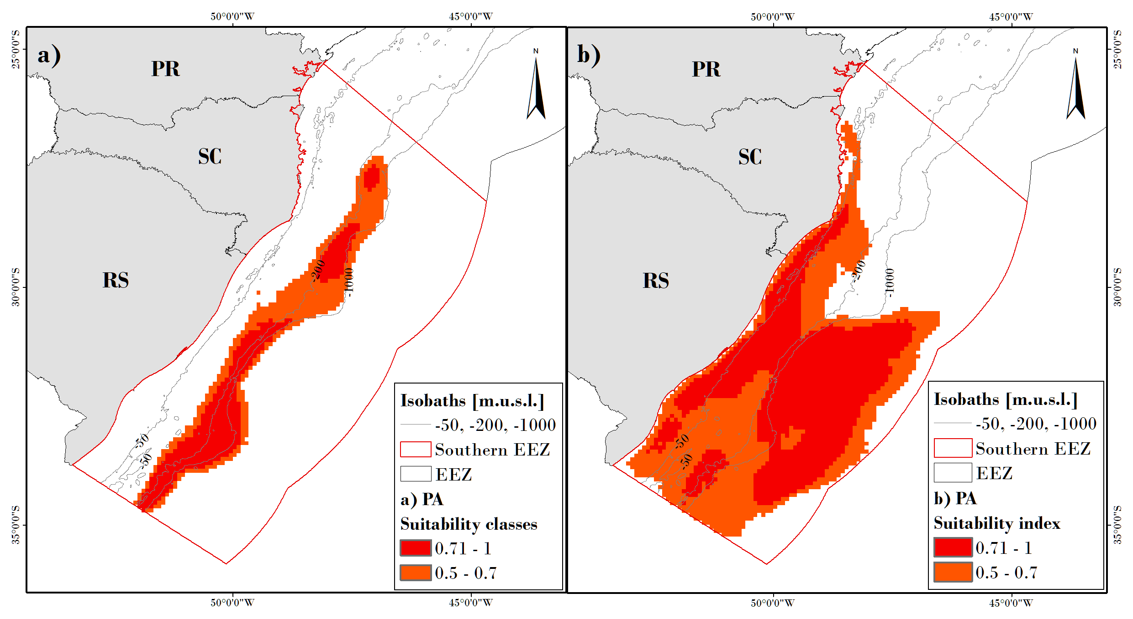
Fig. SM4.4. Seasonal spatial predictions of Ecological Niche Models (ENM) to White-chinned Petrel (PA) displayed as Niche Suitability Index (NSI) >0.5 to 0.7 and >0.71 to 1, to a) warm months and b) cold months modelling.
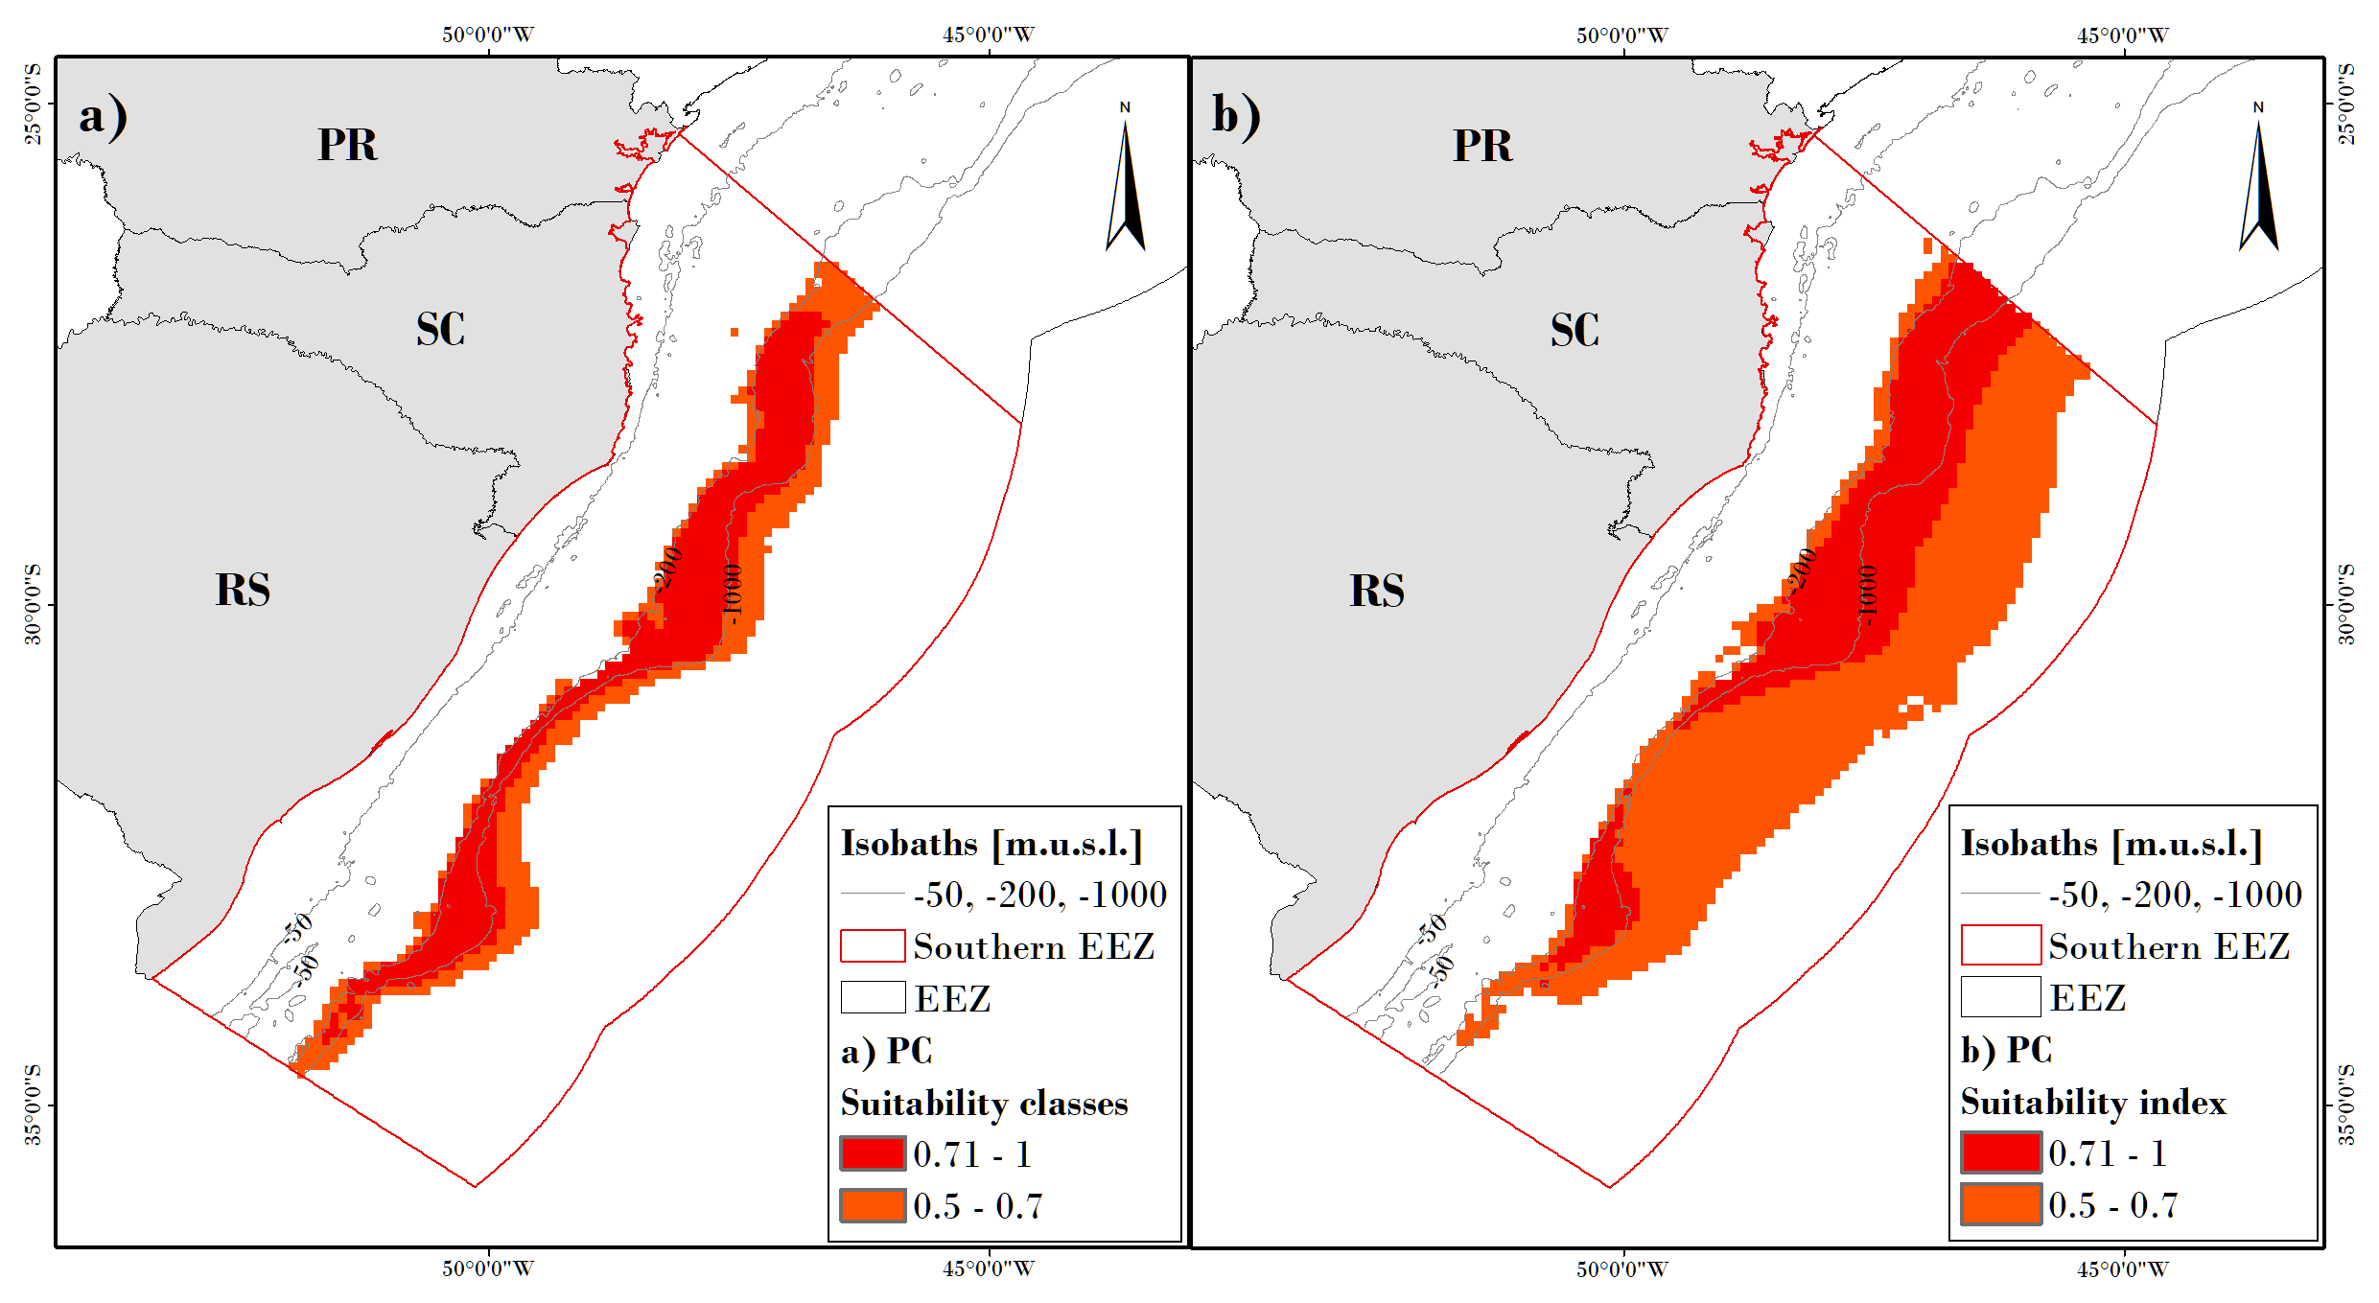
Fig. SM4.5. Seasonal spatial predictions of Ecological Niche Models (ENM) to Spectacled Petrel (PC), displayed as Niche Suitability index (NSI) >0.5 to 0.7 and >0.71 to 1, to a) warm months and b) cold months modelling.
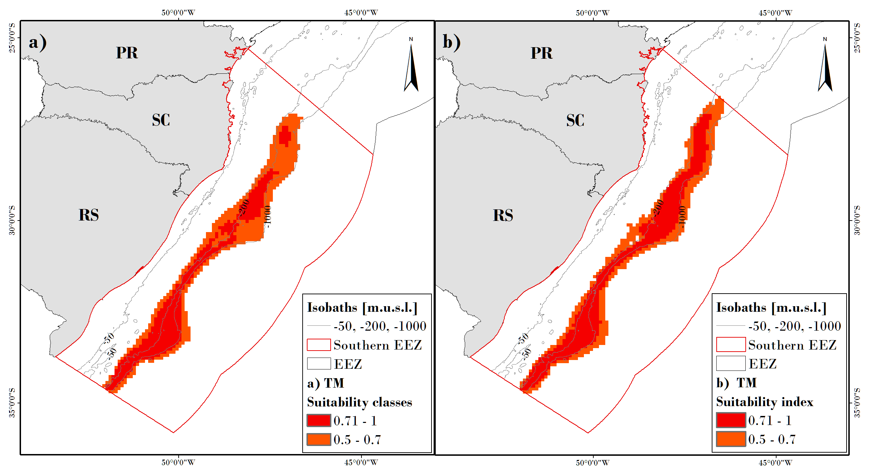
Fig. SM4.6. Seasonal spatial predictions of Ecological Niche Models (ENM) to Black-browed Albatross (TM), displayed as Niche Suitability Index (NSI) >0.5 to 0.7 and >0.71 to 1, to a) warm months and b) cold months modelling.
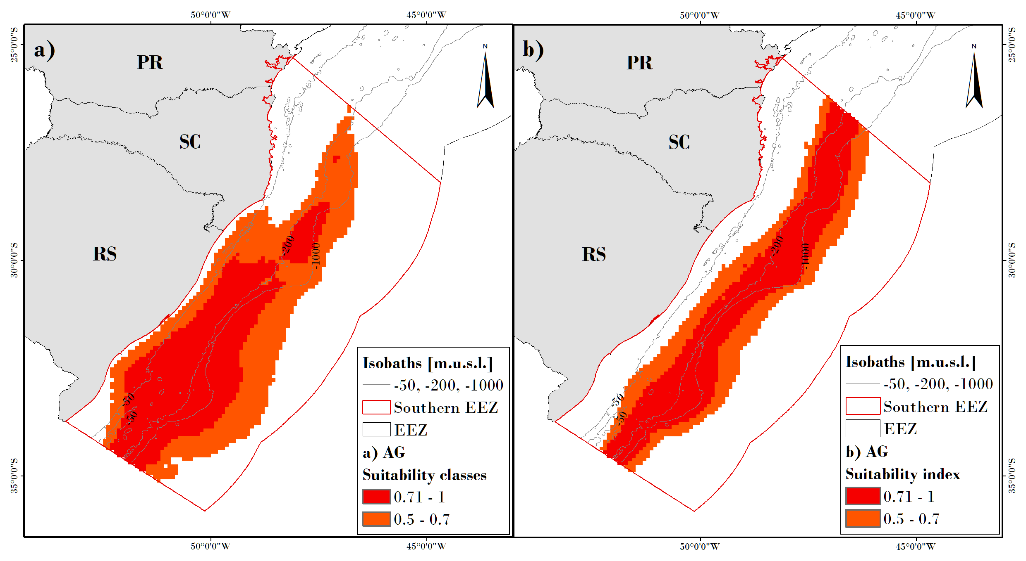
Fig. SM4.7. Seasonal spatial predictions of Ecological Niche Models (ENM) to Great Shearwater (AG), displayed as Niche Suitability Index (NSI) >0.5 to 0.7 and >0.71 to 1, to a) warm months and b) cold months modelling.

Supplementary material 5
Richness index (RI) modellings mapped with Niche Suitability Index (NSI) >0.5 and >0.8 by season.

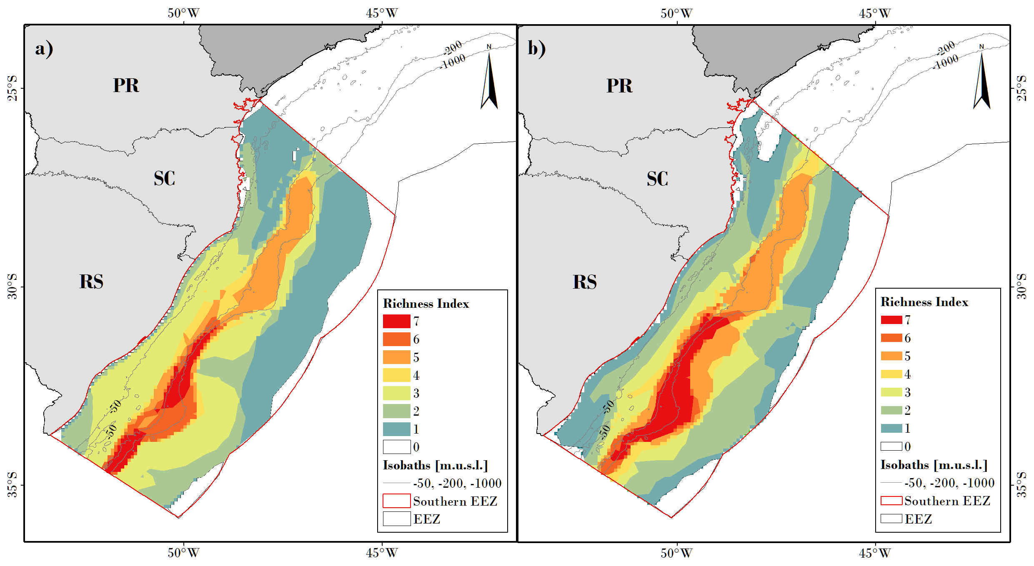
Fig. SM5.1. Richness index mapped for niche suitability index (NSI) >0.5 of the southern Brazilian Exclusive Economic Zone in a) warm and b) cold months.

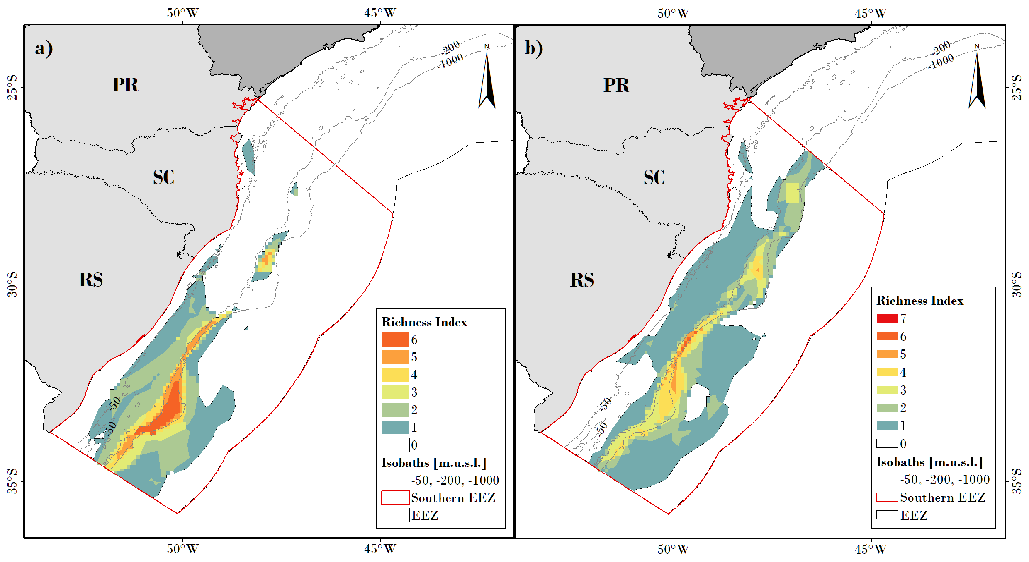
Fig. SM5.2. Richness index mapped for niche suitability index (NSI) >0.8 of the southern Brazilian Exclusive Economic Zone in a) warm and b) cold months.
Supplementary material 6
Richness index (RI) by bathymetric area.

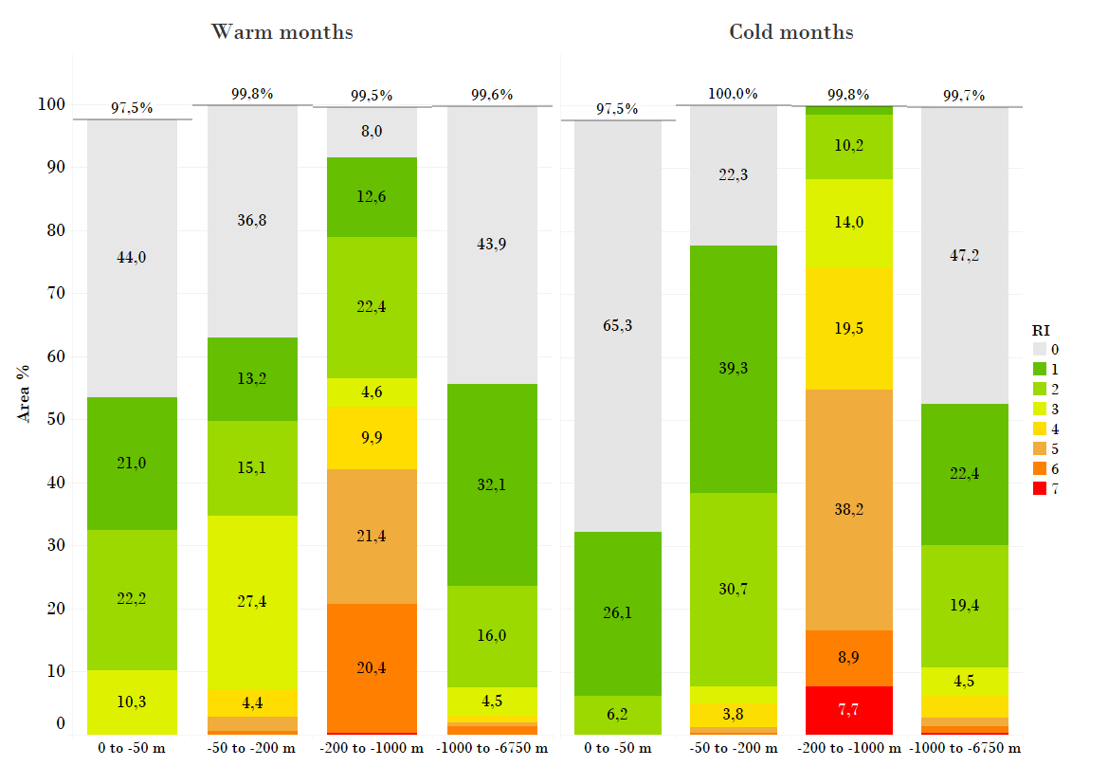
Fig SM 5.1. The proportion of richness index (RI) by bathymetric area of the southern Brazilian Exclusive Economic Zone, in warm (October-March) and cold (April-September) seasons. Note: Total RI areas do not sum 100% of the area because areas of the islands (e.g. Florianópolis island) are not considered in the ecological niche modelling (NoData pixel in the modelling raster). Also, the conversion of raster to vector file may cause distortions in total areas.

