SUPPORTING INFORMATION

A waterfowl seed-dispersal network from the Neotropical region is nested and modular

Giliandro G. Silva¹, Marco Aurélio Pizo², Andy J. Green³, Esther Sebastián-González⁴, Leandro Bugoni¹, Leonardo Maltchick¹

¹Graduate Program in Biology of Continental Aquatic Environments, Universidade Federal do Rio Grande - FURG, Itália Avenue, Km 8, Rio Grande, RS, Brazil
²Institute of Biosciences, Department of Biodiversity, Universidade Estadual Paulista, 13506-900, Rio Claro, SP, Brazil
³Department of Wetland Ecology, Estación Biológica de Doñana (EBD-CSIC), C/Américo Vespucio 26, 41092 Sevilla, Spain
⁴Department of Ecology, Universidad de Alicante, Alicante, Spain

* Corresponding author: giliandrog@gmail.com

Figure S1. Rarefaction curves with percentage of plant richness detected in faeces as a product of the observed richness divided by the richness estimated via Chao 2 non-parametric estimator. Curves were computed for all samples (Total) and for bird species (BT, Brazilian teal; CS, coscoroba swan; RT, ringed teal; WF, white-faced whistling-duck; YT, yellow-billed teal).

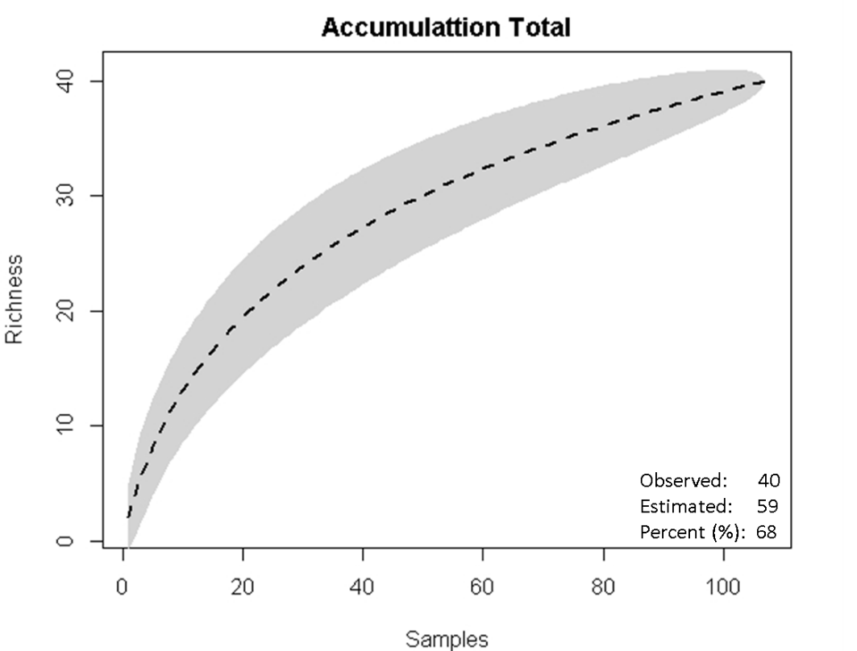 | 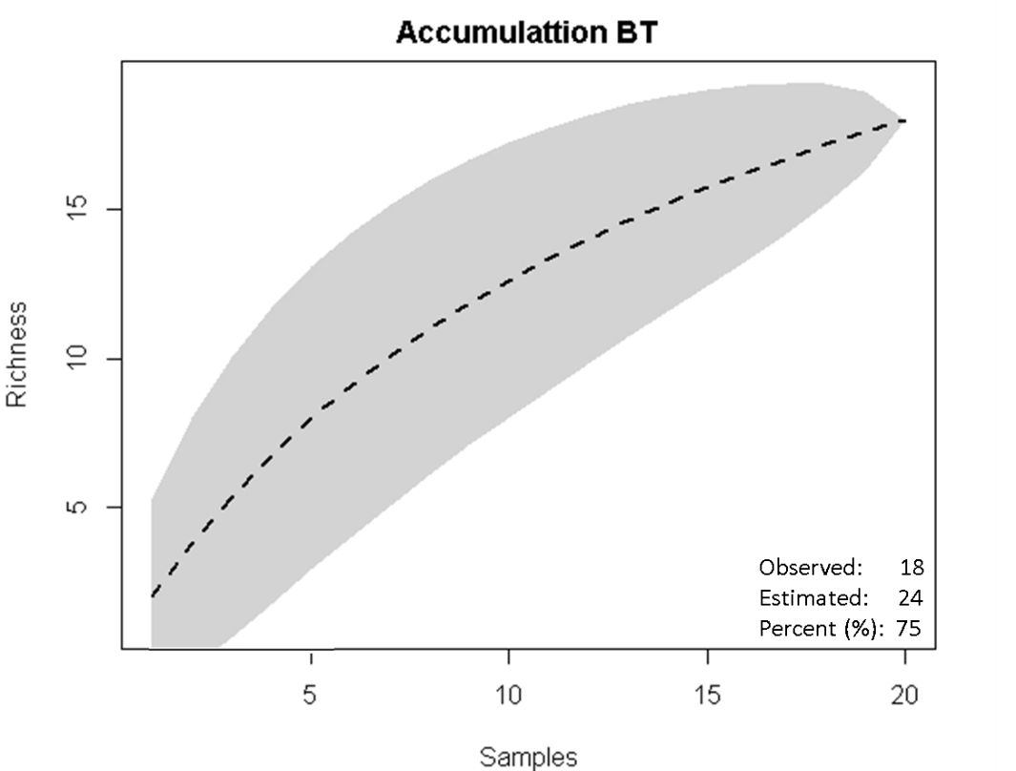 | 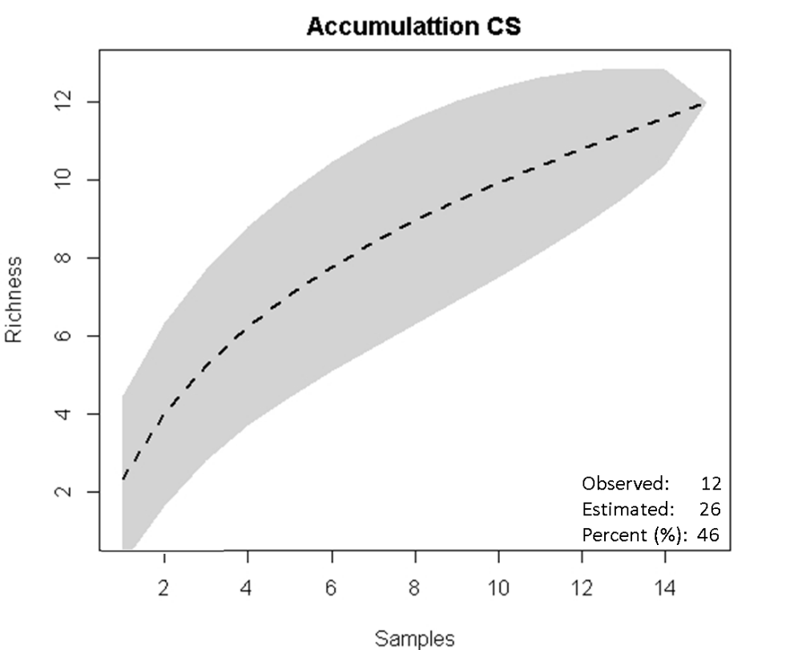
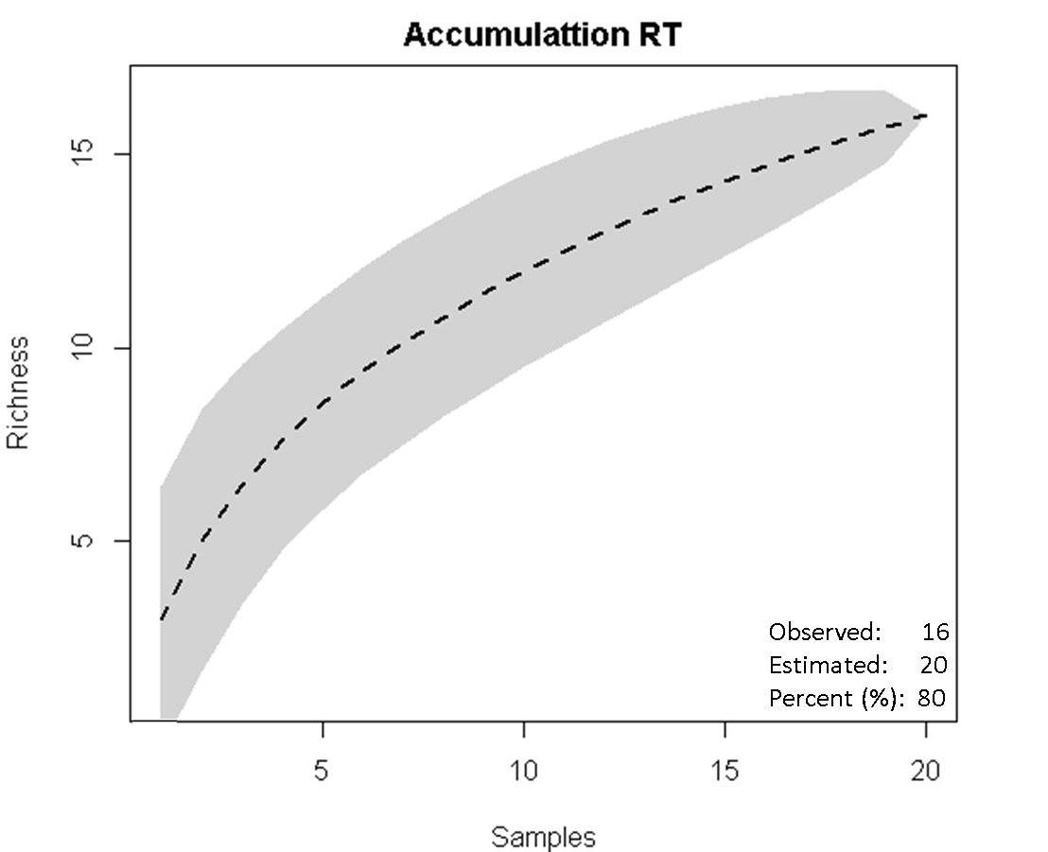 | 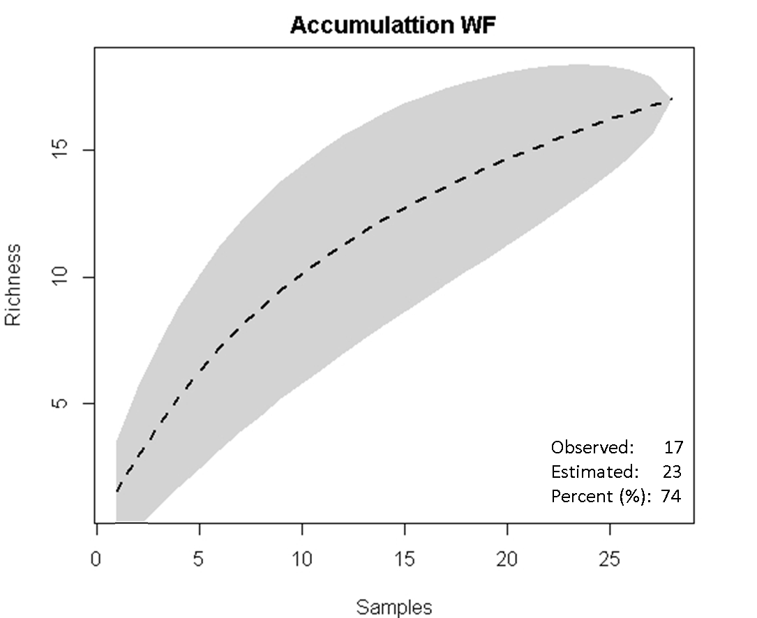 | 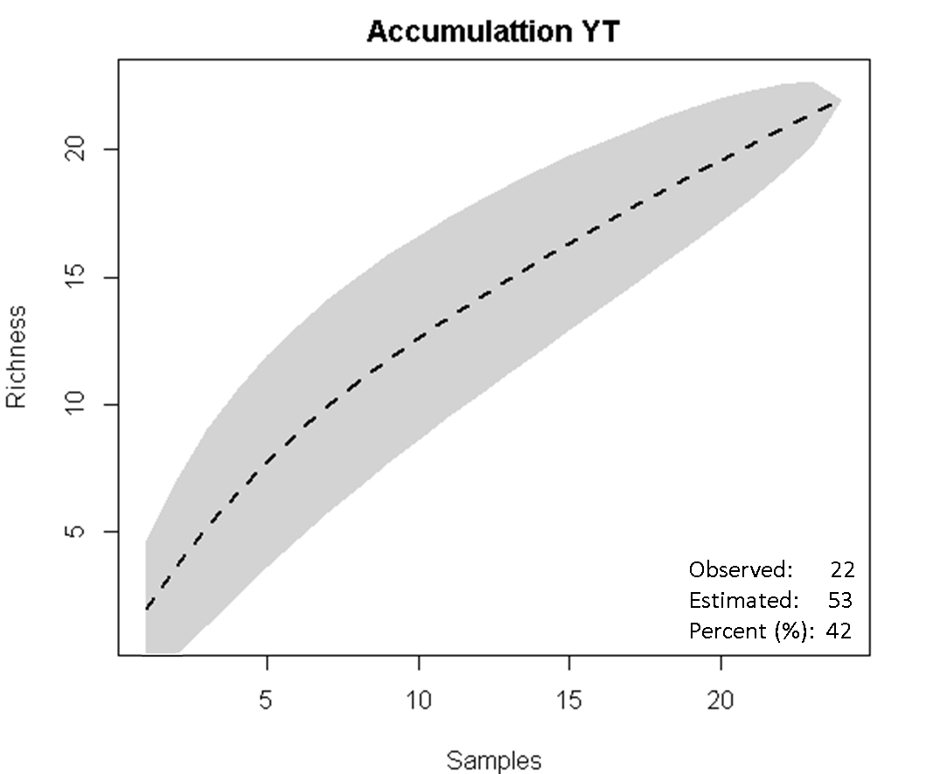

Table S1 Diaspores dispersed by five waterfowl species via endozoochory in southern Brazil in cold and warm periods. Numbers between parentheses represent number of samples with at least one diaspore / total samples. Seeds = total number of intact diaspores recorded. Sws = Number of samples where the respective diaspore was found. In fruits/types: Na = Not applicable.
 |  |  |  |  | Brazilian teal |  | Coscoroba swan |  | Ringed teal |  | White-faced whistling duck |  | Yellow-billed teal |  | Total
 |  |  |  |  | (n = 20/40) |  | (n = 15/22) |  | (n = 14/31) |  | (n = 28/40) |  | (n = 24/32)
Family | Taxa | Abbrev. | Fruit | Type | seed | sws | seed | sws | seed | sws | seed | sws | seed | sws | seed | sws
Acanthaceae | Hygrophila sp. | Hyg_sp | Capsule | Dry | 0 | 0 | 0 | 0 | 0 | 0 | 0 | 0 | 1 | 1 | 1 | 1
Alismataceae | Hydrocleys nymphoides | Hyd_nym | Follicle | Dry | 3 | 1 | 34 | 6 | 0 | 0 | 0 | 0 | 1 | 1 | 38 | 8
Amaranthaceae | Salicornia fruticosa | Sal_fru | Utricle | Dry | 0 | 0 | 0 | 0 | 1 | 1 | 0 | 0 | 0 | 0 | 1 | 1
Apocynaceae | Apocynaceae spp. | Apo_spp | Na | Na | 5 | 2 | 0 | 0 | 0 | 0 | 39 | 6 | 3 | 2 | 47 | 10
Charophyceae | Charophyceae spp. | Cha_spp | Oogonia | Na | 3 | 2 | 0 | 0 | 1 | 1 | 0 | 0 | 185 | 4 | 189 | 7
Cyperaceae | Androtrichum trigynum | And_tri | Achene | Dry | 0 | 0 | 0 | 0 | 1 | 1 | 1 | 1 | 0 | 0 | 2 | 2
Cyperaceae | Cyperus diformiss | Cyp_dif | Achene | Dry | 0 | 0 | 0 | 0 | 0 | 0 | 1 | 1 | 0 | 0 | 1 | 1
Cyperaceae | Eleocharis radicans | Ele_rad | Achene | Dry | 0 | 0 | 1 | 1 | 0 | 0 | 0 | 0 | 0 | 0 | 1 | 1
Cyperaceae | Eleocharis maculosa | Ele_mac | Achene | Dry | 0 | 0 | 0 | 0 | 5 | 2 | 10 | 2 | 0 | 0 | 15 | 4
Cyperaceae | Eleocharis bonariensis | Ele_bon | Achene | Dry | 2 | 2 | 1 | 1 | 19 | 6 | 3 | 2 | 1 | 1 | 26 | 12
Cyperaceae | Eleocharis flavescens | Ele_fla | Achene | Dry | 38 | 5 | 0 | 0 | 0 | 0 | 6 | 3 | 1 | 1 | 45 | 9
Cyperaceae | Eleocharis rabenii | Ele_rab | Achene | Dry | 5 | 2 | 0 | 0 | 1 | 1 | 0 | 0 | 1 | 1 | 7 | 4
Cyperaceae | Eleocharis minima | Ele_min | Achene | Dry | 2 | 1 | 3 | 3 | 165 | 10 | 8 | 4 | 7 | 2 | 185 | 20
Cyperaceae | Fuirena incompleta | Fui_inc | Achene | Dry | 1 | 1 | 0 | 0 | 0 | 0 | 0 | 0 | 0 | 0 | 1 | 1
Cyperaceae | Kyllinga odorata | Kyl_odo | Achene | Dry | 0 | 0 | 0 | 0 | 18 | 4 | 0 | 0 | 0 | 0 | 18 | 4
Cyperaceae | Rynchospora sp. | Ryn_sp | Achene | Dry | 1 | 1 | 0 | 0 | 0 | 0 | 0 | 0 | 492 | 2 | 493 | 3
Cyperaceae | Scirpus sp. | Sci_sp | Achene | Dry | 0 | 0 | 1 | 1 | 0 | 0 | 2 | 2 | 2 | 1 | 5 | 4
Hydrocharitaceae | Najas guadalupensis | Naj_gua | Achene | Dry | 0 | 0 | 0 | 0 | 0 | 0 | 0 | 0 | 1 | 1 | 1 | 1
Isoetaceae | Isoetes cf. maxima | Isso_max | Megaspore | Na | 0 | 0 | 0 | 0 | 0 | 0 | 1 | 1 | 1 | 1 | 2 | 2
Juncaceae | Juncus cf. bufonius | Jun_buf | Capule | Dry | 0 | 0 | 1 | 1 | 0 | 0 | 0 | 0 | 0 | 0 | 1 | 1
Juncaceae | Juncus sp. | Jun_sp | Capule | Dry | 0 | 0 | 0 | 0 | 0 | 0 | 0 | 0 | 2 | 1 | 2 | 1
Menyanthaceae | Nymphoides indica | Nym_ind | Capsule | Dry | 1 | 1 | 24 | 5 | 6 | 4 | 35 | 5 | 33 | 5 | 99 | 20
Onagraceae | Ludwigia erecta | Lud_ere | Capsule | Dry | 0 | 0 | 0 | 0 | 2 | 2 | 1 | 1 | 0 | 0 | 3 | 3
Poaceae | Axonopus purpusii | Axo_pur | Capsule | Dry | 0 | 0 | 0 | 0 | 0 | 0 | 0 | 0 | 2 | 1 | 2 | 1
Poaceae | Echinochloa cruss-galli | Echi_cru | Capsule | Dry | 5 | 4 | 0 | 0 | 0 | 0 | 0 | 0 | 0 | 0 | 5 | 4
Poaceae | Poaceae spp. | Poa_spp | Na | Na | 1 | 1 | 0 | 0 | 0 | 0 | 0 | 0 | 0 | 0 | 1 | 1
Poaceae | Panicum dichotomiflorum | Pan_dic | Capsule | Dry | 6 | 2 | 0 | 0 | 0 | 0 | 0 | 0 | 0 | 0 | 6 | 2
Poaceae | Panicum germinatum | Pan_ger | Capsule | Dry | 4 | 3 | 0 | 0 | 0 | 0 | 0 | 0 | 0 | 0 | 4 | 3
Poaceae | Paspalum repens | Pas_rep | Capsule | Dry | 0 | 0 | 1 | 1 | 0 | 0 | 1 | 1 | 0 | 0 | 2 | 2
Poaceae | Paspalum sp. | Pas_sp | Capsule | Dry | 0 | 0 | 0 | 0 | 0 | 0 | 0 | 0 | 2 | 1 | 2 | 1
Poaceae | Zizaniopsis cf. bonariensis | Ziz_bon | Capsule | Dry | 11 | 5 | 24 | 9 | 480 | 10 | 24 | 4 | 7 | 5 | 546 | 33
Polygonaceae | Polygonum punctatum | Poly_pun | Achene | Dry | 0 | 0 | 4 | 3 | 5 | 2 | 1 | 1 | 1 | 1 | 11 | 7
Pontederacae | Heteranther areniformis | Het_ren | Capsule | Dry | 0 | 0 | 0 | 0 | 0 | 0 | 0 | 0 | 1 | 1 | 1 | 1
Potamogetonaceae | Potamogeton pusillus | Pot_pus | Achene | Dry | 1 | 1 | 0 | 0 | 1 | 1 | 0 | 0 | 46 | 6 | 48 | 8
Ranunculaceae | Ranunculus flagelliformis | Ran_fla | Achene | Dry | 1 | 1 | 0 | 0 | 0 | 0 | 0 | 0 | 0 | 0 | 1 | 1
Rubiaceae | Rubiaceae spp. | Rub_spp | Na | Na | 0 | 0 | 3 | 3 | 1 | 1 | 0 | 0 | 0 | 0 | 4 | 4
Rubiaceae | Oldenlandia salzmannii | Old_sal | Capsule | Dry | 5 | 5 | 1 | 1 | 160 | 12 | 23 | 5 | 17 | 6 | 206 | 29
Ruppiaceae | Ruppia maritima | Rup_mar | Drupe | Fleshy | 0 | 0 | 0 | 0 | 0 | 0 | 0 | 0 | 5 | 1 | 5 | 1
Salviniaceae | Azolla filiculoides | Azo_fil | Sporocarp | Na | 0 | 0 | 0 | 0 | 15 | 2 | 1 | 1 | 0 | 0 | 16 | 3
Solanaceae | Solanum americanum | Sol_ame | Berry | Fleshy | 0 | 0 | 0 | 0 | 0 | 0 | 23 | 2 | 0 | 0 | 23 | 2
Total |  |  |  |  | 95 | 40 | 98 | 35 | 881 | 60 | 180 | 42 | 812 | 46 | 2066 | 223

Table S2. Species contributions to network nestedness, considering waterfowl and plants in a Neotropical wetland network.
Waterfowl | Z-scores
Yellow-billed teal | 2.319
Brazilian teal | 1.789
White-faced whistling-duck | 0.945
Ringed teal | 0.687
Coscoroba swan | 0.367
Plant taxa | Z-scores
Oldenlandia salzmannii | 1.175
Eleocharis bonariensis | 1.159
Eleocharis minima | 1.135
Nymphoides indica | 1.131
Zizaniopsis bonariensis | 1.103
Rynchospora sp. | 1.006
Polygonum punctatum | 0.868
Apocynaceae spp. | 0.662
Eleocharis flavescens | 0.636
Potamogeton pusillus | 0.534
Charophyceae spp | 0.509
Eleocharis rabenii | 0.500
Isoetes maxima | 0.330
Hydrocleys nymphoides | 0.326
Scirpus sp. | 0.129
Cyperus diformiss | 0.100
Paspalum sp. | 0.095
Ruppia maritima | 0.088
Juncus sp. | 0.073
Axonopus purpusii | 0.070
Najas guadalupensis | 0.062
Solanum americanum | 0.061
Hygrophila sp. | 0.059
Heteranthera reniformis | 0.053
Salicornia fruticosa | -0.108
Kyllinga odorata | -0.116
Ranunculus flagelliformis | -0.253
Panicum dichotomiflorum | -0.271
Panicum germinatum | -0.276
Poaceae spp. | -0.277
Echinochloa crussgalli | -0.282
Fuirena incompleta | -0.316
Eleocharis radicans | -0.544
Juncus bufonius | -0.578
Androtrichum trigynum | -0.598
Ludwigia erecta | -0.621
Eleocharis maculosa | -0.645
Azolla filiculoides | -0.646
Paspalum repens | -0.652
Rubiaceae spp. | -0.710

Table S3. Species contributions to network weighted nestedness, considering waterfowl and plants in a Neotropical wetland network.
Waterfowl | Z-scores
Yellow-billed teal | 2.320
Brazilian teal | 1.952
White-faced whistling-duck | 0.830
Ringed teal | 0.674
Coscoroba swan | 0.345
Plant taxa | Z-scores
Oldenlandia salzmannii | 1.184
Eleocharis minima | 1.181
Eleocharis bonariensis | 1.181
Zizaniopsis bonariensis | 1.157
Nymphoides indica | 1.144
Rynchospora sp. | 0.998
Polygonum punctatum | 0.902
Apocynaceae spp | 0.675
Eleocharis flavescens | 0.629
Charophyceae spp | 0.558
Potamogeton pusillus | 0.534
Eleocharis rabenii | 0.498
Hydrocleys nymphoides | 0.390
Isoetes maxima | 0.306
Scirpus sp. | 0.173
Juncus sp. | 0.139
Ruppia maritima | 0.127
Cyperus diformiss | 0.113
Axonopus purpusii | 0.090
Hygrophila sp. | 0.089
Najas guadalupensis | 0.080
Paspalum sp. | 0.075
Heteranthera reniformis | 0.074
Solanum americanum | 0.034
Kyllinga odorata | -0.104
Salicornia fruticosa | -0.128
Echinochloa crussgalli | -0.213
Panicum germinatum | -0.263
Poaceae spp. | -0.264
Fuirena incompleta | -0.286
Panicum dichotomiflorum | -0.287
Ranunculus flagelliformis | -0.318
Ludwigia erecta | -0.579
Juncus bufonius | -0.605
Azolla filiculoides | -0.614
Androtrichum trigynum | -0.629
Eleocharis maculosa | -0.629
Eleocharis radicans | -0.644
Paspalum repens | -0.697
Rubiaceae spp. | -0.742
Table S4. Species contributions to weighted modularity, considering waterfowl and plants in a Neotropical wetland network. Z represents the connection within-modules and C the among-module connectivity. NA values for Z are shown when the species is fully connected within the module, indicating a very large within-module connectivity.
Waterfowl | Z | C
White-faced whistling-duck | 0.707 | 0.220
Yellow-billed teal | NA | 0.291
Brazilian teal | NA | 0.132
Ringed teal | NA | 0.355
Coscoroba swan | -0.707 | 0.039
Plants
Rynchospora sp. | 2.651 | 0.031
Nymphoides indica | 2.566 | 0.215
Eleocharis flavescens | 2.441 | 0.152
Zizaniopsis bonariensis | 2.251 | 0.581
Hydrocleys nymphoides | 1.739 | 0.155
Apocynaceae spp. | 1.013 | 0.325
Charophyceae spp. | 0.705 | 0.210
Eleocharis minima | 0.347 | 0.508
Oldenlandia salzmannii | 0.317 | 0.638
Solanum americanum | 0.305 | 0.000
Panicum dichotomiflorum | -0.131 | 0.000
Potamogeton pusillus | -0.176 | 0.277
Echinochloa crussgalli | -0.211 | 0.000
Eleocharis rabenii | -0.211 | 0.089
Eleocharis maculosa | -0.269 | 0.172
Panicum germinatum | -0.291 | 0.000
Polygonum punctatum | -0.379 | 0.237
Ruppia maritima | -0.435 | 0.000
Axonopus purpusii | -0.454 | 0.000
Juncus sp. | -0.454 | 0.000
Paspalum sp. | -0.454 | 0.000
Heteranthera reniformis | -0.461 | 0.000
Hygrophila sp. | -0.461 | 0.000
Najas guadalupensis | -0.461 | 0.000
Rubiaceae spp. | -0.495 | 0.072
Fuirena incompleta | -0.532 | 0.000
Poaceae spp. | -0.532 | 0.000
Ranunculus flagelliformis | -0.532 | 0.000
Eleocharis bonariensis | -0.535 | 0.674
Kyllinga odorata | -0.541 | 0.000
Scirpus sp. | -0.551 | 0.190
Azolla filiculoides | -0.559 | 0.366
Paspalum repens | -0.595 | 0.000
Ludwigia erecta | -0.638 | 0.416
Eleocharis radicans | -0.639 | 0.000
Juncus bufonius | -0.639 | 0.000
Salicornia fruticosa | -0.644 | 0.000
Androtrichum trigynum | -0.667 | 0.287
Cyperus diformiss | -0.667 | 0.000
Isoetes maxima | -0.667 | 0.301

