Supplementary Material
Trends and population estimate of the threatened Buff-breasted Sandpiper wintering in coastal grasslands of southern Brazil

FERNANDO A. FARIA, RAFAEL A. DIAS, GLAYSON A. BENCKE, LEANDRO BUGONI, NATHAN R. SENNER, JULIANA B. ALMEIDA, GUILHERME TAVARES NUNES, MAYCON S. S. GONÇALVES and JAMES E. LYONS

Any use of trade, product, or firm names is for descriptive purposes only and does not imply endorsement by the U.S. Government.
Table S1. Coordinates of Buff-breasted Sandpiper, Calidris subruficollis, surveys conducted at four wintering locations in southern Brazil, 2008–2019. Lat = Latitude, Lon = Longitude, b = beginning, e = end of transections, and m = meters. All coordinates are in World Geodetic System 84 datum. See Figure 1 in main text for locations of study areas.
Site | Transect | Lat_b | Lon_b | Lat_e | Lon_e | Length (m)
Cordões Litorâneos | 1 | 32°27'48.8"S | 52°27'34.9"W | 32°27'16.6"S | 52°27'28.0"W | 1009
Cordões Litorâneos | 2 | 32°27'10.9"S | 52°27'26.5"W | 32°26'39.4"S | 52°27'17.6"W | 999
Cordões Litorâneos | 3 | 32°26'33.2"S | 52°27'15.9"W | 32°26'01.4"S | 52°27'07.2"W | 1004
Cordões Litorâneos | 4 | 32°25'29.0"S | 52°26'49.2"W | 32°24'58.7"S | 52°26'36.1"W | 994
Taim | 1 | 32°32'29.1"S | 52°32'41.6"W | 32°32'51.8"S | 52°33'09.4"W | 1006
Taim | 2 | 32°32'57.8"S | 52°33'12.0"W | 32°33'22.8"S | 52°33'36.9"W | 1010
Taim | 3 | 32°32'10.6"S | 52°33'56.3"W | 32°32'23.1"S | 52°33'20.7"W | 1005
Taim | 4 | 32°32'25.3"S | 52°32'53.2"W | 32°32'01.0"S | 52°32'27.9"W | 999
Taim | 5 | 32°32'02.7"S | 52°31'52.5"W | 32°31'32.4"S | 52°32'06.0"W | 997
Taim | 6 | 32°32'05.9"S | 52°31'36.8"W | 32°32'11.3"S | 52°30'59.0"W | 999
Torotama | 1 | 31°55'48.7"S | 52°10'00.1"W | 31°55'34.1"S | 52°09'25.5"W | 1013
Torotama | 2 | 31°55'31.3"S | 52°09'23.7"W | 31°55'24.4"S | 52°08'46.1"W | 1010
Torotama | 3 | 31°55'11.9"S | 52°08'21.5"W | 31°55'34.1"S | 52°07'53.4"W | 1002
Lagoa do Peixe NP | 1 | 31°13'20.3"S | 50°56'56.3"W | 31°13'36.7"S | 50°57'28.9"W | 1000
Lagoa do Peixe NP | 2 | 31°15'12.6"S | 50°59'12.3"W | 31°14'50.8"S | 50°58'48.8"W | 900
Lagoa do Peixe NP | 3 | 31°15'15.4"S | 50°59'22.0"W | 31°15'35.7"S | 50°59'47.5"W | 950
Lagoa do Peixe NP | 4 | 31°19'45.0"S | 51°03'49.0"W | 31°19'17.7"S | 51°03'28.3"W | 1000
Lagoa do Peixe NP | 5 | 31°26'28.5"S | 51°09'51.7"W | 31°26'55.4"S | 51°10'08.9"W | 950
Lagoa do Peixe NP | 6 | 31°27'03.0"S | 51°10'14.9"W | 31°27'26.9"S | 51°10'42.3"W | 1000

Table S2. There was no increasing or decreasing trend in Buff-breasted Sandpiper (Calidris subruficollis) density over time at any of the four wintering areas in southern Brazil, 2008-2020. (A–D) Coefficients, standard error (SE), t value, and P value from linear regression of estimated bird density on time (year). Buff-breasted Sandpiper density was estimated using line transect and distance sampling methods. Bird density estimates (birds per ha) and sample sizes are provided in Table 2 of the main text.

A. Cordões Litorâneos (2008-2012)
 | Coefficient | SE | t | P(>|t|)
Intercept | 0.27 | 0.28 | 0.96 | 0.41
year | 0.03 | 0.08 | 0.31 | 0.78
B. Torotama (2008-2013, 2015, 2018-2019)
 | Coefficient | SE | t | P(>|t|)
Intercept | 7.43 | 2.11 | 3.53 | 0.01
year | -0.10 | 0.31 | -0.32 | 0.76
C. Lagoa do Peixe (2008-2015, 2018-2019)
 | Coefficient | SE | t | P(>|t|)
Intercept | 4.36 | 2.30 | 1.90 | 0.09
year | 0.02 | 0.34 | 0.05 | 0.96
D. Taim (2008-2012, 2015)
 | Coefficient | SE | t | P
Intercept | 0.07 | 0.17 | 0.43 | 0.69
year | 0.04 | 0.04 | 0.96 | 0.39

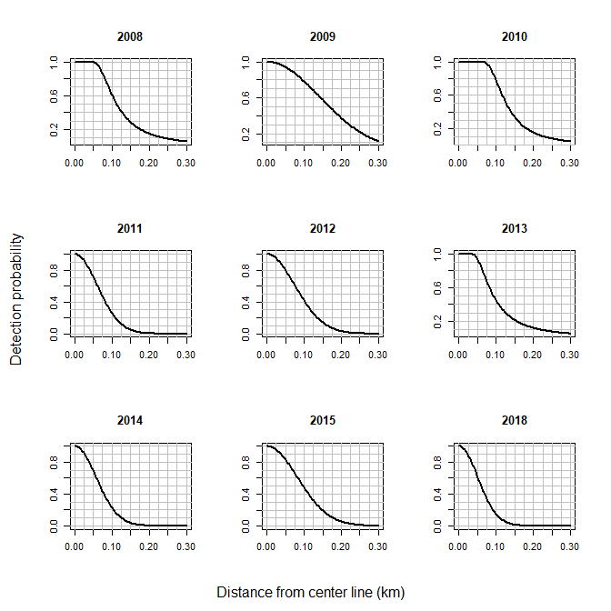
Figure S1. Detection functions from a hierarchical distance sampling model of Buff-breasted Sandpiper (Calidris subruficollis) density at four wintering locations in Brazil, 2008–2019. A hazard rate function was used in 2008, 2010, and 2013; a half-normal function was used in all other years.

