Habitat use of nesting female olive ridley turtles (Lepidochelys olivacea) inferred by stable isotopes in eggs

Pâmela Soares de Castro Echevenguá, Roberta Petitet*, Jaqueline C. Castilhos, Fábio Lira C. Oliveira, Leandro Bugoni
*Corresponding author: rpetitet@hotmail.com

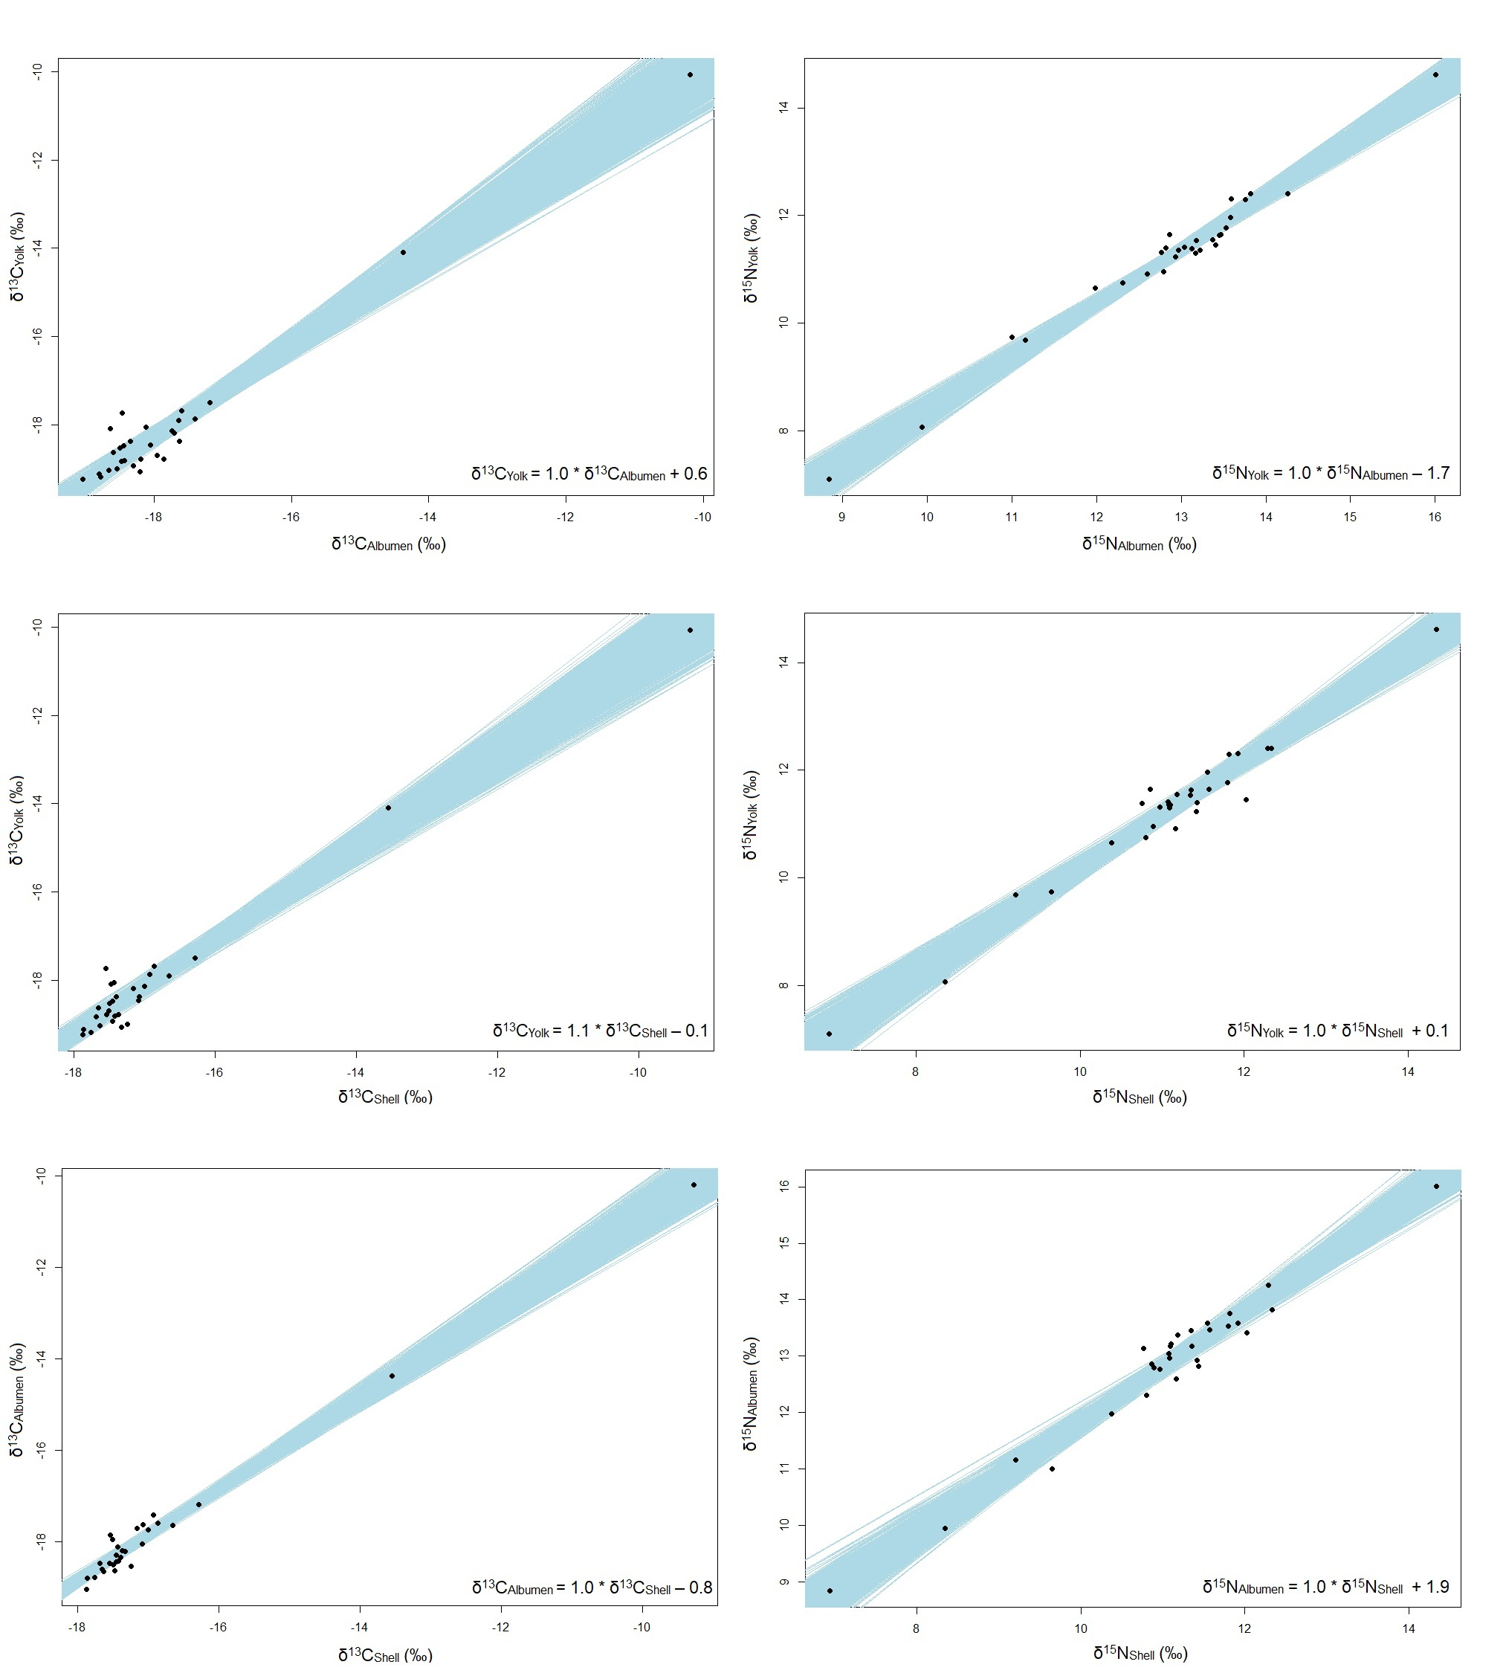

Fig. S1. Bayesian generalized linear model of carbon and nitrogen values, δ¹³C and δ¹⁵N, of components of fresh eggs of female olive ridley sea turtles (Lepidochelys olivacea) (n = 29) from northeastern Brazil. In the lower right corner are the equations of the relationship between each component.

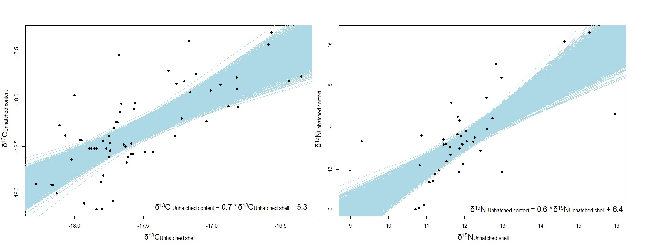
Fig. S2. Bayesian generalized linear model of the carbon and nitrogen values, δ¹³C and δ¹⁵N, of unhatched egg components of female olive ridley sea turtles (Lepidochelys olivacea) (n_{nest} = 25) from northeastern Brazil. The black dots are the data of unhatched eggs from known females (n_{nest} = 15) and unknown females (n_{nest} = 10). In the lower right corner are the equations of the relationship between each component.

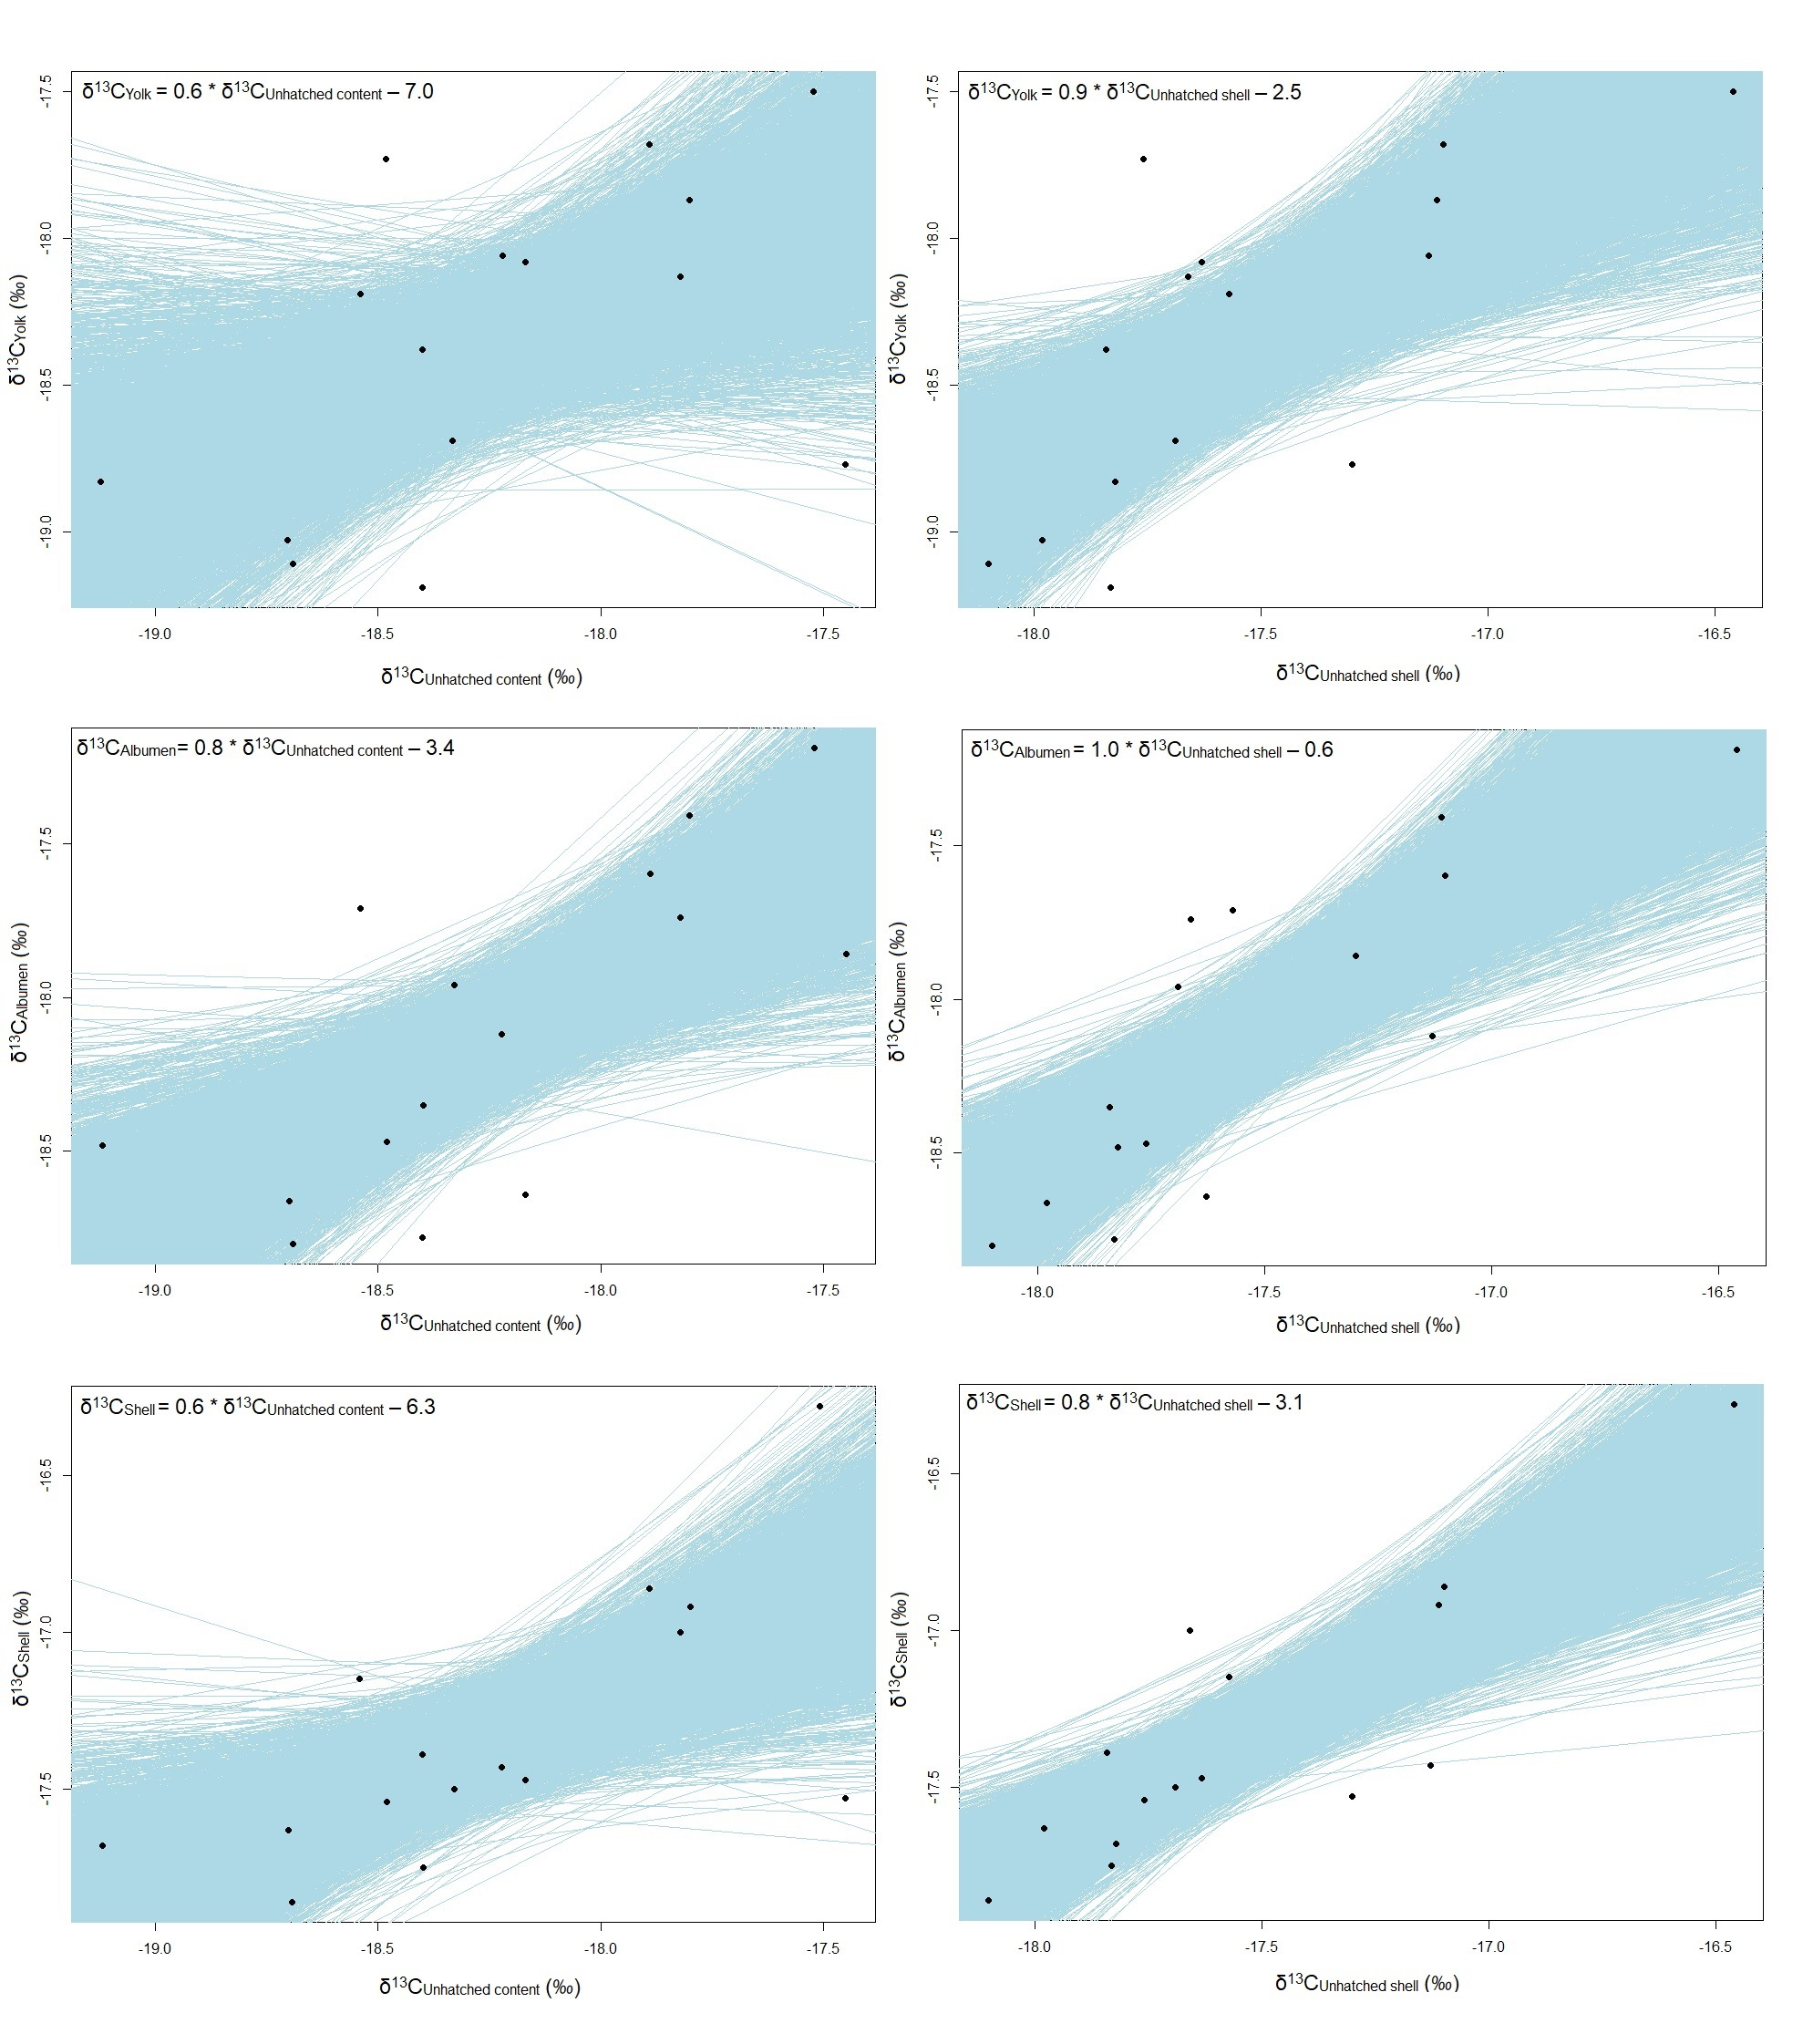
Fig. S3. Bayesian generalized linear model of the carbon (δ¹³C) values of fresh egg components and of unhatched egg components of female olive ridley sea turtles (Lepidochelys olivacea) (n = 15) from northeastern Brazil. In the upper left corner are the equations of the relationship between each component.
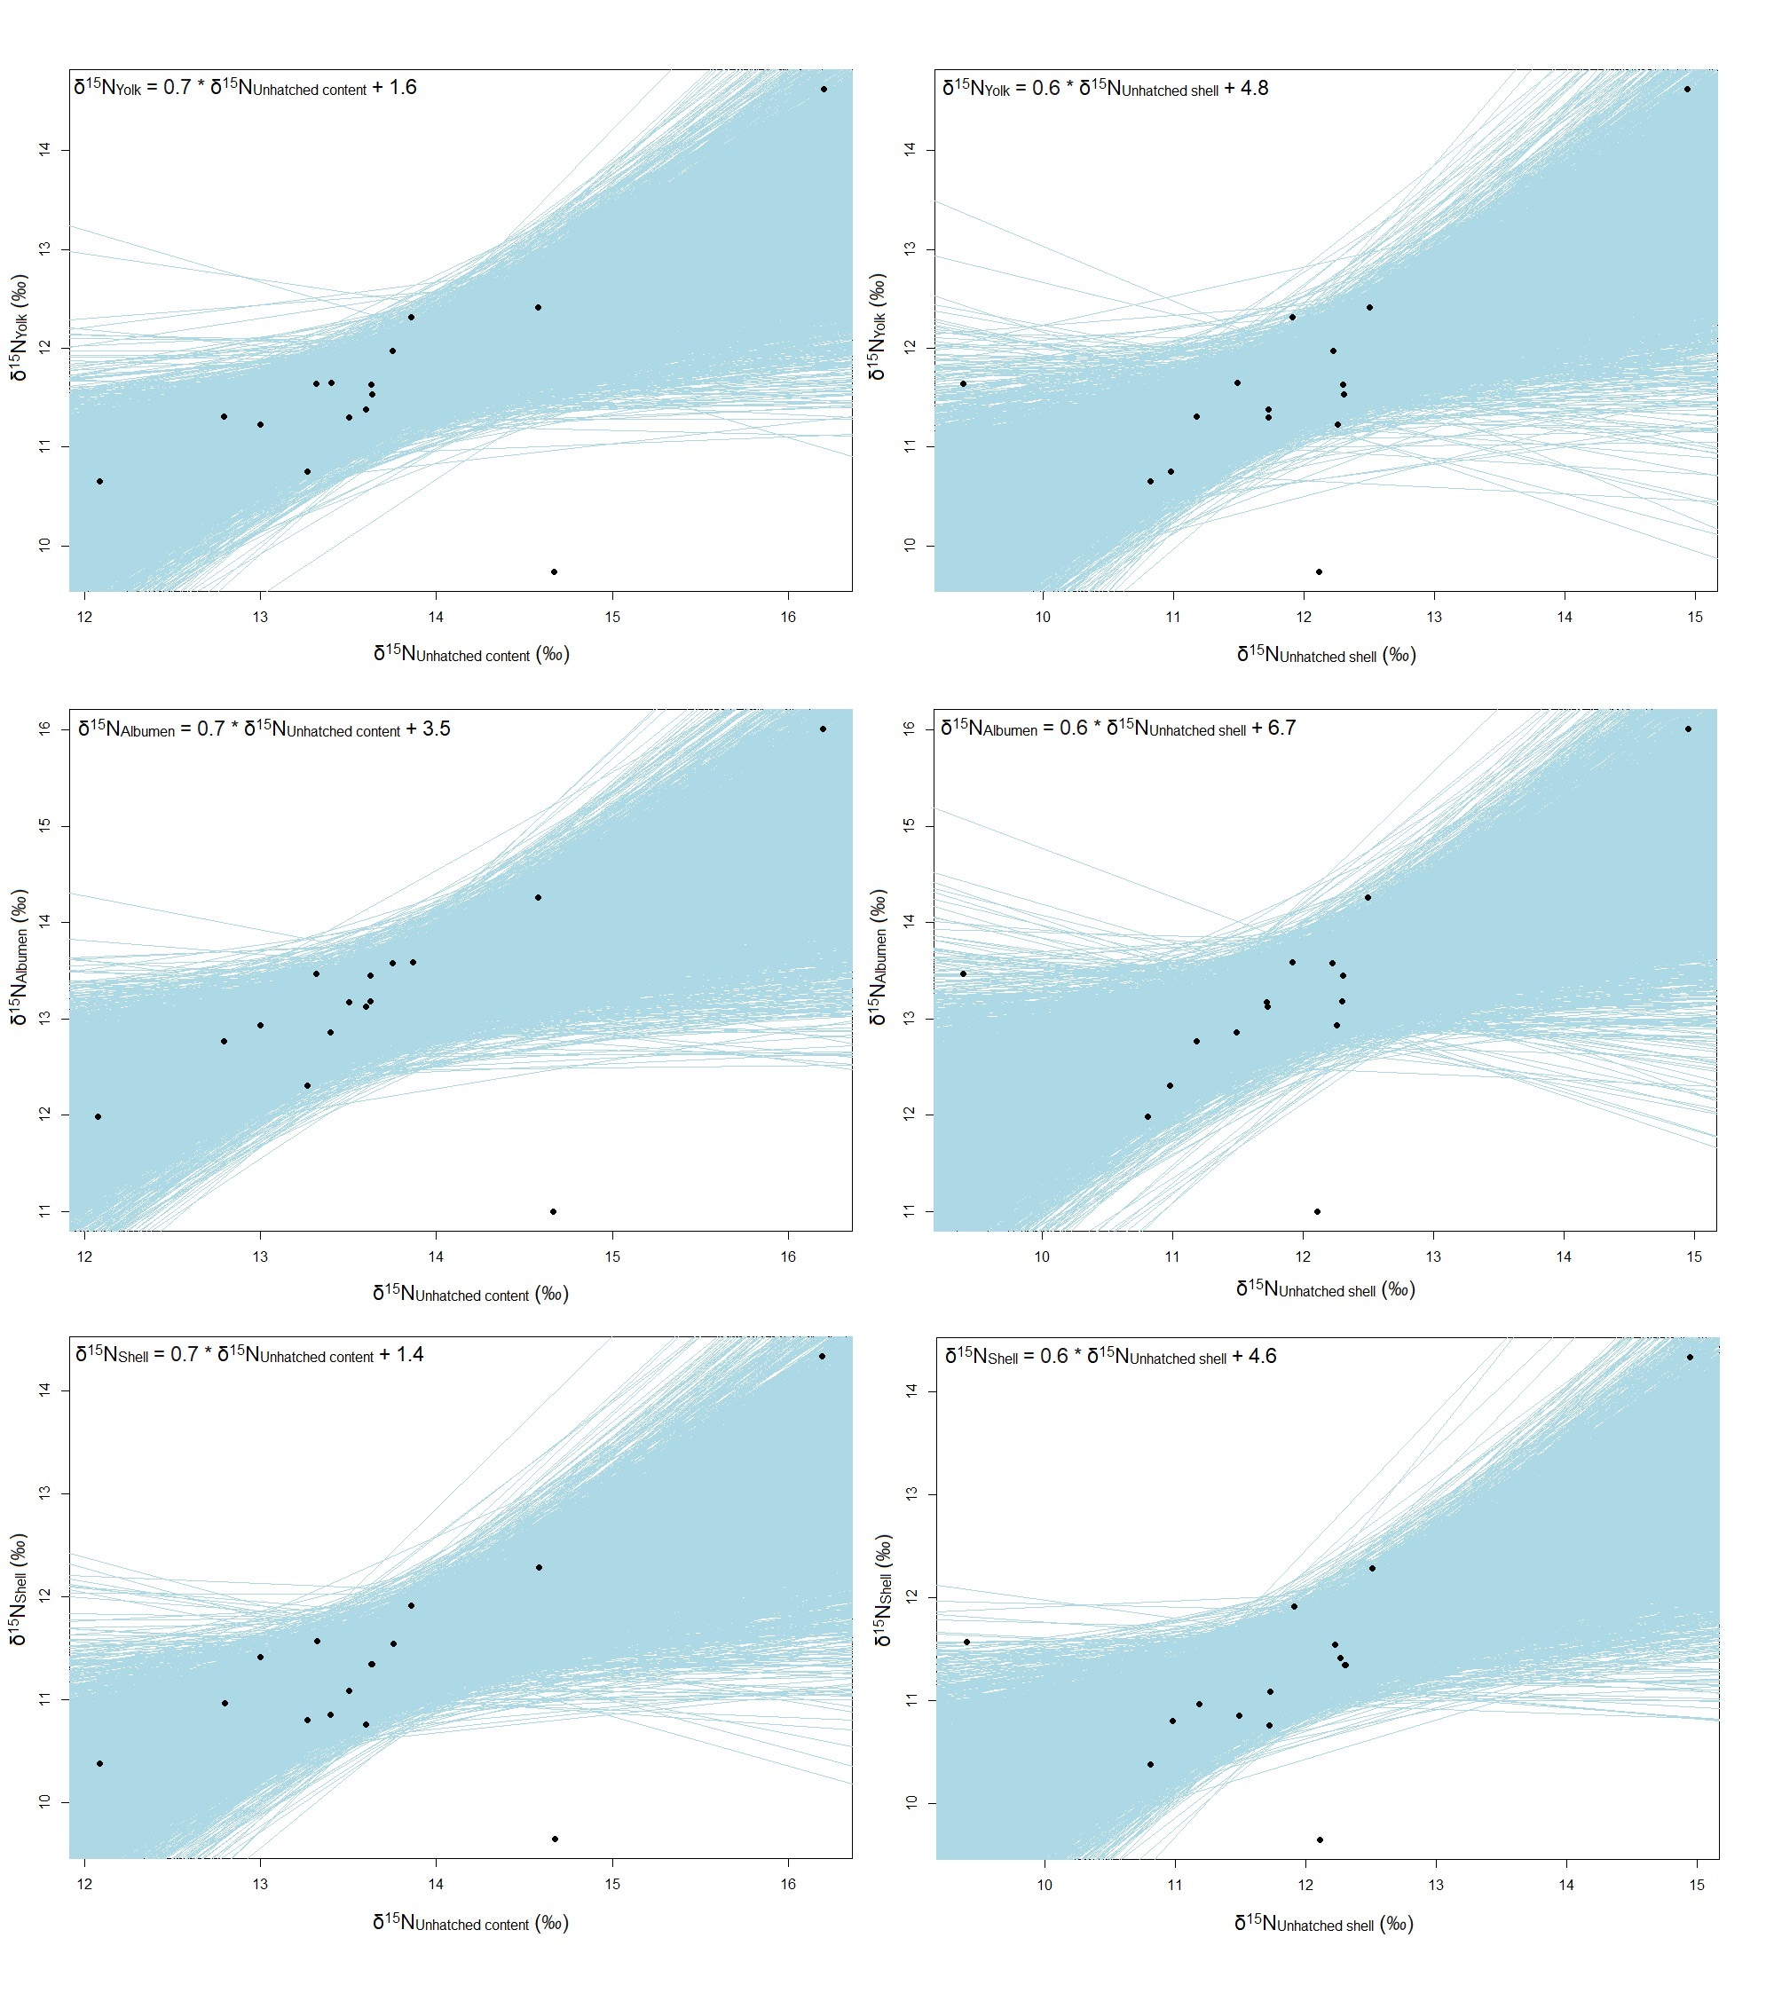
Fig. S4. Bayesian generalized linear model of the nitrogen (δ¹⁵N) values of fresh egg components and of unhatched egg components of female olive ridley sea turtles (Lepidochelys olivacea) (n = 15) from northeastern Brazil. In the upper left corner are the equations of the relationship between each component.

