**SUPPORTING INFORMATION**

**Role of environmental factors in the genetic structure of a highly mobile seabird**

**Vitória Muraro, Mariana Scain Mazzochi, Aline M.C.R. Fregonezi, Leandro Bugoni**

* 1. **Taxon sampling**

Band number of sampled individuals in the five colonies with the year of sampling, evidencing sex determination and the presence of stable isotope (SI) and morphometric data. M - Male, F - Female, ND - not defined.

|  |  |  |  |  |  |
| --- | --- | --- | --- | --- | --- |
| Band Number | Island/Archipelago | Year | Sex | SI | Morphometry |
| U39168 | Fernando de Noronha | 2011 | M | Yes | Yes |
| V21675 | Fernando de Noronha | 2011 | M | Yes | Yes |
| V21679 | Fernando de Noronha | 2011 | M | Yes | Yes |
| V21680 | Fernando de Noronha | 2011 | M | Yes | Yes |
| V21682 | Fernando de Noronha | 2011 | M | Yes | Yes |
| V21683 | Fernando de Noronha | 2011 | M | Yes | Yes |
| V21684 | Fernando de Noronha | 2011 | F | Yes | Yes |
| V21685 | Fernando de Noronha | 2011 | M | Yes | Yes |
| V21686 | Fernando de Noronha | 2011 | F | Yes | Yes |
| V21687 | Fernando de Noronha | 2011 | F | Yes | Yes |
| V21688 | Fernando de Noronha | 2011 | M | Yes | Yes |
| V21689 | Fernando de Noronha | 2011 | F | Yes | Yes |
| V21691 | Fernando de Noronha | 2011 | M | Yes | Yes |
| V21692 | Fernando de Noronha | 2011 | M | Yes | Yes |
| V21694 | Fernando de Noronha | 2011 | F | Yes | Yes |
| V21696 | Fernando de Noronha | 2011 | M | Yes | Yes |
| V21698 | Fernando de Noronha | 2011 | M | Yes | Yes |
| V21699 | Fernando de Noronha | 2011 | F | Yes | Yes |
| V21700 | Fernando de Noronha | 2011 | F | Yes | Yes |
| V29796 | Fernando de Noronha | 2011 | F | Yes | Yes |
| V40409 | Fernando de Noronha | 2011 | M | Yes | Yes |
| V40410 | Fernando de Noronha | 2011 | F | Yes | Yes |
| V21674 | Fernando de Noronha | 2011 | M | Yes | Yes |
| V21676 | Fernando de Noronha | 2011 | F | Yes | Yes |
| V21678 | Fernando de Noronha | 2011 | F | Yes | Yes |
| V21604 | Rocas Atoll | 2010 | F | Yes | Yes |
| V21605 | Rocas Atoll | 2010 | M | Yes | Yes |
| V21609 | Rocas Atoll | 2010 | M | Yes | Yes |
| V21611 | Rocas Atoll | 2010 | F | Yes | Yes |
| V21613 | Rocas Atoll | 2010 | M | Yes | Yes |
| V21615 | Rocas Atoll | 2010 | M | Yes | Yes |
| V21618 | Rocas Atoll | 2010 | M | Yes | Yes |
| V21619 | Rocas Atoll | 2010 | M | Yes | Yes |
| V21620 | Rocas Atoll | 2010 | M | Yes | Yes |
| V21621 | Rocas Atoll | 2010 | F | Yes | Yes |
| V21623 | Rocas Atoll | 2010 | F | Yes | Yes |
| V21624 | Rocas Atoll | 2010 | M | Yes | Yes |
| V21625 | Rocas Atoll | 2010 | M | Yes | Yes |
| V21631 | Rocas Atoll | 2010 | M | Yes | Yes |
| V21633 | Rocas Atoll | 2010 | M | Yes | Yes |
| V21637 | Rocas Atoll | 2010 | M | Yes | Yes |
| V21638 | Rocas Atoll | 2010 | F | Yes | Yes |
| V21639 | Rocas Atoll | 2010 | F | Yes | Yes |
| V21641 | Rocas Atoll | 2010 | M | Yes | Yes |
| V21642 | Rocas Atoll | 2010 | F | Yes | Yes |
| V21643 | Rocas Atoll | 2010 | F | Yes | Yes |
| V21644 | Rocas Atoll | 2010 | F | Yes | Yes |
| V21646 | Rocas Atoll | 2010 | F | Yes | Yes |
| V23275 | Rocas Atoll | 2010 | F | Yes | Yes |
| V21645 | Rocas Atoll | 2010 | M | Yes | Yes |
| U17609 | Abrolhos | 2011 | M | Yes | Yes |
| U19672 | Abrolhos | 2011 | F | Yes | Yes |
| U19682 | Abrolhos | 2011 | M | Yes | Yes |
| U19684 | Abrolhos | 2011 | M | Yes | Yes |
| U31240 | Abrolhos | 2011 | M | Yes | Yes |
| U36477 | Abrolhos | 2011 | F | Yes | Yes |
| V21650 | Abrolhos | 2011 | M | Yes | Yes |
| V21651 | Abrolhos | 2011 | M | Yes | Yes |
| V21652 | Abrolhos | 2011 | M | No | Yes |
| V21653 | Abrolhos | 2011 | F | Yes | Yes |
| V21654 | Abrolhos | 2011 | M | No | Yes |
| V21656 | Abrolhos | 2011 | F | Yes | Yes |
| V21657 | Abrolhos | 2011 | F | Yes | Yes |
| V21658 | Abrolhos | 2011 | F | Yes | Yes |
| V21659 | Abrolhos | 2011 | M | Yes | Yes |
| V21660 | Abrolhos | 2011 | M | Yes | Yes |
| V21661 | Abrolhos | 2011 | M | Yes | Yes |
| V21663 | Abrolhos | 2011 | F | Yes | Yes |
| V21664 | Abrolhos | 2011 | M | Yes | Yes |
| V21665 | Abrolhos | 2011 | M | Yes | Yes |
| V21666 | Abrolhos | 2011 | M | Yes | Yes |
| V21668 | Abrolhos | 2011 | F | Yes | Yes |
| V21669 | Abrolhos | 2011 | F | Yes | Yes |
| U31789 | Abrolhos | 2011 | ND | No | Yes |
| U38038 | Abrolhos | 2011 | ND | No | Yes |
| U19631 | Trindade | 2007 | F | Yes | No |
| U19632 | Trindade | 2007 | M | Yes | No |
| U38298 | Trindade | 2007 | F | Yes | No |
| U19629 | Trindade | 2007 | F | Yes | No |
| U19630 | Trindade | 2007 | F | Yes | No |
| U19627 | Trindade | 2007 | F | Yes | No |
| V40989 | Trindade | 2022 | ND | Yes | Yes |
| V40990 | Trindade | 2022 | M | Yes | Yes |
| V40991 | Trindade | 2022 | M | Yes | Yes |
| V40992 | Trindade | 2022 | ND | Yes | Yes |
| V40993 | Trindade | 2022 | ND | Yes | Yes |
| V40994 | Trindade | 2022 | ND | Yes | Yes |
| V40995 | Trindade | 2022 | ND | Yes | Yes |
| V40996 | Trindade | 2022 | ND | Yes | Yes |
| V40997 | Trindade | 2022 | ND | Yes | Yes |
| V40998 | Trindade | 2022 | ND | Yes | Yes |
| V40999 | Trindade | 2022 | ND | Yes | Yes |
| V41000 | Trindade | 2022 | ND | Yes | Yes |
| V41001 | Trindade | 2022 | ND | Yes | Yes |
| V41002 | Trindade | 2022 | ND | Yes | Yes |
| V41003 | Trindade | 2022 | ND | Yes | Yes |
| V41004 | Trindade | 2022 | ND | Yes | Yes |
| U57264 | Martin Vaz | 2022 | ND | Yes | Yes |
| U57269 | Martin Vaz | 2022 | ND | Yes | Yes |
| U57268 | Martin Vaz | 2022 | ND | Yes | Yes |
| U57254 | Martin Vaz | 2022 | ND | Yes | Yes |
| V26370 | Martin Vaz | 2022 | ND | Yes | Yes |
| V41082 | Martin Vaz | 2022 | ND | Yes | Yes |
| V40361 | Martin Vaz | 2022 | M | Yes | Yes |
| U57255 | Martin Vaz | 2022 | M | Yes | Yes |
| V40363 | Martin Vaz | 2022 | ND | Yes | Yes |
| U57256 | Martin Vaz | 2022 | ND | Yes | Yes |
| U57258 | Martin Vaz | 2022 | M | Yes | Yes |
| U57259 | Martin Vaz | 2022 | M | Yes | Yes |
| U57260 | Martin Vaz | 2022 | F | Yes | Yes |
| U57261 | Martin Vaz | 2022 | M | Yes | Yes |
| U57262 | Martin Vaz | 2022 | ND | Yes | Yes |
| U57263 | Martin Vaz | 2022 | F | Yes | Yes |
| U57265 | Martin Vaz | 2022 | F | Yes | Yes |
| U57266 | Martin Vaz | 2022 | M | Yes | Yes |
| U57267 | Martin Vaz | 2022 | M | Yes | Yes |
| U57270 | Martin Vaz | 2022 | M | Yes | Yes |
| V40984 | Martin Vaz | 2022 | F | Yes | Yes |
| V40985 | Martin Vaz | 2022 | ND | Yes | Yes |
| V40986 | Martin Vaz | 2022 | ND | Yes | Yes |
| V40987 | Martin Vaz | 2022 | F | Yes | Yes |
| V40988 | Martin Vaz | 2022 | F | Yes | Yes |

**1.2. PCR amplification, conditions, and sequencing**

To amplify the control region of masked booby, *Sula dactylatra*, SdMCR-L100B and SdMCR-H70 primers described by Steeves, Anderson, & Friesen (2005) were used, which are specific for this species. PCR reactions were performed with a final volume of 20 µl, containing 15 ng of DNA, 0.2 µM of forward and reverse primers, 0.1 mM of each dNTP, 1.5 mM of MgCl2, 1× buffer, and 0.5 units of Taq DNA Polymerase Platinum. The PCR program was established as follows: 95°C for 3 min, followed by 34 cycles of 95°C for 30 s, 59°C of annealing for 30 s, and 72°C for 1 min, with a final elongation of 72°C for 5 min. After that, a fragment of 442 base pairs was obtained.

For cytochrome *b*, B3 and B6 primers described by Patterson, Morris-Pocock, & Friesen (2010) for Sulidae were used. PCR reactions were performed with a final volume of 20 µl, containing 30 ng of DNA, 0.2 µM of forward and reverse primers, 0.2 mM of each dNTP, 2.5 mM of MgCl2, 1× buffer, and 1 unit of Taq DNA Polymerase Platinum. The touchdown PCR program was established as follows: 95°C for 3 min, followed by 10 cycles of 95°C for 30 s, 55–50.5°C annealing for 30 s (-0.5°C for each cycle), 72°C for 45 s; followed by 30 cycles of 95°C for 30 s, 50° annealing for 30 s, 72°C for 45 s with a final elongation of 72°C for 10 min. After that, a fragment of 772 base pairs was obtained.

PCR products were checked by electrophoresis in a 1% agarose gel with GelRed® dye. Sequences with well-defined bands were purified with ExoSAP-ITTM enzyme and sent for Sanger sequencing.

**1.3. MtDNA analysis**

In Arlequin 3.5.2.2 (Excoffier & Lischer, 2010), the analysis of molecular variance (AMOVA) was carried out with a 95% confidence interval after 1000 permutations. For the time-calibrated tree genealogy for mtDNA lineages, the yule-tree prior model was used with only one sequence representing each haplotype. All Bayesian analyses were performed assuming a strict molecular clock with a substitution rate of 1×10-8 ± 2.5×10-9 per site per year (s/s/y) (Garcia-Moreno, 2004). The HKY+I evolutionary sequence model was used, as determined by the corrected Akaike Information Criterion (AICc) in jModelTest2 (Darriba, Taboada, Doalla, & Posada, 2012). Two independent runs were performed with 100 million MCMC chains, sampling every 10,000 trees, and 10% burn-in. TRACER v 1.7.1 software (Rambaut, Drummond, Xie, Baele, & Suchard, 2018) was used to verify the convergence of MCMC chains and the appropriate effective sample sizes (ESS > 200), after excluding the first 10% of generations as burn-in.

**1.4. Genetic structure with UCEꞌs loci**

For the analysis of the best number of K with the sNMF command, α = 100 and 1000 repetitions were defined and a discriminant analysis of principal components via the ‘adegenet’ package (Jombart, 2008) was performed. Fifty-seven principal components were conserved in the analysis and the best number of K was defined with the Bayesian Information Criterion.

**1.5. Stable Isotope Analysis (SIA)**

For analysis in the Isotope-Ratio Mass Spectrometer (IRMS), blood samples were lyophilized and 0.7 mg weighed into tin capsules. SIA was performed at the IRMS of the Integrated Analysis Center of the Federal University of Rio Grande (CIA-FURG, BR) for 70 samples. The remaining samples (*n* = 48) had been previously prepared and processed at the Laboratory of Analytical Chemistry (LAC) at the University of Georgia (UoG, USA) by Mancini, Hobson, & Bugoni (2014). The result of the isotopic composition is expressed in delta notation (*δ*) in parts per thousand (‰) and reflects the difference between the isotopic value of the sample and the international standard of carbon (Vienna Pee Dee Belemnite) and nitrogen (atmospheric air) according to Bond & Hobson (2012), where R = 13C/12C or 15N/14N:

*δ*13C or *δ*15N (‰) = (Rsample/standard) – 1

A *t*-test showed a significant difference between values of *δ*13C or *δ*15N analyzed in the two labs (Student's paired *t*-test = -2.59 for *δ*13C and 4.46 for *δ*15N, *n* = 10, *p* < 0.05). For this reason, *δ*13C and *δ*15N values of the samples analyzed at CIA-FURG were transformed according to a linear regression equation for the LAC-UoG standard, making values comparable. We used SIBER: Stable Isotope Bayesian Ellipses in R (Jackson, Parnell, Inger, & Bearhop, 2011) to infer isotopic niches through Standard Ellipse Areas (SEA) and Standard Bayesian Ellipse Areas (SEAb).

**1.6.** **Obtaining environmental variables**

The monthly means of each environmental variable were extracted between 2000 to 2014 with 0.25 arc degrees of resolution with the ‘sdmpredictors’ package (Bosch & Fernandez, 2022) in an R environment (R Core Team, 2023). Raster files were cropped using the package raster (Hijmans, 2022), considering a maximum foraging range, represented by a circular area around each colony of 200 km (Roy, Delord, Nunes, Barbraud, Bugoni, & Lanco-Bertrand, 2021).

**1.7.** **Sexual size dimorphism**

Sexual dimorphism related to the morphometry of masked boobies has been previously documented (Sommerfeld, Kato, Ropert-Coudert, Garthe, & Hindell, 2013). To access the presence of such biometric distinction between individuals sampled in the current study, the MCMC method was used to obtain *a posteriori* distribution of biometric variables (mass, culmen, wing, tarsus) between males (*n* = 52) and females (*n* = 37) of the five colonies analyzed.

The MCMC was performed considering each sex separately with the ‘jagsUI’ package (Kellner, 2019) in R environment (R Core Team, 2023). Three chains with 12,000 iterations with burn-in 2000 were defined. *A priori* distributions chosen were vague, with tau ~ Gamma (0.01, 0.01) and μ ~ N*(mA, 10-6), so that mA represents the sampled mean of each of the variables morphometric for both sexes. The ‘HDInterval’ package (Meredith & Kruschke, 2020) was used to calculate the posterior distributions and intervals of 95% maximum density with High-Density Interval (HDI) (Meredith & Kruschke, 2020). The Bayes Factor (Kinas & Andrade, 2010) was considered to compare the posterior distributions generated, and equal *a priori* chances were defined, corresponding to equal biometric measurements between females and males.

**REFERENCES**

Bond, A. L., & Hobson, K. A. (2012). Reporting stable-isotope ratios in ecology: recommended terminology, guidelines and best practices. *Waterbirds*, *35*, 324–331. https://doi.org/10.1675/063.035.0213

Bosch, S., & Fernandez, S. (2022). *sdmpredictors: species distribution modelling predictor datasets*. R package version 0.2.12.

Darriba, D., Taboada, G. L., Doallo, R., & Posada, D. (2012). jModelTest 2: more models, new heuristics and parallel computing. *Nature Methods*, *9*, 772. https://doi.org/10.1038/nmeth.2109

Excoffier, L., & Lischer, H. E. L. (2010). Arlequin suite ver 3.5: a new series of programs to perform population genetics analyses under Linux and Windows. *Molecular Ecology Resources*, *10*, 564–567. https://doi.org/10.1111/j.1755-0998.2010.02847.x

Garcia-Moreno, J. (2004). Is there a universal mtDNA clock for birds? *Journal of Avian Biology*, *38*, 465–468. https://doi.org/10.1111/j.0908-8857.2004.03316.x

Hijmans, R. J. (2022). *raster: Geographic Data Analysis and Modeling*. R package version 3.5–15.

Jackson, A. L., Parnell, A. C., Inger, R., & Bearhop, S. (2011). Comparing isotopic niche widths among and within communities: SIBER - Stable Isotope Bayesian Ellipses in R. *Journal of Animal Ecology*, *80*, 595–602. https://doi.org/10.1111/j.1365-2656.2011.01806.x

Jombart, T. (2008). adegenet: a R package for the multivariate analysis of genetic markers. *Bioinformatics*, *24*, 1403–1405. https://doi.org/10.1093/bioinformatics/btn129

Kellner, K. (2019). *jagsUI: A Wrapper Around 'rjags' to Streamline 'JAGS' Analyses*. R package version 1.5.1.

Kinas, P. G., & Andrade, H. A. (2010). *Introdução à Análise Bayesiana* (com R). Porto Alegre, Consultor Editor.

Mancini, P.L., Hobson, K.A., & Bugoni, L. (2014). Role of body size in shaping the trophic structure of tropical seabird communities. *Marine Ecology Progress Series*, *497*, 243–257. https://doi.org/10.3354/meps10589

Meredith, M., & Kruschke, J. (2020). *HDInterval: Highest (Posterior) Density Intervals*. R package version 0.2.2.

Patterson, S. A., Morris-Pocock, J. A., & Friesen V. L. (2010). A multilocus phylogeny of the Sulidae (Aves: Pelecaniformes). *Molecular Phylogenetics and Evolution*, *58*, 181–191. https://doi.org/10.1016/j.ympev.2010.11.021

R Core Team. (2023). *R: a Language and Environment for Statistical Computing*. R Foundation for Statistical Computing.

Rambaut, A., Drummond, A. J., Xie, D., Baele, G., & Suchard, M. A. (2018). Posterior summarization in Bayesian phylogenetics using Tracer 1.7. *Systematic Biology*, *67*, 901–904. https://doi.org/10.1093/sysbio/syy032

Roy, A., Delord, K., Nunes, G. T., Barbraud, C., Bugoni, L., & Lanco-Bertrand, S. (2021). Did the animal move? A cross-wavelet approach to geolocation data reveals year- round whereabouts of a resident seabird. *Marine Biology*, *168*, 114. https://doi.org/10.21203/rs.3.rs-118834/v1

Sommerfeld, J., Kato, A., Ropert-Coudert, Y., Garthe, S., & Hindell, M. A. (2013). The individual counts: within sex differences in foraging strategies are as important as sex-specific differences in masked boobies *Sula dactylatra*. *Journal of Avian Biology*, *44*, 531–540. https://doi.org/10.1111/j.1600-048X.2013.00135.x

Steeves, T. E., Anderson, D. J., & Friesen, V. L. (2005). The Isthmus of Panama: a major physical barrier to gene flow in a highly mobile pantropical seabird. *Journal of Evolutionary Biology*, *18*, 1000–1008. https://doi.org/10.1111/j.1420-9101.2005.00906.x

**SUPPORTING INFORMATION**

**TABLES**

**TABLE S1** Diversity values and indexes for each one of the five populations of masked booby, *Sula dactylatra*, from the southwestern Atlantic Ocean (*n* = 59) estimated from two concatenated mtDNA regions (1214 pb): control region and cytochrome *b*. Diversity values are presented by mean ± standard deviation. Tajimaꞌs *D* and Fuꞌs *Fs* indexes represent the test values and their respective *p*-values are between brackets. Rocas - Rocas Atoll; Abrolhos - Abrolhos Archipelago; Noronha - Fernando de Noronha Archipelago; Martin Vaz - Martin Vaz Island; Trindade - Trindade Island.

|  |  |  |  |  |  |  |
| --- | --- | --- | --- | --- | --- | --- |
| Population | Haplotype number | Haplotype diversity | Nucleotide diversity | Watterson's Theta  (Theta S) | Tajima's *D* | Fu's *F*s |
| Metapopulation (*n* = 59) | 22 | 0.9 ± 0.02 | 0.004 ± 0.002 | 6.24 ± 1.99 | -0.13 (0.52) | -4.25 (0.09) |
| Rocas (*n* = 13) | 9 | 0.93 ± 0.05 | 0.003 ± 0.002 | 5.8 ± 2.51 | -0.69 (0.24) | -1.86 (0.16) |
| Abrolhos (*n* = 12) | 6 | 0.84 ± 0.07 | 0.002 ± 0.001 | 3.97 ± 1.85 | -1.34 (0.08) | -0.56 (0.35) |
| Noronha (*n* = 11) | 7 | 0.87 ± 0.08 | 0.004 ± 0.002 | 5.8 ± 2.61 | -0.41 (0.36) | -0.21 (0.45) |
| Martin Vaz (*n* = 10) | 3 | 0.6 ± 0.13 | 0.003 ± 0.002 | 4.24 ± 2.03 | 0.02 (0.53) | 4.27 (0.97) |
| Trindade (*n* =13) | 5 | 0.76 ± 0.09 | 0.003 ± 0.002 | 4.51 ± 2.02 | 0.16 (0.6) | 2.25 (0.86) |

**TABLE S2** Genetic indexes of 1748 SNPs belonging to UCEs loci of the five populations of masked booby, *Sula dactylatra*, from the southwestern Atlantic Ocean (*n* = 57). *F*IS - inbreeding coefficient; Ho = observed heterozygosity; He = expected heterozygosity; Bartlett's K-squared and respective *p*-values for homogeneity of variances between the values of expected and observed heterozygosity. Values statistically significant are marked with *, considering *p* < 0.05. Rocas - Rocas Atoll (*n* = 11); Abrolhos - Abrolhos Archipelago (*n* = 11); Noronha - Fernando de Noronha Archipelago (*n* = 11); Martin Vaz - Martin Vaz Island (*n* = 12); Trindade - Trindade Island (*n* = 12).

|  |  |  |  |  |
| --- | --- | --- | --- | --- |
|  | *F*IS | Ho | He | Bartlett's K-squared |
| Metapopulation | 0.50 | 0.089 | 0.179 | 367.71 (2.2×10-16)* |
| Rocas | 0.51 | 0.084 | 0.181 | 178 (2.2×10-16)* |
| Abrolhos | 0.52 | 0.083 | 0.177 | 153.39 (2.2×10-16)* |
| Noronha | 0.48 | 0.099 | 0.181 | 132.67 (2.2×10-16)* |
| Martin Vaz | 0.50 | 0.084 | 0.169 | 117.54 (2.2×10-16)* |
| Trindade | 0.47 | 0.097 | 0.186 | 129.25 (2.2×10-16)* |

**TABLE S3** Median migration rates between the five populations of the masked booby, *Sula dactylatra*,in the southwestern Atlantic Ocean estimated with BayesAss-SNPs, from UCEs data (*n* = 57). Values between brackets represent 95% highest density intervals. Columns are the origin populations of migrants and rows are the destination ones. Rocas - Rocas Atoll (*n* = 11); Abrolhos - Abrolhos Archipelago (*n* = 11); Noronha - Fernando de Noronha Archipelago (*n* = 11); Martin Vaz - Martin Vaz Island (*n* = 12); Trindade - Trindade Island (*n* = 12).

|  |  |  |  |  |  |
| --- | --- | --- | --- | --- | --- |
|  | Abrolhos | Rocas | Noronha | Martin Vaz | Trindade |
| Abrolhos | 0.83  (0.75 – 0.91) | 0.083  (0.01 – 0.25) | 0.02  (1.7×10-7 – 0.06) | 0.04  (0.01 – 0.09) | 0.02  (1.34×10-7 – 0.05) |
| Rocas | 0.02  (5.50×10-8 – 0.06) | 0.75  (0.68 – 0.81) | 0.1  (0.03 – 0.17) | 0.1  (0.03 – 0.17) | 0.02  (5.50×10-7 – 0.06) |
| Noronha | 0.02  (1.81×10-8 – 0.06) | 0.06  (0.01 – 0.12) | 0.81  (0.74 – 0.90) | 0.07  (0.01 – 0.14) | 0.02  (2.38×10-7 – 0.06) |
| Martin Vaz | 0.019  (1.31×10-8 – 0.05) | 0.07  (0.01 – 0.14) | 0.01  (1.19×10-8 – 0.05) | 0.86  (0.78 – 0.93) | 0.01  (1.10×10-8 – 0.05) |
| Trindade | 0.01  (1.37×10-7 – 0.05) | 0.07  (0.01 – 0.14) | 0.01  (7.65×10-8 – 0.05) | 0.19  (0.12 – 0.27) | 0.68  (0.66 – 0.72) |

**TABLE S4** Hotelling's T2 test for biometrical measures between four populations of masked booby, *Sula dactylatra*, in the southwestern Atlantic Ocean (*n* = 87). Due to the lack of biometrical information on individuals from Trindade, this island was excluded from the analysis. The matrix shows malesꞌ results (*n* = 50) below the main diagonal and femalesꞌ above (*n* = 37). *P*-values are presented between brackets and, when they were too low (*p* < 0.001), we were not able to estimate them. Values with statistically significant correlations are marked with * (*p* < 0.05). Rocas - Rocas Atoll (males, *n* = 14; females, *n* = 11); Abrolhos - Abrolhos Archipelago (males, *n* = 14; females, *n* = 9); Noronha - Fernando de Noronha Archipelago (males, *n* = 14; females, *n* = 11); Martin Vaz - Martin Vaz Island (males, *n* = 8; females, *n* = 6).

|  |  |  |  |  |
| --- | --- | --- | --- | --- |
|  | Rocas | Abrolhos | Noronha | Martin Vaz |
| Rocas | - | 0.6* | 0.37 | 0.67* |
| Abrolhos | 0.62* | - | 0.67* | 0.83* |
| Noronha | 0.48* | 0.51* | - | 0.79* |
| Martin Vaz | 0.51* | 0.55* | 0.56* | - |

**FIGURES**

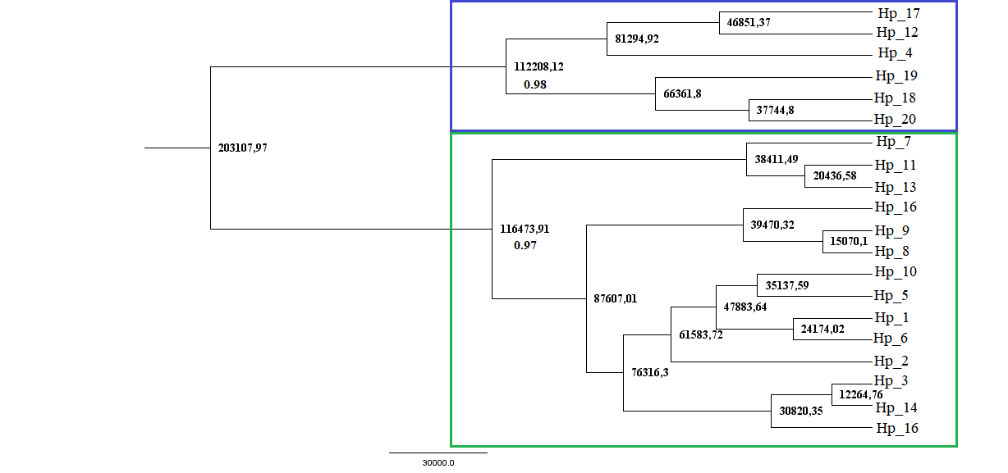

**FIGURE S1** Time-calibrated tree genealogy for mtDNA lineages of the five populations of masked booby, *Sula dactylatra*, from the southwestern Atlantic Ocean (*n* = 59) estimated from haplotypes of two concatenated mtDNA regions (1214 bp): control region and cytochrome *b*. Support values ​​above 0.8 are shown on the chart, and the year of divergence is present in each node. Different colors indicate the two principal clades: green for the most coastal haplotypes and blue for the most oceanic ones. The scale bar represents the years.

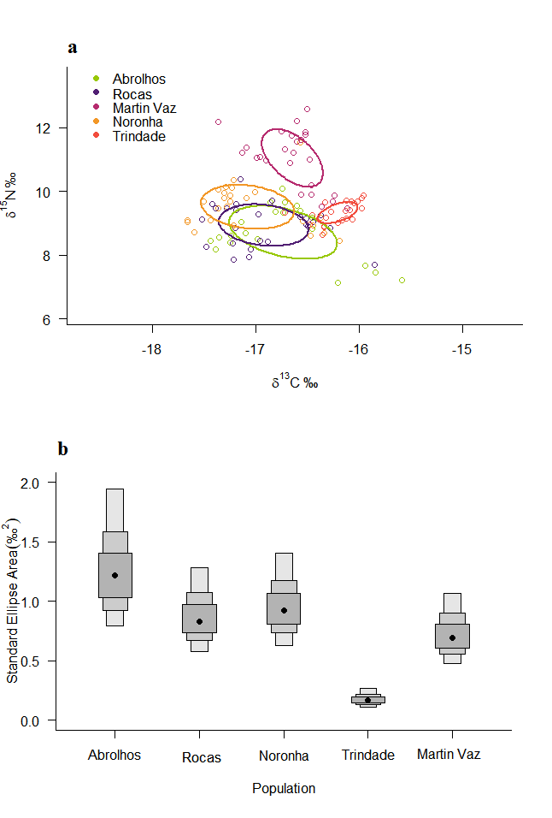

**FIGURE S2** a) Estimates of isotopic niche breadth (*δ*13C and *δ*15N) of the masked booby, *Sula dactylatra*, in the five colonies in the southwestern Atlantic Ocean (*n* = 118), represented by Standard Ellipses Area – SEA with 40% confidence intervals; b) - Posterior Bayesian estimates of isotopic niche represented by Standard Bayesian Ellipses Area - SEAb. Modes for the posterior distribution of each population are represented by black circles, while the boxes represent different confidence intervals (50%, 75%, and 95%). Rocas - Rocas Atoll (*n* = 25); Abrolhos - Abrolhos Archipelago (*n* = 21); Noronha - Fernando de Noronha Archipelago (*n* = 25); Martin Vaz - Martin Vaz Island (*n* = 25); Trindade - Trindade Island (*n* = 22).

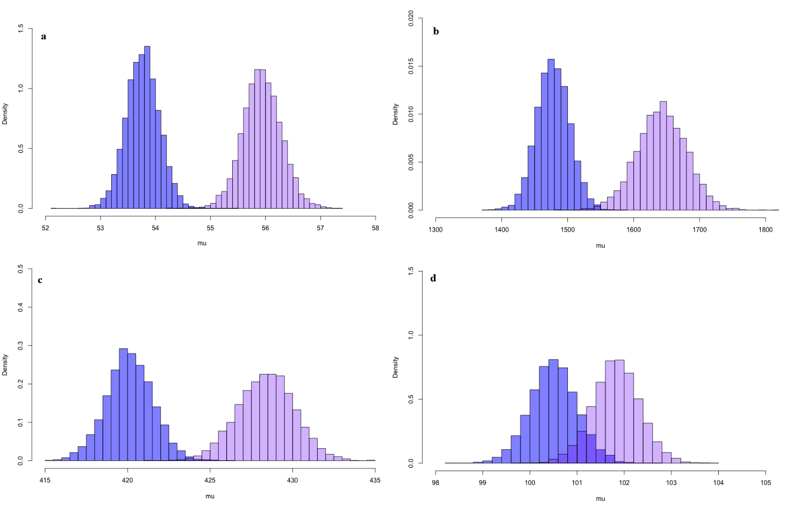

**FIGURE S3** Distributions *a posteriori* of mean biometric measures of females and males (*μ*) of masked boobies, *Sula dactylatra*, metapopulation in its four colonies in the southwestern Atlantic Ocean: Rocas Atoll (males, *n* = 14; females, *n* = 11), Abrolhos Archipelago (males, *n* = 14; females, *n* = 9), Fernando de Noronha Archipelago (males, *n* = 14; females, *n* = 11), Martin Vaz Island (males, *n* = 8; females, *n* = 6). Due to the lack of biometrical information on individuals from Trindade, this island was excluded from the analysis. Data were simulated by Monte Carlo via Markov Chains (MCMC). Blue and light purple histograms represent, respectively, males and females. a) tarsus length (mm); b) mass (g); c) wing length (mm); and d) culmen length (mm).