**SUPPLEMENTARY RESULTS**

**Resource partitioning influences levels of toxic trace elements in sympatric tropical seabirds**

**Bruno de Andrade Linhares, Guilherme Tavares Nunes, Adalto Bianchini, Luísa Bertolini, Fiorella Vilela, Márcio Amorim Efe, Fábio Lameiro Rodrigues, Sophie Lanco, Yuri Dornelles Zebral, Patrícia Gomes Costa, Leandro Bugoni**

*Science of the Total Environment*, vol xx, article xxxx (2024).

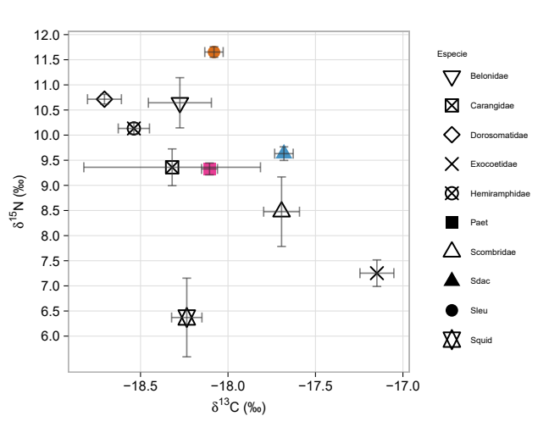

**Fig. S1.** Carbon and nitrogen isospace representing mean and standard deviations of raw isotope data for Red-billed tropicbirds *Phaethon aethereus* (Paet), Masked *Sula dactylatra* (Sdac) and Brown *Sula leucogaster* (Sleu) boobies and their prey in the Abrolhos Archipelago, southwestern Atlantic Ocean.

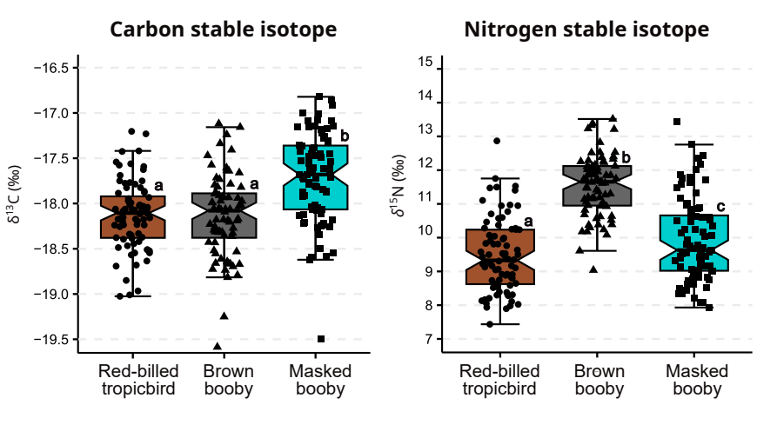

**Fig. S2.** Carbon (*δ*13C) and nitrogen (*δ*15N) isotopic values of Red-billed tropicbirds *Phaethon aetehreus*, Brown booby *Sula leucogaster* and Masked booby *Sula dactylatra* breeding in the Abrolhos Archipelago, southwestern Atlantic Ocean. Notch on boxplots represent the confidence interval of 95% around the median, and black symbols raw data points. Lowercase letters top-right on boxplots represent results (*p* < 0.05) of pairwise contrast analysis implemented for linear mixed models.

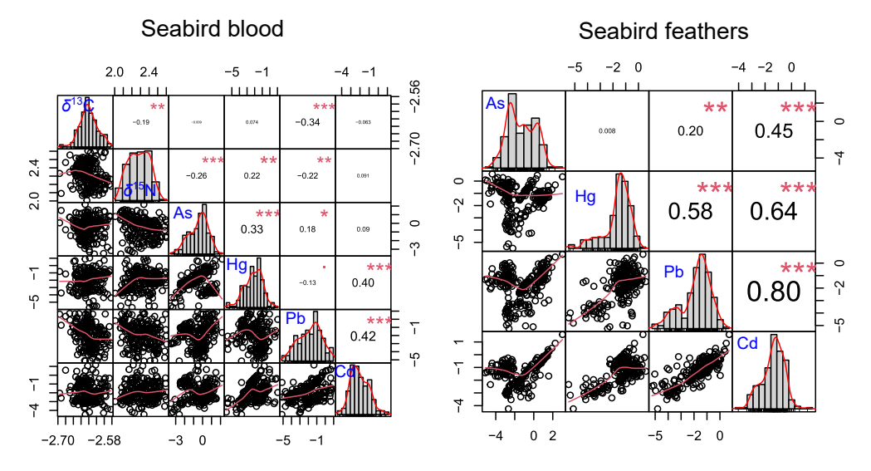**Fig. S3.** Pearson correlation matrix among transformed data of trace elements and stable isotopes in seabird blood and feather. Stable nitrogen isotopes and trace elements were log-transformed before the analysis, while stable carbon isotopes were cube root transformed. Values in the right represent the direction and strength of the correlation, and asterisks represent significance level of the correlation test (* *p* < 0.05; ** *p* < 0.01; *** *p* < 0.001).

**Table S1** Carbon and nitrogen stable isotopes (‰) and trace element concentration data (mg/kg dry mass) in seabird blood and feathers.

|  |  |  |  |  |  |  |
| --- | --- | --- | --- | --- | --- | --- |
| **Tissue/Element** | **Red-billed tropicbird** | | **Brown booby** | | **Masked booby** | |
| **Blood** | **Mean±SD** | **Min-max** | **Mean±SD** | **Min**–**max** | **Mean±SD** | **Min**–**max** |
| *δ*15N | 9.42±1.1 | 7.43–12.87 | 11.55±0.89 | 9.61–13.52 | 9.98±1.29 | 7.93–13.45 |
| *δ*13C | -18.14±0.38 | -19.03–17.2 | -18.17±0.46 | -19.59– -17.12 | -17.72±0.5 | -19.5– -16.82 |
| As | 1.11±1.18 | 0.03–4.86 | 0.88±1.15 | 0.07–8.91 | 1.29±1.14 | 0.04–4.58 |
| Pb | 0.5±0.61 | 0.01–2.62 | 0.3±0.43 | 0.01–1.93 | 0.2±0.27 | 0.01–1.75 |
| Cd | 0.36±0.57 | 0.01–3.2 | 0.25±0.28 | 0.01–1.76 | 0.18±0.21 | 0.02–1.36 |
| Hg | 0.17±0.21 | 0–0.95 | 0.37±0.52 | 0–2.83 | 0.26±0.32 | 0–2.07 |
| **Feathers** | **-** | **-** | **-** | **-** | **-** | **-** |
| As | 1.38±2.85 | 0.05–20.48 | 0.83±1.01 | 0.01–4.53 | 0.7±1.1 | 0.01–4.82 |
| Pb | 0.33±0.37 | 0.01–2.04 | 0.24±0.25 | 0.01–1.4 | 0.32±0.26 | 0.01–0.98 |
| Cd | 0.47±0.66 | 0.03–4.87 | 0.36±0.26 | 0.04–1.48 | 0.36±0.23 | 0.01–1.25 |
| Hg | 0.29±0.25 | 0.01–1.6 | 0.42±0.3 | 0–1.33 | 0.47±0.35 | 0–1.78 |

**Table S2** Response variable, tissue, residual distribution, marginal and conditional R2 estimates from linear mixed models (LMM) and generalized LMM (GLMM) constructed for stable isotope values and element concentration in seabird blood and feather.

|  |  |  |  |  |
| --- | --- | --- | --- | --- |
| **Response variable** | **Tissue** | **Residual distribution** | **Marginal R2** | **Conditional R2** |
| *δ*13C | blood | Gaussian | 0.15 | 0.48 |
| *δ*15N | blood | Gaussian | 0.38 | 0.60 |
| log(Hg) | blood | Gaussian | 0.06 | 0.18 |
| As | blood | Gamma (inverse) | 0.02 | 0.40 |
| log(Cd) | blood | Gaussian | 0.02 | 0.33 |
| Pb | blood | Gamma (inverse) | 0.02 | 0.94 |
| Hg | feather | Gamma (inverse) | 0.04 | 0.88 |
| log(As) | feather | Gaussian | 0.04 | 0.80 |
| Cd | feather | Gamma (inverse) | 0.01 | 0.93 |
| Pb | feather | Gamma (inverse) | 0.01 | 0.98 |

**Table S3**

Dietary table informing prey-specific measures. Complementary to the Table 2 in the main text.

|  |  |  |  |  |  |  |  |  |  |  |  |  |
| --- | --- | --- | --- | --- | --- | --- | --- | --- | --- | --- | --- | --- |
| **Prey species** | **Masked booby (*n* = 31)** | | | | **Brown booby (*n* = 28)** | | | | **Red-billed tropicbird (*n* = 60)** | | | |
|  | **%FO** | **%PN** | **%PW** | **%PSIRI** | **%FO** | **%PN** | **%PW** | **%PSIRI** | **%FO** | **%PN** | **%PW** | **%PSIRI** |
| APOGONIDAE | - | - | - | - | - | - | - | - | 1.67 | 33.33 | 9.92 | 0.36 |
| *Apogon pseudomaculatus* | - | - | - | - | - | - | - | - | 2.56 | 50 | 16.18 | 0.85 |
| BELONIDAE | 22.58 | 34.52 | 23.87 | 6.6 | 18.52 | 84.43 | 87.18 | 15.89 | 11.67 | 69.05 | 60.4 | 7.55 |
| *Ablennes hians* | 3.57 | 100 | 100 | 3.57 | 16 | 82.81 | 85.65 | 13.48 | 5.13 | 100 | 100 | 5.13 |
| *Tylosurus acus* | 7.14 | 58.33 | 26.82 | 3.04 | - | - | - | - | - | - | - | - |
| CARANGIDAE | 3.23 | 16.67 | 37.59 | 0.88 | - | - | - | - | 3.33 | 100 | 100 | 3.33 |
| *Decapterus tabl* | - | - | - | - | - | - | - | - | 2.56 | 100 | 100 | 2.56 |
| *Decapterus* sp. | 3.57 | 33.33 | 64.44 | 1.75 | - | - | - | - | 2.56 | 100 | 100 | 2.56 |
| CEPHALOPODA | - | - | - | - | - | - | - | - | 10 | 57.64 | 27.12 | 4.24 |
| Lula | - | - | - | - | - | - | - | - | 15.38 | 57.64 | 29.18 | 6.68 |
| DOROSOMATIDAE | 19.35 | 67.04 | 46.43 | 10.98 | 25.93 | 69.87 | 74.64 | 18.74 | 13.33 | 82.44 | 87.02 | 11.3 |
| *Opisthonema oglinum* | 21.43 | 94.44 | 90.43 | 19.81 | 16 | 74.17 | 87.35 | 12.92 | - | - | - | - |
| *Sardinella brasiliensis* | - | - | - | - | 4 | 9.09 | 2.3 | 0.23 | 17.95 | 79.93 | 86.09 | 14.9 |
| EXOCOETIDAE | 61.29 | 78.46 | 87.6 | 50.89 | - | - | - | - | 28.33 | 68.38 | 77.36 | 20.64 |
| *Cheilopogon cyanopterus* | 17.86 | 76.67 | 85.96 | 14.52 | - | - | - | - | - | - | - | - |
| *Cheilopogon melanurus* | 39.29 | 84.85 | 86.96 | 33.75 | - | - | - | - | 7.69 | 54.17 | 81.43 | 5.22 |
| *Cheilopogon* sp. | 3.57 | 66.67 | 54.41 | 2.16 | - | - | - | - | 5.13 | 50 | 85.33 | 3.47 |
| *Exocoetus volitans* | - | - | - | - | - | - | - | - | 2.56 | 50 | 20.79 | 0.91 |
| *Hirundichtys affinis* | 3.57 | 33.33 | 63.05 | 1.72 | - | - | - | - | 2.56 | 100 | 100 | 2.56 |
| *Hirundichtys* sp. | - | - | - | - | - | - | - | - | 2.56 | 100 | 100 | 2.56 |
| HEMIRAMPHIDAE | 16.13 | 73.06 | 56.48 | 10.45 | 74.07 | 85.27 | 84.76 | 62.97 | 35,00 | 89.63 | 91.51 | 31.7 |
| *Euleptorhamphus velox* | 3.57 | 100 | 100 | 3.57 | - | - | - | - | 2.56 | 75,00 | 89.56 | 2.11 |
| *Hemiramphus balao* | - | - | - | - | 32 | 77.27 | 82.16 | 25.51 | 38.46 | 90.48 | 92.05 | 35.1 |
| *Hemiramphus brasiliensis* | - | - | - | - | 36 | 65.15 | 62.05 | 22.9 | 2.56 | 100 | 100 | 2.56 |
| *Hemiramphus* sp. | 3.57 | 8.33 | 11.02 | 0.35 | 24 | 61.96 | 67.68 | 15.56 | 7.69 | 100 | 100 | 7.69 |
| *Hyporhramphus unifasciatus* | - | - | - | - | 4 | 16.67 | 4.09 | 0.42 | - | - | - | - |
| *Hyporhamphus* sp. | 7.14 | 79.17 | 62.27 | 5.05 | 12 | 62.22 | 44.98 | 6.43 | - | - | - | - |
| PRISTIGASTERIDAE | - | - | - | - | 3.7 | 83.33 | 46.36 | 2.4 | - | - | - | - |
| *Pellona harroweri* | - | - | - | - | 4 | 83.33 | 44.91 | 2.56 | - | - | - | - |
| SCOMBRIDAE | 22.58 | 83.33 | 95.69 | 20.12 | - | - | - | - | 28.33 | 72.55 | 74.8 | 20.87 |
| *Euthynnus alletteratus* | 7.14 | 100 | 100 | 7.14 | - | - | - | - | 5.13 | 100 | 100 | 5.13 |
| *Katsuwonus pelamis* | 3.57 | 100 | 100 | 3.57 | - | - | - | - | - | - | - | - |

**Table S4** Morphometric measurements for prey taxa obtained from regurgitates of the masked booby (*Sula dactylatra*).

|  |  |  |  |  |
| --- | --- | --- | --- | --- |
| **Prey species** | **Masked booby** | | | |
| **TL (mm)** | **Fork-length (mm)** | **CPD (mm)** | **Anal-caudal distance (mm)** |
| APOGONIDAE | - | - | - | - |
| *Apogon pseudomaculatus* | *-* | - | - | - |
| BELONIDAE | - | - | 6.04±1.73 (*n*=7) | 93.12±17.77 (*n*=5) |
| *Ablennes hians* | 347.00 | 338.56±78.02* (*n*=7) | 6.03±1.10 (*n*=12) | 101.40±30.29 (*n*=7) |
| *Tylosurus acus* | 347.79±59.05* (*n*=3) | - | 7.63±0.98 (*n*=3) | 107.47±18.25 (*n*=3) |
| CARANGIDAE | - | - | - | - |
| *Decapterus tabl* | *-* | - | - | - |
| *Decapterus* sp. | 260.5 | 235.1 | - | 9.6 |
| CEPHALOPODA | - | - | - | - |
| Squid | - | - | - | - |
| DOROSOMATIDAE | - | - | - | - |
| *Opisthonema oglinum* | 195.80±23.35 (*n*=8) | 158.70±22.75 (*n*=3) | 13.62±1.19 (*n*=11) | 79.30±8.93 (*n*=8) |
| *Sardinella brasiliensis* | *-* | - | - | - |
| EXOCOETIDAE | - | - | 12.78±3.95 (*n*=8) | 113.67±24.25 (*n*=3) |
| *Cheilopogon cyanopterus* | 349.90±18.64 (*n*=5) | 313.9 | 19.31±3.83 (*n*=5) | 133.60±5.75 (*n*=5) |
| *Cheilopogon melanurus* | 291.82±39.29 (*n*=11) | 223.65±46.32 (*n*=2) | 14.91±1.60 (*n*=11) | 111.06±13.66 (*n*=11) |
| *Cheilopogon* sp. | - | - | 11.90±0.39 (*n*=2) | 88.65±0.88 (*n*=2) |
| *Exocoetus volitans* | *-* | - | - | - |
| *Hirundichtys affinis* | 252.5 | 193.4 | 18.00 | 121.3 |
| *Hirundichtys* sp. | *-* | - | - | - |
| HEMIRAMPHIDAE | - | - | 11.90±0.39 (*n*=2) | 88.65±0.88 (*n*=2) |
| *Euleptorhamphus velox* | 339.5 | 318.8 | 6.4 | 97.8 |
| *Hemiramphus balao* | *-* | - | - | - |
| *Hemiramphus brasiliensis* | *-* | - | - | - |
| *Hemiramphus* sp. | - | - | 12.3 | 80.7 |
| *Hyporhramphus unifasciatus* | *-* | - | - | - |
| *Hyporhamphus* sp. | - | - | 4.96±1.71 (*n*=13) | 48.09±28.71 (*n*=7) |
| PRISTIGASTERIDAE | - | - | - | - |
| *Pellona harroweri* | *-* | - | - | - |
| SCOMBRIDAE | - | - | 9.22±4.43 (*n*=5) | 12.1 |
| *Euthynnus alletteratus* | 318.93±5.70 (*n*=2) | 297.37±5.32 (*n*=2) | 7.65±0.35 (*n*=2) | 126.40±2.26 (*n*=2) |
| *Katsuwonus pelamis* | 334.4 | - | 7.6 | 125.4 |

* morphometric data estimated from FishBase.

**Table S5** Morphometric measurements for prey taxa obtained from regurgitates of the brown booby (*Sula leucogaster*).

|  |  |  |  |  |
| --- | --- | --- | --- | --- |
| **Prey species** | **Brown booby** | | | |
| **TL (mm)** | **Fork-length (mm)** | **CPD (mm)** | **Anal-caudal distance (mm)** |
| APOGONIDAE | - | - | - | - |
| *Apogon pseudomaculatus* | - | - | - | - |
| BELONIDAE | - | - | 4.53±0.67 (*n*=4) | 99,20 |
| *Ablennes hians* | 350.04±80.58 (*n*=7) | 338.56±78.02 (*n*=7) | 6.03±1.10 (*n*=12) | 101.40±30.29 (*n*=7) |
| *Tylosurus acus* | - | - | - | - |
| CARANGIDAE | 4.70 | 36.50 | 3.60 | 24.50 |
| *Decapterus tabl* | - | - | - | - |
| *Decapterus* sp. | - | - | - | - |
| CEPHALOPODA | - | - | - | - |
| Squid | - | - | - | - |
| DOROSOMATIDAE | 37.24±2.34 (*n*=5) | 34.08±1.44 (*n*=4) | 6.66±3.63 (*n*=11) | - |
| *Opisthonema oglinum* | 195.70±26.19 (*n*=9) | 155.19±18.40 (*n*=4) | 13.58±1.26 (*n*=10) | 80.97±10.05 (*n*=7) |
| *Sardinella brasiliensis* | - | - | - | - |
| EXOCOETIDAE | - | - | - | - |
| *Cheilopogon cyanopterus* | - | - | - | - |
| *Cheilopogon melanurus* | - | - | - | - |
| *Cheilopogon* sp. | - | - | - | - |
| *Exocoetus volitans* | - | - | - | - |
| *Hirundichtys affinis* | - | - | - | - |
| *Hirundichtys* sp. | - | - | - | - |
| HEMIRAMPHIDAE | - | - | 4.90 | 42.40 |
| *Euleptorhamphus velox* | - | - | - | - |
| *Hemiramphus balao* | 240.43±57.93 (*n*=23) | 212.65±46.93 (*n*=6) | 8.05±2.32 (*n*=25) | 60.23±14.70 (*n*=24) |
| *Hemiramphus brasiliensis* | 246.33±32.58 (*n*=26) | 197.09±34.42 (*n*=7) | 8.87±1.44 (*n*=27) | 62.82±6.92 (*n*=25) |
| *Hemiramphus* sp. | 178.00 | 159.00 | 7.64±1.53 (*n*=13) | 63.39±12.18 (*n*=7) |
| *Hyporhramphus unifasciatus* | 164.00 | - | 5.90 | 42.80 |
| *Hyporhamphus* sp. | 141.72±40.41 (*n*=10) | 141.63±23.85 (*n*=3) | 5.72±0.62 (*n*=9) | 44.90±5.13 (*n*=6) |
| PRISTIGASTERIDAE | - | - | - | - |
| *Pellona harroweri* | - | - | - | - |
| SCOMBRIDAE | - | - | - | - |
| *Euthynnus alletteratus* | - | - | - | - |
| *Katsuwonus pelamis* | - | - | - | - |

**Table S6** Morphometric measurements for prey taxa obtained from regurgitates of the red-billed tropicbird (*Phaethon aethereus*).

|  |  |  |  |  |
| --- | --- | --- | --- | --- |
| **Prey species** | **Red-billed tropicbird** | | | |
| **TL (mm)** | **Fork-length (mm)** | **CPD (mm)** | **Anal-caudal distance (mm)** |
| APOGONIDAE | - | - | - | - |
| *Apogon pseudomaculatus* | 110.00 | 93.2 | 9.1 | 50.3 |
| BELONIDAE | - | - | 8.60±1.61 (*n*=3) | - |
| *Ablennes hians* | - | - | 6.8 | - |
| *Tylosurus acus* | - | - | - | - |
| CARANGIDAE | - | - | - | - |
| *Decapterus tabl* | - | - | - | - |
| *Decapterus* sp. | - | - | - | - |
| CEPHALOPODA | - | - | - | - |
| Squid | 160.8 | - | - | - |
| DOROSOMATIDAE | - | - | 14,00 | 78.2 |
| *Opisthonema oglinum* | - | - | - | - |
| *Sardinella brasiliensis* | 176.38 | - | 14.1 | 70.6 |
| EXOCOETIDAE | - | - | 9.63±2.75 (*n*=9) | 68.36±23.78 (*n*=5) |
| *Cheilopogon cyanopterus* | - | - | - | - |
| *Cheilopogon melanurus* | 234.74±+9.22 (*n*=4) | 195.35±1.06 (*n*=2) | 11.73±1.35 (*n*=6) | 83.23±7.85 (*n*=6) |
| *Cheilopogon* sp. | - | - | 12.4 | 82.00 |
| *Exocoetus volitans* | - | - | - | - |
| *Hirundichtys affinis* | - | - | - | - |
| *Hirundichtys* sp. | - | - | 12.6 | 95.5 |
| HEMIRAMPHIDAE | - | - | 26.50±35.00 (*n*=4) | 66.03±5.54 (*n*=4) |
| *Euleptorhamphus velox* | 357.45±44.90 (*n*=2) | 304.6 | 8.33±0.31 (*n*=3) | 112.75±1.48 (*n*=2) |
| *Hemiramphus balao* | 322.50 | - | 13.4 | 76.1 |
| *Hemiramphus brasiliensis* | - | - | 8.5 | 68.6 |
| *Hemiramphus* sp. | - | - | 9,00 | 36.40±44.83 (n=2) |
| *Hyporhramphus unifasciatus* | - | - | - | - |
| *Hyporhamphus* sp. | - | - | - | - |
| PRISTIGASTERIDAE | - | - | - | - |
| *Pellona harroweri* | - | - | - | - |
| SCOMBRIDAE | - | - | 5.72±1.57 (*n*=11) | 67.84±22.71 (*n*=5) |
| *Euthynnus alletteratus* | - | - | - | - |
| *Katsuwonus pelamis* | - | - | - | - |