Supplementary material 1. Antigens of the genus Leptospira sp. used in the microscopic agglutination test in Phaethon aethereus, Sula leucogaster, S. dactylatra, Pterodroma arminjoniana, and Thalassarche chlororhynchos sampled in southwestern Atlantic Ocean. Antigens are listed according to species, serogroup, serovar and strain
Species | Serogroup | Serovar | Strain
Leptospira interrogans | Australis | Australis | Ballico
 | Autumnalis | Autumnalis | Akyiami
 | Bataviae | Bataviae | Van Tienem
 | Australis | Bratislava | Jez Bratislava
 | Canicola | Canicola | Hond Utrecht IV
 | Icterohaemorrhagiae | Copenhageni | M-20
 | Icterohaemorrhagiae | Icterohaemorrhagiae | RGA
 | Sejroe | Hardjoprajitno | Hardjoprajitno
 | Hebdomadis | Hebdomadis | Hebdomadis
 | Pomona | Pomona | Pomona
 | Pyrogenes | Pyrogenes | Salinem
 | Djasiman | Sentot | Sentot
L. borgpetersenii | Ballum | Castellonis | Castellon -3
 | Sejroe | Hardjobovis | Sponselee
 | Javanica | Javanica | VeldradtBataviae - 46
 | Tarassovi | Tarassovi | Perepelitsin
 | Celledoni | Whitcombi | Whitcombi
L. kirschneri | Cynopteri | Cynopteri | 3522C
 | Grippotyphosa | Grippotyphosa | Moskva-V
 | Autumnalis | Butembo | Butembo
L. santarosai | Sejroe | Guaricura | BOV- 6
 | Shermani | Shermani | 1342-K
L. noguchi | Panama | Panama | CZ -214

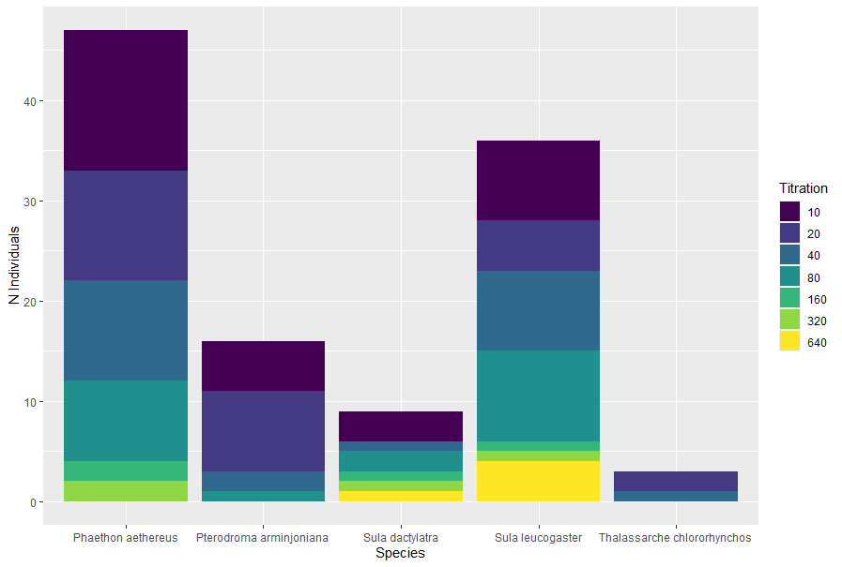
Supplementary material 2. Number of individuals of Phaethon aethereus, Sula leucogaster, Sula dactylatra, Pterodroma arminjoniana, and Thalassarche chlororhynchos sampled in southwestern Atlantic Ocean, according to species and anti-Toxoplasma gondii antibody titration using Modified Agglutination Test (MAT), Cut-off = 1:5

