APPENDICES – All Appendix legends are provided below. Tables from S1-S4 and S6-S9 are provided on a separate excel sheet and figures from S5, S10, & S11 and provided with their respective legends below.

Appendix S1 – Scores (Avg – All Reviews)
Average threat vulnerability scores as provided by the experts consulted using all expert reviews, indicating the IUCN Red List extinction risk status and population trend of the species based on the most recent International Union of Conservation Network (IUCN) global species assessment (www.iucnredlist.org; accessed Apr 2023). Threats include climate change threats: ocean acidification (OA), oxygen minimum zones (OMZ), ultraviolet radiation (UV), sea level rise (SLR), and temperature extremes (TE); Coastal impact threats: agriculture runoff (AGRI), urban runoff (URB), aquaculture (AQUA), tourism (TOUR), direct human intrusions (DHI), and light pollution (LIGHT); Fishing threats: drifting longliners (DLONG), seiners (SEINE), trawlers (TRAWL), fixed gear (FIXED), trollers (TROLL), pole & line (POLE), and artisanal fisheries (ART); and maritime disturbance threats: shipping (SHIP), benthic oil rigs (OIL), noise pollution (NOIS), plastics & other solid waste (PLAS), and maritime pollution (MPOLL). '-' indicates a vulnerability score of 0, and 'NA' indicates we received no expert reviews for that species-threat combination. The color of the cell indicates the vulnerability level: red = high vulnerability, orange = medium vulnerability, yellow = low vulnerability, and no color = negligible vulnerability. 'N threats' indicates the total number of threats to which each species was rated as having at least low vulnerability.

Appendix S2 – Threats
Threat definitions given to expert reviewers and adapted from the International Union for Conservation of Nature (IUCN) Threats Classification Scheme v3.3 (iucnredlist.org/resources/threat-classification-scheme; Accessed Apr 2023). See footnotes for full dataset references.

Appendix S3 – Surveys
List of questions used in surveys sent to experts.

Appendix S4 – N (All reviews)
Number of expert reviews per species-threat combination for each timing (Tim), scope (Sco), and severity (Sev) score. Values highlighted in gray indicate we received fewer than three expert reviews for that variable, '-' indicates no reviews, and "Glob" is the number of expert reviews indicating the threat impacts of species on the global scale.

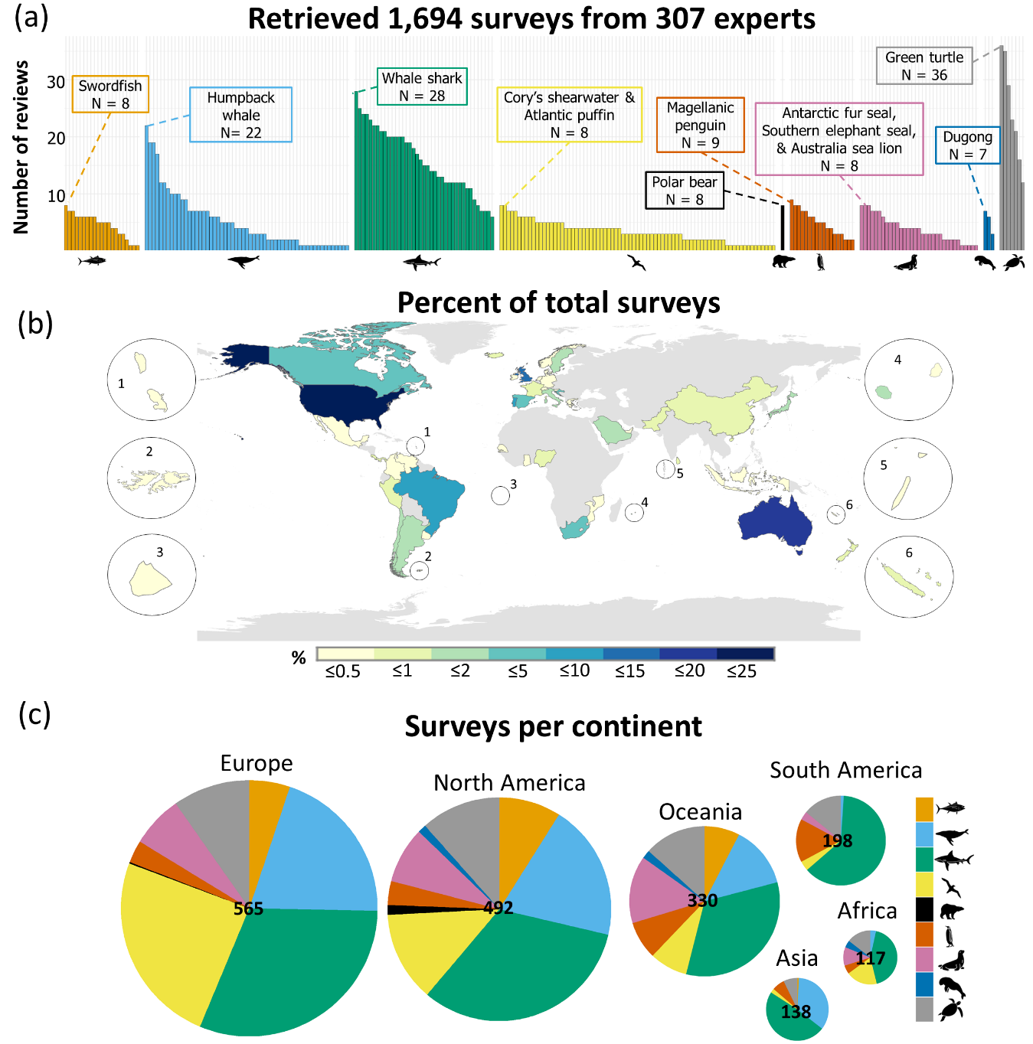

Appendix S5. Results from our expert elicitation surveys. Shown are the (a) number of surveys retrieved per species, and distribution of expertise by percent of total surveys received (b) per country and (c) per continent. The values within each pie chart shown in (c) indicate the total number of surveys per continent, and the colors represent the proportion of surveys per taxa group for each continent. Silhouettes represent bony fishes, cetaceans, elasmobranchs, flying birds, polar bear, penguins, pinnipeds, sirenians, and turtles.

Appendix S6 – Experts
Summary of expert demographics across all survey responses for all species and per taxa grouping. '*' indicates multiple options possible per expert, so values will not necessarily add up to the total number of surveys per grouping.

Appendix S7 – Scores (Avg – R≥3)
Average vulnerability scores as provided by the experts consulted for all species-threat combinations with at least three expert reviews and after removing minimum and maximum scores. '-' indicates a vulnerability score of 0, and 'NA' indicates we received no expert reviews for that species-threat combination. The color of the cell indicates the vulnerability level: red = high vulnerability, orange = medium, yellow = low, and no color = negligible. 'N threats' indicates the total number of threats to which each species was rated as having at least low vulnerability. See Appendix S1 for threat abbreviations.

Appendix S8 – Scores (CI – R≥3)
Vulnerability scores at 5 and 95% confidence intervals as provided by the experts consulted for all species-threat combinations with at least three expert reviews and after removing minimum and maximum scores. '-' indicates a vulnerability score of 0, and 'NA' indicates we received no expert reviews for that species-threat combination. The color of the cell indicates the vulnerability level: red = high vulnerability, orange = medium, yellow = low, and no color = negligible. See Appendix S1 for threat abbreviations.

Appendix S9 – Expert certainty
Average expert certainty score across timing, scope, and severity scores for all species threat combinations. See Appendix S1 for threat abbreviations.

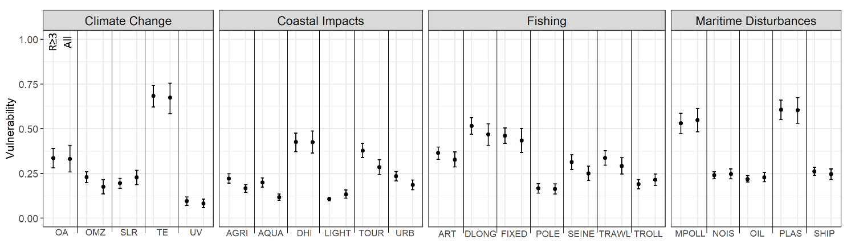

Appendix S10. Average vulnerability of species obtained for each threat showing the 5 and 95% confidence intervals. Two scenarios were considered for all data for any species-threat combination with at least: i) one expert review (All; Appendix S1), and ii) three expert reviews and removing the minimum and maximum timing, scope, and severity scores from each combination (R≥3; Appendix S8), showing patterns are similar across all datasets. See Appendix S1 for threat abbreviations. Threats include climate change threats: ocean acidification (OA), oxygen minimum zones (OMZ), ultraviolet radiation (UV), sea level rise (SLR), and temperature extremes (TE); Coastal impact threats: agriculture runoff (AGRI), urban runoff (URB), aquaculture (AQUA), tourism (TOUR), direct human intrusions (DHI), and light pollution (LIGHT); Fishing threats: drifting longliners (DLONG), seiners (SEINE), trawlers (TRAWL), fixed gear (FIXED), trollers (TROLL), pole & line (POLE), and artisanal fisheries (ART); and maritime disturbance threats: shipping (SHIP), benthic oil rigs (OIL), noise pollution (NOIS), plastics & other solid waste (PLAS), and maritime pollution (MPOLL).
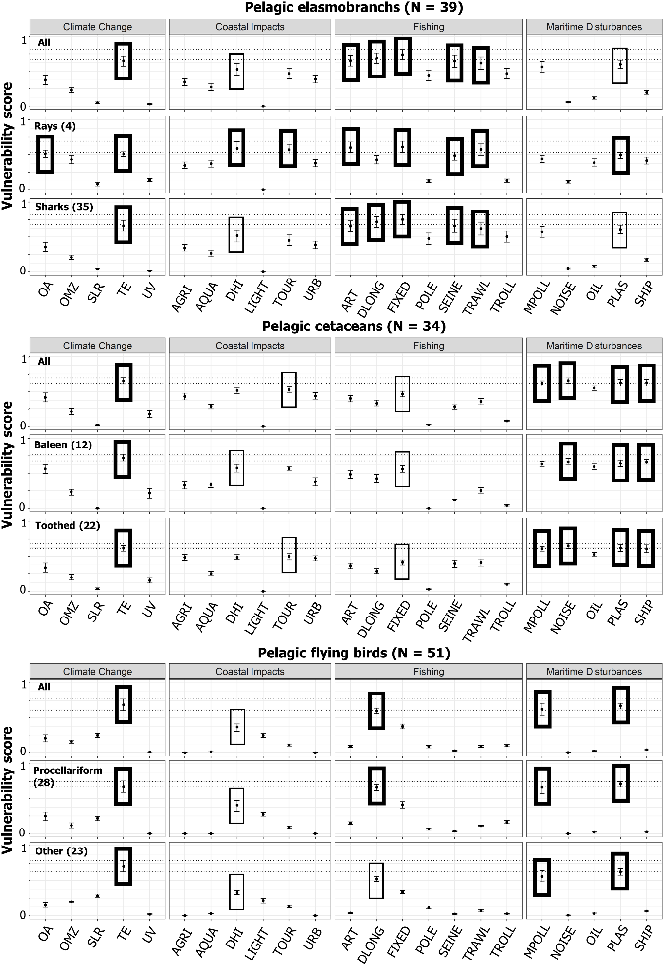

Appendix S11. Average vulnerability scores for pelagic cetaceans, elasmobranchs, and flying birds and their respective sub-taxa groupings for each threat considered in each category. Depicted are the averages per taxa (circles) with confidence intervals (shown as bars). The highest vulnerability scores are indicated with thick boxes indicating the threat(s) that result in the highest vulnerability for each taxon; and thin boxes indicate the threat resulted in the highest vulnerability score in each threat category for each taxon (where no threats from that category are among the highest for that taxa). Dotted lines represent the confidence intervals for the threat that had the highest average vulnerability score for that taxa. Threats include climate change threats: ocean acidification (OA), oxygen minimum zones (OMZ), ultraviolet radiation (UV), sea level rise (SLR), and temperature extremes (TE); Coastal impact threats: agriculture runoff (AGRI), urban runoff (URB), aquaculture (AQUA), tourism (TOUR), direct human intrusions (DHI), and light pollution (LIGHT); Fishing threats: drifting longliners (DLONG), seiners (SEINE), trawlers (TRAWL), fixed gear (FIXED), trollers (TROLL), pole & line (POLE), and artisanal fisheries (ART); and maritime disturbance threats: shipping (SHIP), benthic oil rigs (OIL), noise pollution (NOIS), plastics & other solid waste (PLAS), and maritime pollution (MPOLL).

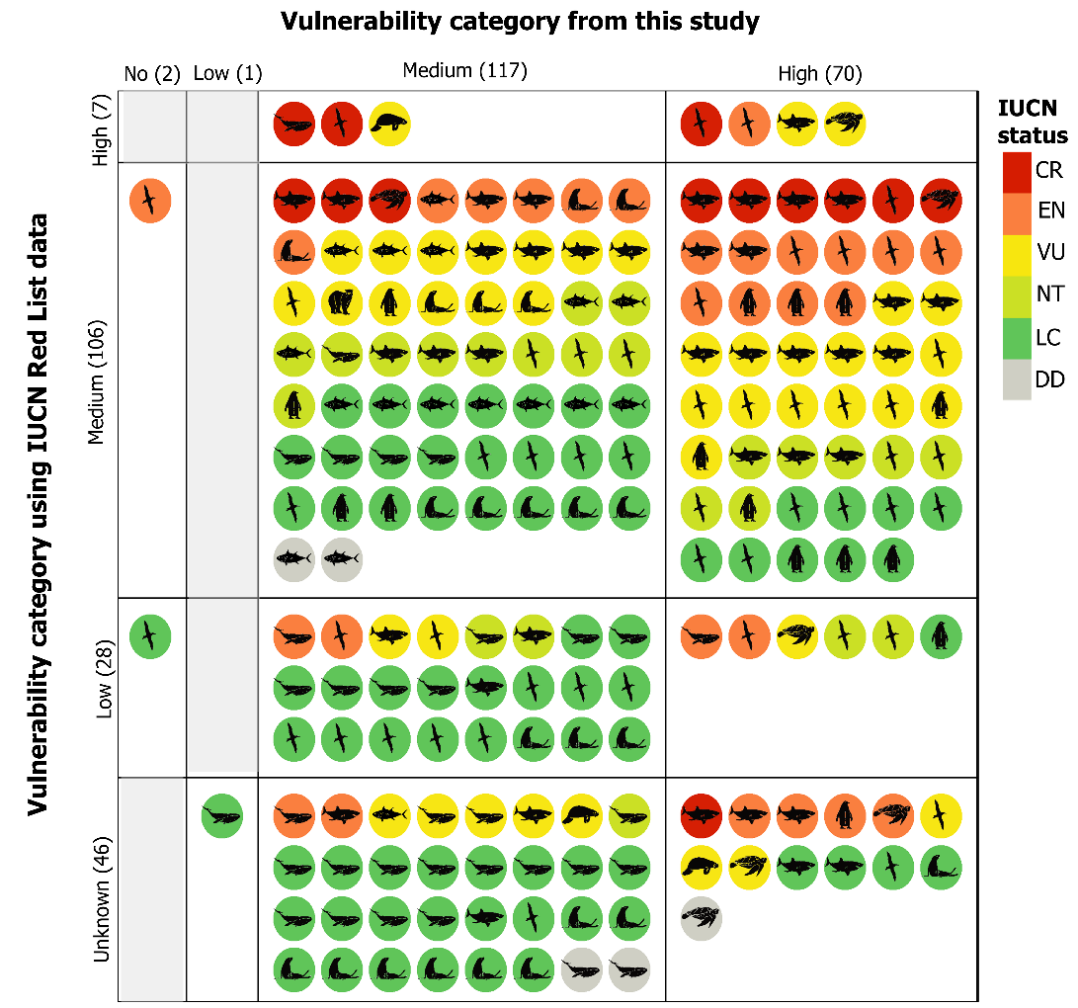

Appendix S12. Matrix of species ranked in high, medium, or low vulnerability categories to at least one threat. Vulnerability categories depicted on the x-axis are derived from the average vulnerability scores for the 23 threats calculated in the present study, while the y-axis depicts those using the most recent IUCN Red List species assessments for each species considering all threats rated by the IUCN Red List (The International Union for Conservation of Nature; iucnredlist.org; accessed Apr 2023). ‘Unknown’ indicates that no threat had timing, scope, and severity (i.e., the components of vulnerability category scores) rated for that species on the IUCN Red List assessment. Silhouettes represent bony fishes, cetaceans, elasmobranchs, flying birds, polar bear, penguins, pinnipeds, sirenians, and turtles. CR = Critically Endangered, EN = Endangered, VU = Vulnerable, NT = Near Threatened, LC = Least Concern, and DD = Data Deficient.

