SUPPLEMENTARY MATERIAL

Movement and diet of brown boobies in a remote protected area suggest temporal variations in foraging strategies

Fiorella Vilela^{1,3}*, Júlia Jacoby^{2,3}, Maicon Pegoraro^{2,3}, Felipe Campos Nery³, Sophie Lanco⁴, Leandro Bugoni⁵, Guilherme Tavares Nunes^{1,2,3}

¹ Programa de Pós-Graduação em Biologia Animal, Universidade Federal do Rio Grande do Sul (UFRGS), Porto Alegre, RS, Brazil
² Programa de Pós-Graduação em Ecologia, Universidade Federal do Rio Grande do Sul (UFRGS), Porto Alegre, RS, Brazil
³ Laboratório de Aves Costeiras e Marinhas, Centro de Estudos Costeiros, Limnológicos e Marinhos, Universidade Federal do Rio Grande do Sul (UFRGS), Imbé, RS, Brazil
⁴ Institut de Recherche pour le Développement (IRD), Marbec (Université De Montpellier, IFREMER, CNRS, IRD), Sète, France
⁵ Laboratório de Aves Aquáticas e Tartarugas Marinhas (LAATM), Universidade Federal do Rio Grande (FURG), Brazil
* Corresponding author: fiorella.vilelar@gmail.com
Table S1 Prey composition in regurgitated material from brown boobies (Sula leucogaster) in austral winter 2023 and austral summer 2024 in the Saint Peter and Saint Paul Archipelago, northeastern Brazil. Analyses were made by family (2023 = 40 regurgitates*, 2024 = 9) and by species (2023 = 38 regurgitates*, 2024 = 9). FO = numerical frequency of occurrence; %FO = frequency of occurrence; N = sample size; %PN = prey-specific abundance; %PM = prey-specific mass. NI = non-identified to species level.
Prey | Austral winter |  |  |  |  |  | Austral summer
Prey | FO | %FO | N | %PN | %PM |  | FO | %FO | N | %PN | %PM
Carangidae | 5 | 12.50 | 8 | 37 | 48.70 |  | - | - | - | - | -
Caranx crysos | 1 | 2.63 | 2 | 25 | 45.88 |  | - | - | - | - | -
Elegatis bipinnulata | 2 | 5.26 | 3 | 66.66 | 80.49 |  | - | - | - | - | -
Exocoetidae | 34 | 85 | 124 | 82.09 | 87.37 |  | 8 | 88.89 | 20 | 82.49 | 92.84
Cheilopogon melanurus | 1 | 2.63 | 1 | 100 | 100 |  | - | - | - | - | -
Cheilopogon cyanopterus | 2 | 5.26 | 3 | 66.66 | 82.01 |  | 2 | 22.22 | 2 | 100 | 100
Exocoetus volitans | 28 | 73.68 | 72 | 75.95 | 80.58 |  | 5 | 55.56 | 7 | 48.33 | 60.18
Prognichthys gibbifrons | 1 | 2.63 | 2 | 33.33 | 31.80 |  | - | - | - | - | -
Cheilopogon sp. | - | - | - | - | - |  | 3 | 33.33 | 3 | 58.33 | 71.75
Hemiramphidae | 18 | 45 | 43 | 50.21 | 39.17 |  | 4 | 44.44 | 7 | 47.47 | 36.33
Oxyporhamphus micropterus | 18 | 47.37 | 43 | 62.20 | 52.37 |  | 3 | 33.33 | 6 | 41.66 | 20.81
Euleptorhamphus velox | - | - | - | - | - |  | 1 | 11.11 | 1 | 100 | 100
Scombridae | 1 | 2.5 | 1 | 16.66 | 50.55 |  | - | - | - | - | -
Thunnus albacares | 1 | 2.63 | 1 | 20 | 59.97 |  | - | - | - | - | -
Ommastrephidae | 3 | 7.5 | 3 | 34.44 | 10.03 |  | 2 | 22.22 | 2 | 24.99 | 5.95
Squid NI | 3 | 7.89 | 3 | 36.11 | 12.79 |  | 2 | 22.22 | 2 | 29.17 | 10.69
Notes: *The number of regurgitates in the analyses at the family and species levels differ, due to the degree of decomposition of certain prey items hampering identification down to the species level.

Table S2 Foraging areas (km²) and confidence intervals (95% CI) estimated by AKDE at 50%, 75% and 95% of kernel utilization distribution (UD) of brown boobies by sex, season and year in the Saint Peter and Saint Paul Archipelago. CI – confidence interval
 | Foraging areas estimated by AKDE (km²)
 | 50% (UD) (CI range) | 75% (UD) (CI range) | 95% (UD) (CI range)
Female
2015 | 85.7 (49.8 – 131.3) | 168.1 (97.6 – 257.6) | 338.3 (196.4 – 518.2)
2023 | 475.8 (225.9 – 817.0) | 931.5 (442.4 – 1599.7) | 1938.7 (920.7 – 3329.4)
2024 | 78.7 (20.3 – 176.2) | 236.0 (60.7 – 528.1) | 616.1 (158.5 – 1378.3)
Male
2015 | 72.0 (38.0 – 116.6) | 154.1 (81.4 – 249.6) | 360.5 (190.4 – 584.0)
2023 | 197.0 (24.1 – 547.1) | 381.5 (46.8 – 1059.7) | 752.6 (92.2 – 2090.6)
2024 | 72.5 (23.2 – 149.4) | 176.3 (56.5 – 363.2) | 453.1 (145.1 – 933.4)
Austral winter
2014 | 83.8 (58.7 – 113.3) | 196.3 (137.5 – 265.6) | 453.3 (317.4 – 613.0)
2015 | 88.0 (57.4 – 125.1) | 176.5 (115.1 – 250.8) | 420.9 (274.5 – 598.2)
2023 | 276.4 (3.7 – 1104.5) | 548.6 (7.3 – 2192.4) | 1130.0 (15.1 – 4515.4)
Austral summer
2024 | 68.8 (20.8 – 145.0) | 201.7 (61.0 – 424.8) | 554.6 (167.9 – 1168.3)

Table S3. Time allocation across behavioral states by sex and season in brown boobies (Sula leucogaster) from the Saint Peter and Saint Paul Archipelago, tropical Atlantic Ocean. Values are mean ± standard deviation
Group | N trips | Traveling (%) | Foraging (%) | Searching (%)
Overall | 706 | 36.3 ± 18.8 | 12.3 ± 11.5 | 51.4 ± 17.6
By sex
Female | 372 | 36.7 ± 19.0 | 13.0 ± 11.8 | 50.2 ± 17.6
Male | 258 | 37.7 ± 18.5 | 11.3 ± 11.0 | 51.0 ± 17.6
By season
Winter 2023 | 252 | 48.1 ± 14.4 | 11.5 ± 10.1 | 40.3 ± 13.3
Summer 2024 | 240 | 29.7 ± 16.2 | 11.9 ± 9.5 | 58.4 ± 15.9

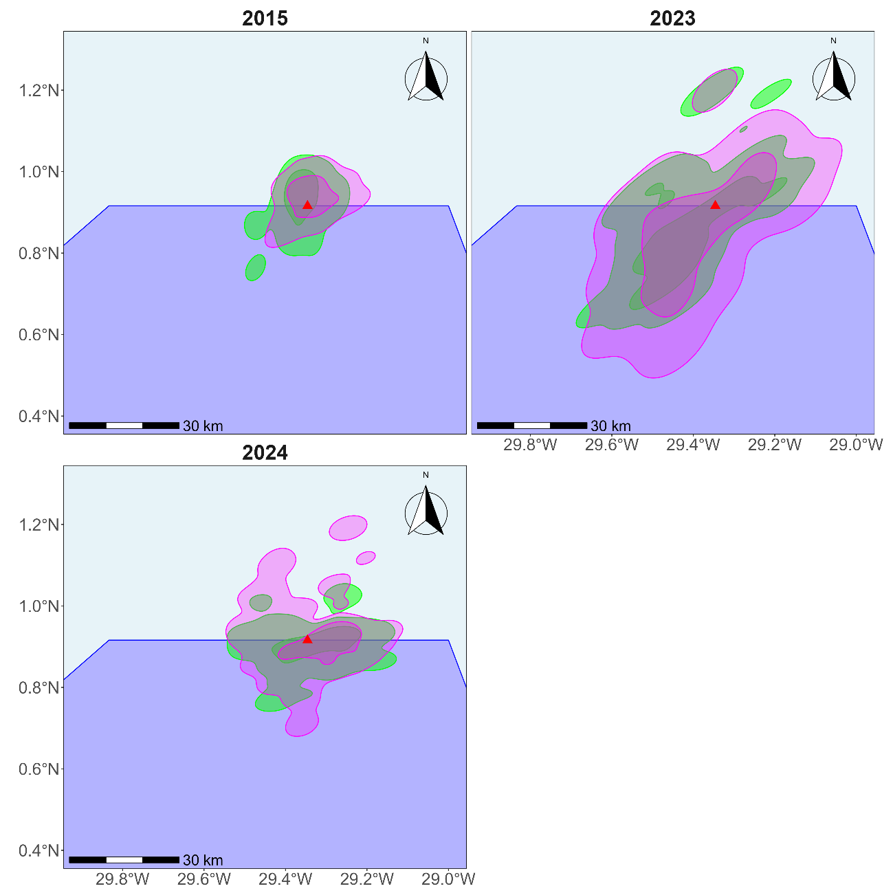Fig. S1 Foraging areas (95% and 50% kernel utilization distributions) of male (green) and female (pink) of brown boobies (Sula leucogaster) by year in the Saint Peter and Saint Paul Archipelago, tropical Atlantic Ocean. Red triangle indicates the colony location. Background colors represent protected areas: APA (Environmental Protection Area) in light blue and MONA (Natural Monument) in blue.
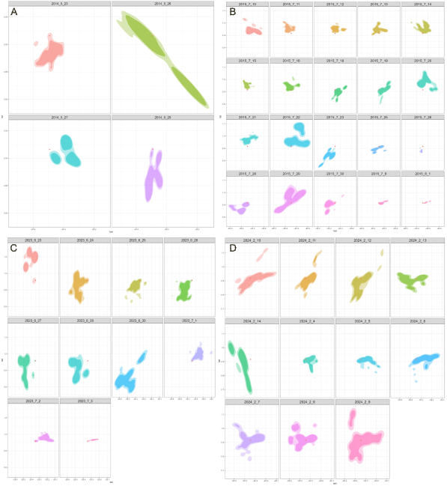Fig. S2 Daily foraging area utilization distributions for brown boobies (Sula leucogaster) at SPSP by year: (A) 2014, (B) 2015, (C) 2023, and (D) 2024. Colors represent different days within each year, illustrating high day-to-day variability in foraging directions. Contours show 95% kernel density estimates.
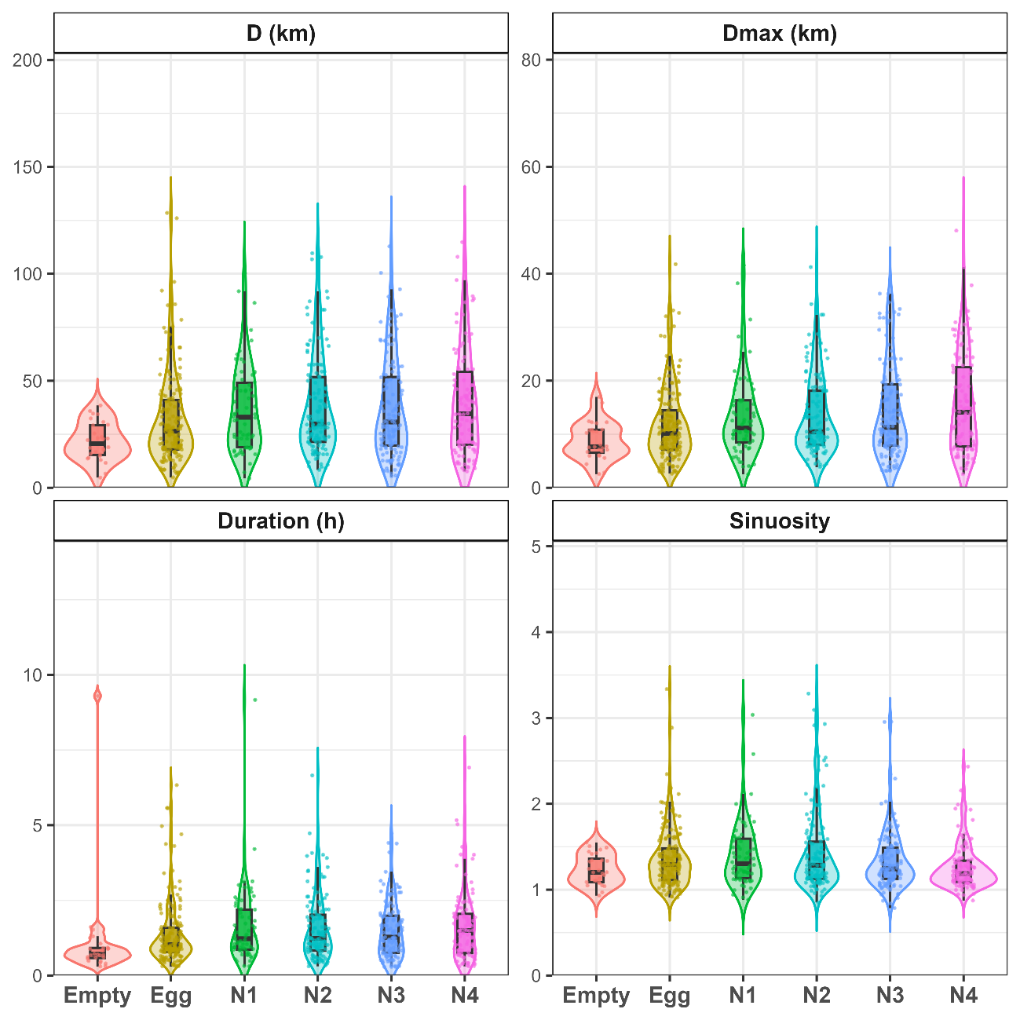
Fig. S3 Foraging trip metrics of brown boobies (Sula leucogaster) by nest (N1 = 0–2 weeks, N2 = 3–6 weeks, N3 = 7–14 weeks, and N4 > 15 weeks) content in the Saint Peter and Saint Paul Archipelago. Metrics include: total distance traveled (D, km), maximum distance from colony (Dmax, km), trip duration (h), and sinuosity.

